Commonwealth of Massachusetts
Executive Office of Health and Human Services

Office of Medicaid
www.mass.gov/masshealth

MassHealth
Acute Inpatient Hospital Bulletin 152
July 2015

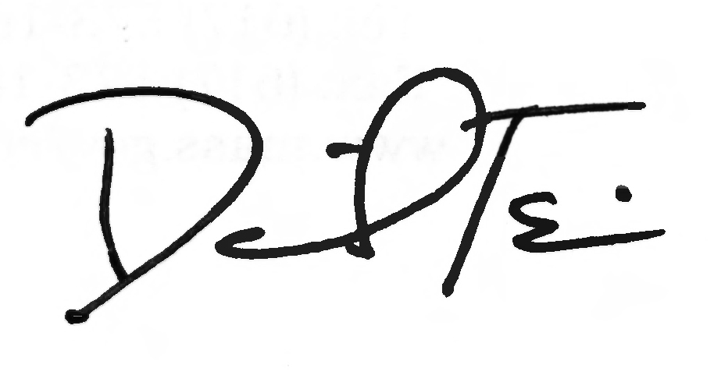
TO: Acute Inpatient Hospitals Participating in MassHealth

FROM: Daniel Tsai, Assistant Secretary for MassHealth

RE: Massachusetts Application for Health and Dental Coverage and Help Paying Costs (ACA-3)

Background

MassHealth, in conjunction with the Massachusetts Health Connector (the “Connector”) and the Health Safety Net (HSN), has updated the paper application for health benefits. The new Massachusetts Application for Health and Dental Coverage and Help Paying Costs (ACA-3), revised in March 2015, is intended for the following populations in Massachusetts:
- individuals younger than age 65 who do not need long-term-care services (either in a nursing facility or in the community);
- parents of children younger than age 19 and adult relatives living with or taking care of children younger than age 19 when neither parent is living in the home; and
- individuals who are disabled and who are either working 40 or more hours a month or are currently working and have worked at least 240 hours in the six months immediately before the month of the application or, if younger than age 65, not working.

Individuals aged 65 or older, including those in mixed households, and those of any age who need long-term-care services (either in a nursing facility or in the community) will need to fill out the Application for Health Coverage for Seniors and People Needing Long-Term-Care Services (SACA-2).

The ACA-3 captures applicant information to determine eligibility for benefits as required by the Affordable Care Act (ACA). This application is designed to align with the online application from the state-based marketplace that is the “front door” for applying for assistance from MassHealth and the Massachusetts Health Connector. MAhealthconnector.org is the state-based marketplace where individuals in Massachusetts can apply for and purchase health care benefits.

The revised version of the ACA-3 has been updated to better align with the online application, clarify language to more effectively gather accurate data, and incorporate certain changes recommended by field workers and advocates.

Some questions asked on the application are conditional upon a certain answer to other questions. In general, though, all information requested on the ACA-3 is required and should be provided in order to prevent a delay in the processing of an application.

(continued on next page)

MassHealth
Acute Inpatient Hospital Bulletin 152
July 2015

Page 2

Summary of Changes

This version of the ACA-3 includes the following changes.
- General
  - Added a section for a fourth person.
- For households with more than four people, applicants can copy the blank pages for Person 4 and use the copied pages to list the additional members of the household on the application. Alternatively, applicants can include the Massachusetts Application for Health and Dental Coverage and Help Paying Costs — Additional Persons (ACA-3-AP) form with their application. This form can be downloaded from the Applications and Member Forms page at www.mass.gov/eohhs/gov/departments/masshealth/applications-and-member-forms.html.
  - Updated the fax number of the Health Insurance Processing Center.
  - Added instructions for the Special Enrollment Period Form.
  - Bolded sections requiring a signature.
- Step 1, Person 1
  - Added identifying fields to ensure that all household members are included on the application.
- Step 2
  - Updated information about whom to include/not to include to determine accurate households.
  - Added language about copying blank pages for Person 4.
  - Added or reordered questions about tax information, marriage status, dependent status, date of birth for caretaker relatives, pregnancy, breast or cervical cancer diagnosis, and HIV status.
  - Revised Current Job and Income Information section to include instructions about pre-tax deductions, to get information about seasonal employees’ work, and to clarify yearly income questions.
- Step 5
  - Section added to capture information about noncustodial parents.
- Step 6
  - Added questions to the incarceration section.
- Supplement A (Health Coverage from Jobs)
  - Expanded instructions.
  - Clarified question 15.
- Added Supplement D (Special Enrollment Period Form)
  - This Special Enrollment Period Form for the Connector aims to capture information about those applicants who qualify to enroll because of certain life events but who are applying outside the open enrollment period.

How to Apply

The updated paper application is currently available.

Individuals are encouraged to apply online at MAhealthconnector.org. Applying online is the fastest way to get coverage.

(continued on next page)

MassHealth
Acute Inpatient Hospital Bulletin 152
July 2015

Page 3

How to Apply (cont.)

Mail the filled-out, signed application to

Health Insurance Processing Center
P.O. Box 4405
Taunton, MA 02780

Fax the filled-out, signed application to 1-857-323-8300 (NOTE: new fax number).

To apply by telephone, call the MassHealth Customer Service Center at 1-800-841-2900
(TTY: 1-800-497-4648 for people who are deaf, hard of hearing, or speech disabled)
or 1-800-MA ENROLL (1-800-623-6765).

Visit a MassHealth Enrollment Center (MEC) to apply in person.

Supplies and Use of Earlier Versions of the ACA-3

Earlier versions of the ACA-3 may be accepted. When you receive a supply of the new ACA-3 (March 2015), please recycle earlier versions of the form. Although earlier versions will continue to be accepted, they should not be distributed to the public.

Location of Printable Application on the MassHealth Website

The new ACA-3 and ACA-3-AP can be printed from the MassHealth website. Go to
www.mass.gov/eohhs/gov/departments/masshealth/applications-and-member-forms.html.

Questions

If you have any questions about the information in this bulletin, please contact the MassHealth Customer Service Center at 1-800-841-2900, e-mail your inquiry to providersupport@mahealth.net, or fax your inquiry to 617-988-8974.

Follow us on Twitter @MassHealth

