Commonwealth of Massachusetts
Executive Office of Health and Human Services

Office of Medicaid
www.mass.gov/masshealth

MassHealth
Acute Inpatient Hospital Bulletin 166
December 2018

TO: Acute Inpatient Hospital Providers Participating in MassHealth
FROM: Daniel Tsai, Assistant Secretary for MassHealth 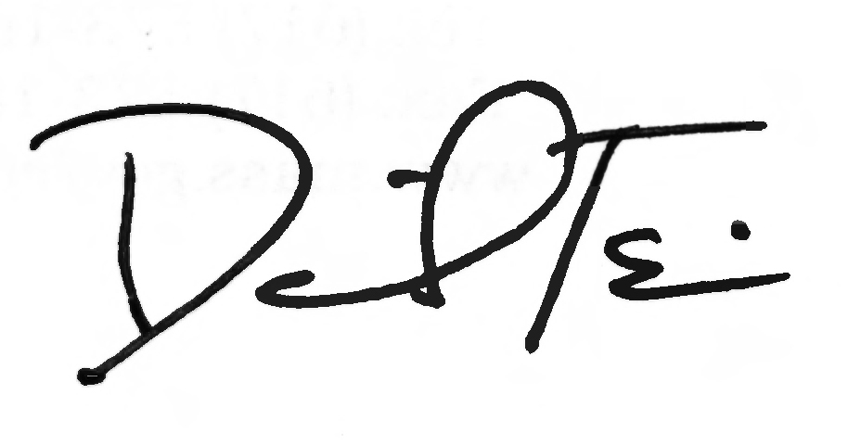

RE: Application for Health Coverage for Seniors and People Needing Long-Term-Care Services (SACA-2)

Background

MassHealth has updated the paper application for health benefits for seniors and people
needing long-term-care services. The updated Application for Health Coverage for Seniors and People Needing Long-Term-Care Services (SACA-2), revised in October 2018, is intended for the following populations in Massachusetts:
- an individual 65 years of age or older and living at home and
- not the parent of a child younger than 19 years of age who lives with the individual; or
- not an adult relative living with and taking care of a child younger than 19 years of age when neither parent is living in the home; or
- an individual of any age who needs long-term-care services in a medical institution or a nursing facility; or
- an individual who is eligible under certain programs to get long-term-care services to live at home; or
- a member of a married couple living together and
- both spouses are applying for health coverage;
- there are no children younger than 19 years of age living with the couple; and
- one spouse is 65 years of age or older and the other spouse is younger than 65 years of age.

If an individual 65 years of age or older meets any of the following exceptions, they should complete the Application for Health and Dental Coverage and Help Paying Costs (ACA-3). He or she
- is the parent of a child younger than 19 years of age who lives with him or her; or
- is an adult relative living with and taking care of a child younger than 19 years of age when neither parent is living in the home; or
- is disabled and is either employed 40 hours or more a month or is currently employed and has been employed at least 240 hours in the six months immediately before the month of application.

Summary of Changes

Below is a summary of changes made in the October 2018 version of the SACA-2.

(continued on next page)

MassHealth
Acute Inpatient Hospital Bulletin 166
December 2018

Page 2

Summary of Changes (cont.)

- Minor updates were made to the language in the tax filing questions (Person 1, Question 6; Person 2, Question 16).
- Bolded “You do NOT need to file a tax return to apply for or to get MassHealth or HSN, if you qualify” on tax filing questions (Person 1: Page 2, Question 6; Person 2: Page 7, Question 16).
- Removed option for 2nd job (due to spacing issues), but kept instruction to attach another sheet of paper if more room is needed (Person 1: Page 5, Question 21; Person 2: Page 9, Question 31).
- Updated list of deductions to align with changes to the HIX in Release 16, which occurred in October 2018 (Person 1: Page 6, Question 32; Person 2: Page 10, Question 40).
- Clarified instructions for the Race and Ethnicity section on page 20.
- Re-ordered some items on the signature page and slightly changed some text (not affecting content) to align the paper signature page with the online signature page. Examples are changing “or” to “and/or” and changing “eligible members” to “I.”

Supplies and Use of Revised Forms

The April and July 2018 version of the SACA-2 are obsolete. The October 2018 version is now available.

How to Apply

Mail the filled-out, signed application to

MassHealth Enrollment Center
Central Processing Unit
P.O. Box 290794
Charlestown, MA 02129-0214.

Fax the filled-out, signed application to (617) 887-8799.

Visit a MassHealth Enrollment Center (MEC) to apply in person.

Location of the Printable Application on the MassHealth Website

The Senior Guide to Health Care Coverage (SACA-1) and the SACA-2 can be printed
from the MassHealth website. Go to https://www.mass.gov/how-to/apply-for-masshealth-coverage-for-seniors-and-people-of-any-age-who-need-long-term-care.

MassHealth Website

This bulletin is available on the MassHealth website at www.mass.gov/masshealth-provider-bulletins.

To sign up to receive email alerts when MassHealth issues new bulletins and transmittal letters, send a blank email to join-masshealth-provider-pubs@listserv.state.ma.us. No text in the body or subject line is needed.

(continued on next page)

MassHealth
Acute Inpatient Hospital Bulletin 166
December 2018

Page 3

Questions

If you have any questions about the information in this bulletin, please contact the MassHealth Customer Service Center at (800) 841-2900, email your inquiry to providersupport@mahealth.net, or fax your inquiry to (617) 988-8974.

Follow us on Twitter @MassHealth

