Commonwealth of Massachusetts
Executive Office of Health and Human Services

Office of Medicaid
www.mass.gov/masshealth

MassHealth
Acute Outpatient Hospital Bulletin 31
February 2015
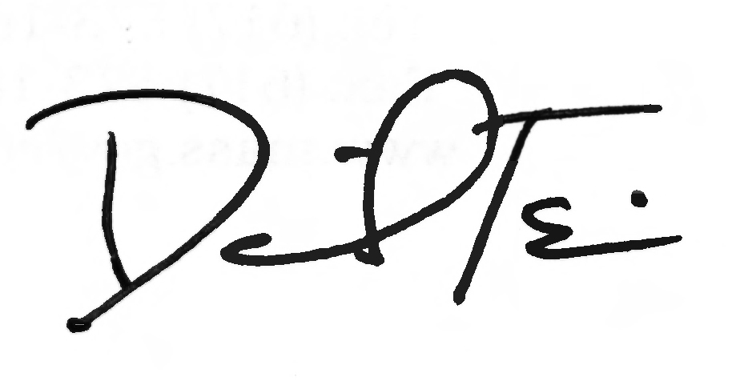

TO: Acute Outpatient Hospitals Participating in MassHealth

FROM: Daniel Tsai, Assistant Secretary and Director of MassHealth

RE: Section 1202 Rates for Hospital-Based Physicians and Physicians Working in Group Practices Who Provide Primary Care Services

Background

For dates of service in calendar years 2013 and 2014, Section 1202 of the federal Affordable Care Act (ACA) requires Medicaid agencies to provide payment for certain primary care services delivered by eligible physicians (including osteopathic physicians), consistent with rules set forth in 42 CFR Part 447, Subpart G (Section 1202 rates) and 101 CMR 317.00: Medicine. Please note that Congress has not extended Section 1202, so physicians are being paid the standard, unenhanced MassHealth rates for dates of service beginning in January 2015.

Section 1202 applies to physicians who are salaried and contracted by hospitals (“hospital-based physicians”) and physicians working in group practices, in addition to individual MassHealth participating physicians. Hospitals and group practices must pass along the direct benefit of the Section 1202 payment to the eligible physician providing the service.

This bulletin updates All Provider Bulletin 235, issued in August 2013 (which in turn had updated All Provider Bulletin 230, issued in December 2012). All Provider Bulletins 230 and 235 remain in effect for claims with dates of service in calendar years 2013 and 2014 with the following clarification.
- For hospital-based physicians and physicians working in group practices, the 60%-of-claims attestation for eligibility to receive Section 1202 rates will include claims paid to the hospital or group practice for services provided by the rendering physician.

Hospital-Based Nonbilling Provider Enrollment

In order for hospitals to be paid Section 1202 rates for services provided by their hospital-based Section 1202-eligible physicians, those physicians must be enrolled with MassHealth and must attest to Section 1202 eligibility. Section 1202-eligible hospital-based physicians who are not already enrolled with MassHealth should work with their primary hospital to complete the Hospital-Based Nonbilling Provider Enrollment Form and the MassHealth Nonbilling Provider Contract for Individuals (Contract). Section 1202-eligible hospital-based physicians who are already enrolled with MassHealth should complete the Hospital-Based Nonbilling Provider Enrollment Form in order to attest to Section 1202 eligibility and to show hospital affiliations, but should not complete the Contract. As previously communicated to hospitals, these enrollment materials must be submitted to MassHealth by April 1, 2015.
(continued on next page)

MassHealth

Acute Outpatient Hospital Bulletin 31

February 2015

Page 3

Hospital-Based Nonbilling Provider Enrollment (cont.)

In addition to using the Hospital-Based Nonbilling Provider Enrollment Form to attest to Section 1202 eligibility, hospital-based physicians, as well as hospital-based dentists and podiatrists, will use this form to enroll with MassHealth as nonbilling providers for other purposes, including ordering, referring, or prescribing medications, equipment, supplies, or services to MassHealth members. MassHealth will be issuing further information about nonbilling provider enrollment for purposes other than Section 1202 eligibility.

Hospital-based physicians need to complete only one Hospital-Based Nonbilling Provider Enrollment Form to cover all the hospitals that bill for their services. Physicians must list the Provider Identification/Service Location (PID/SL) of their primary affiliated hospital on the form, and should also list each location (PID/SL) at which they provide services billed by hospitals. Physicians in hospital-affiliated group practices should not complete the Hospital-Based Nonbilling Provider Enrollment Form.

Hospital-based nonbilling physicians will also need to sign and return the Contract. The Hospital-Based Nonbilling Provider Enrollment Form and Contract may not be used to newly enroll as a MassHealth billing provider. A provider wishing to enroll with MassHealth as a billing provider should contact the MassHealth Customer Service Center at 1-800-841-2900.

In addition to the information provided in this bulletin, acute hospitals will receive the Hospital-Based Nonbilling Provider Enrollment Form by e-mail.

These enrollment materials must be submitted to MassHealth on or before April 1, 2015, for a hospital-based physician to be eligible for Section 1202 rates. Once enrollment is complete, payments to the hospital can then be made for dates of service starting with January 1, 2013, or the physician’s date of eligibility for Section 1202 rates, whichever is later.

Section 1202 Requirements for Hospitals and Group Practices

Hospitals and group practices must ensure that the physicians for whose professional services the entities are billing receive the direct benefit of the entire payment increase for each of the Section 1202 primary care services they provide. Options for meeting this requirement include increasing salaries or providing additional or bonus payments to Section 1202 eligible physicians. In the event of a state or federal audit, hospitals and group practices must be prepared to demonstrate that they have met the requirements of Section 1202.

Section 1202 Hospital Claiming Instructions (All Claims Other than Medicare Crossovers)

Hospitals will be eligible to receive Section 1202 payments for services provided starting on January 1, 2013, by an eligible nonbilling hospital-based physician only after MassHealth receives the Hospital-Based Nonbilling Provider Enrollment Form and a signed Contract for that physician and MassHealth has processed these documents. MassHealth will send a welcome letter to each physician containing his or her provider number when the physician is enrolled.
(continued on next page)

MassHealth

Acute Outpatient Hospital Bulletin 31

February 2015

Page 5

Section 1202 Hospital Claiming Instructions (All Claims Other than Medicare Crossovers) (cont.)

In order for hospitals to be paid Section 1202 rates for previously paid claims for services provided by a Section 1202-eligible physician, hospitals must adjust the claims for any dates of service starting with January 1, 2013, or the physician’s date of eligibility for Section 1202 rates, whichever is later.

Hospitals can confirm that enrollments for their hospital-based physicians have been processed by visiting the Provider Online Service Center (POSC). To access the POSC, a hospital will need to complete and submit a Data Collection Form (DCF) for each Section 1202-eligible rendering physician. You may visit the POSC at newmmis-portal.ehs.state.ma.us/EHSProviderPortal/appmanager/provider/desktop. DCFs are available at www.mass.gov/eohhs/docs/masshealth/provider-services/forms/posc-dc.pdf. In addition to confirming enrollments in using the POSC, after Hospital-Based Nonbilling Provider Enrollment Forms and Contracts have been submitted for a hospital’s physicians, the hospital administrative staff can e-mail a roster of their physicians to providersupport@mahealth.net. MassHealth will validate the list and respond to the sender within 15 business days.

Hospitals can begin to receive 1202 payments by submitting a file of only Section 1202-eligible claims for their hospital-based physicians whose enrollment has been completed. Adjusted claims for Section 1202-eligible services rendered by Section 1202-eligible, hospital-based physicians must include the rendering physician information on the claim. All adjusted claims must be submitted by September 1, 2015.

When submitting adjusted claims for dates of service starting with January 1, 2013, hospitals should submit for Section 1202 eligible services only. Hospitals may be subject to a post-payment review of the claims. Any claim paid Section 1202 rates for non-Section 1202 services, or that does not meet submission deadlines, or that was not eligible under the submission deadline waivers will be considered an overpayment as referenced in 130 CMR 450.235: Overpayments and will be subject to recovery by MassHealth.

Adjusting a Claim in a Paid Status within One Year of the Date of Service

Hospitals that have been paid for a Section 1202-eligible claim that did not include the rendering provider information on their claim should follow the guidelines below to adjust the claim and enter the rendering provider information. Prepare an adjustment using your electronic software (837P) (Void/replace transaction). Identify the Internal Control Number (ICN) of the originally paid claim and use this when submitting the adjusted claim. Enter the Rendering Provider Name and Rendering Provider National Provider Identifier (NPI).

Adjusting a Claim in a Paid Status More than One Year from the Date of Service

Hospitals should send an e-mail to ClaimsSupport@massmail.state.ma.us to request a waiver of the one-year claim submission deadline for any Section 1202-eligible claims that exceed that deadline. Hospitals must indicate in the subject line of the e-mail “Section 1202 Project.”
(continued on next page)

MassHealth

Acute Outpatient Hospital Bulletin 31

February 2015

Page 7

Adjusting a Claim in a Paid Status More than One Year from the Date of Service (cont.)

Then in the e-mail they must indicate their PID/SL, the number of claims being submitted, and the date range of the claims. MassHealth will respond to the provider’s request by e-mail within ten business days. Once the hospital receives MassHealth’s waiver of the one-year claim submission deadline, the hospital must submit its adjusted 1202 claims directly to MassHealth through the 837 HIPAA batch transaction. If the claims that were granted the one year submission deadline waiver deny for other edits, providers must follow the appeal process as outlined in the MassHealth regulations and billing instructions.

Section 1202 Hospital Claiming Instructions: Medicare Crossover and Section 1202 Eligible Claims

In order to be paid Section 1202 rates for previously paid crossover claims for services provided by a Section 1202-eligible hospital-based physician, hospitals may submit adjustments for dates of service starting with January 1, 2013, or the hospital-based physician’s date of eligibility for Section 1202 rates, whichever is later. Hospitals must submit these crossover claim adjustments from June 1, 2015, to September 1, 2015, and ensure that the correct Section 1202 eligible Rendering Provider Name and Rendering Provider National Provider Identifier (NPI) is included. Section 1202 rates for hospital based physician adjustments will only be applied to Medicare crossover claims adjustments submitted between June 1, 2015, to September 1, 2015.

Questions

If you have any questions about the information in this bulletin, please contact the MassHealth Customer Service Center at 1-800-841-2900, e-mail your inquiry to providersupport@mahealth.net, or fax your inquiry to 617-988-8974.

Follow us on Twitter @MassHealth.

