Commonwealth of Massachusetts
Executive Office of Health and Human Services

Office of Medicaid
www.mass.gov/masshealth

MassHealth
Acute Outpatient Hospital
Bulletin AOH-32
August 2016

TO: Acute Outpatient Hospitals Participating in MassHealth
FROM: Daniel Tsai, Assistant Secretary for MassHealth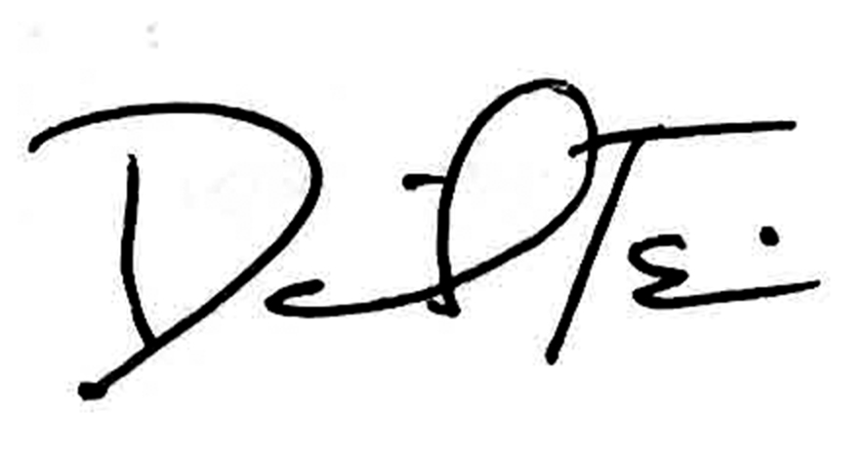

RE: Dental Third-Party Administrator for MassHealth and Health Safety Net Providers

Dental Third-Party Administrator

As part of the Commonwealth’s commitment to ensure access to dental services for eligible MassHealth members and increase efficiencies across programs, the Executive Office of Health and Human Services is pleased to announce that it has signed a contract with Dental Service of Massachusetts, Inc. and its subcontractor DentaQuest (DQ) to provide dental third-party administrator (TPA) services for MassHealth and the Health Safety Net (HSN). DQ has an extensive experience as a dental TPA, and has served as the TPA for the MassHealth Dental Program since 2007.

The status of MassHealth-only providers (i.e., individual dentists, dental clinics, dental schools, public health dental hygienists, and dental hygiene schools) will not be impacted by the new TPA contract and no action on the part of those providers is needed at this time. As described below, certain new features and enhancements will be available to MassHealth dental providers under the new contract, but claims processing, customer service, and other administrative functions for MassHealth-only dental providers will remain largely the same. The new contract will, however, impact a number of these functions for HSN dental providers, as further outlined below.

MassHealth Providers

Participating MassHealth providers can look forward to an enhanced provider portal. The new portal will have real-time claims information and 24/7 availability of eligibility information, the option to request a “peer-to–peer” consultation, and the ability to submit appeals and complaints. The portal will have a single sign-on feature for the user and user-specific access to appropriate portal functions. The portal will also have an online chat feature which will allow the provider to communicate with a customer service representative in real-time without having to call the customer service center. To enhance communication, the portal also has a “chatter” function which allows more than two people to engage in online chat at the same time.

Additionally, current and prospective providers will be able complete the credentialing and enrollment process through a new online application called AppCentral, which will be accessed from the provider portal. AppCentral allows applicants to save application information inputted prior to submitting and prepopulates existing providers’ information on applications to streamline the re-credentialing process for providers.

(continued on next page)

MassHealth
Acute Outpatient Hospital
Bulletin AOH-32
August 2016

Page 2

The Health Safety Net

Beginning later this year, DQ will process dental claims on behalf of the HSN and will provide customer service for HSN dental providers.

The HSN pays only community health centers, acute outpatient hospital departments, and hospital-licensed health centers for certain dental services to qualifying patients, including MassHealth members age 21 and older, in accordance with the Health Safety Net Eligible Services regulation, 101 CMR 613.00.

The HSN only makes payments for dental services to community health centers, acute hospital outpatient departments, and hospital-licensed health centers; these providers are considered HSN dental providers. All HSN dental providers must also be MassHealth providers. Other MassHealth dental providers such as individual dentists, dental clinics, dental laboratories, dental schools, Public Health Dental Hygienists, and dental hygiene schools may not be HSN providers.

Health Safety Net Providers

MassHealth and DQ are currently in the process of implementing the new contract and developing the operational processes related to HSN.

Below highlights key functions that DQ will manage on behalf of the HSN.

- Claims Processing. HSN dental providers will be required to submit electronic claims to DQ.
- Customer Service.
  - HSN dental providers will contact DQ for claim and authorization questions.
  - HSN dental providers will continue to contact the HSN helpdesk for questions related to payments.
- Provider Relations. DQ will be providing support and training to HSN providers regarding the upcoming changes related to claim submission, accessing the new provider portal, key resources, and customer service support.

Further details will be forthcoming in future provider bulletins.

Future Communication, Training, and Implementation

It is important for HSN dental providers to be prepared for the operational changes, new claims submission process, and the enhanced provider web portal before implementation. This bulletin provides some of the high-level information on these changes, but transition

activities will be described in greater detail at upcoming in-person training sessions, webinar training sessions, and in future provider bulletins.

Please look for specific provider communications via letter/e-mail from DentaQuest within the next 30 days. HSN dental providers are urged to participate in one of the training

(continued on next page)

MassHealth
Acute Outpatient Hospital
Bulletin AOH-32
August 2016

Page 3

Future Communication, Training, and Implementation (cont.)

sessions and webinars hosted by DentaQuest. Training dates will be forthcoming. These trainings will provide critical information about how the pre-implementation of the claims submission may impact you and your business.

The anticipated implementation of the processes impacting HSN dental providers is scheduled for fall 2016.

Questions

If you have any questions about the information in this bulletin, please contact the MassHealth Customer Service Center at 1-800-841-2900, e-mail your inquiry to providersupport@mahealth.net, or fax your inquiry to 617-988-8974.

