Commonwealth of Massachusetts
Executive Office of Health and Human Services

Office of Medicaid
www.mass.gov/masshealth

MassHealth
Acute Outpatient Hospital Bulletin 33
October 2016

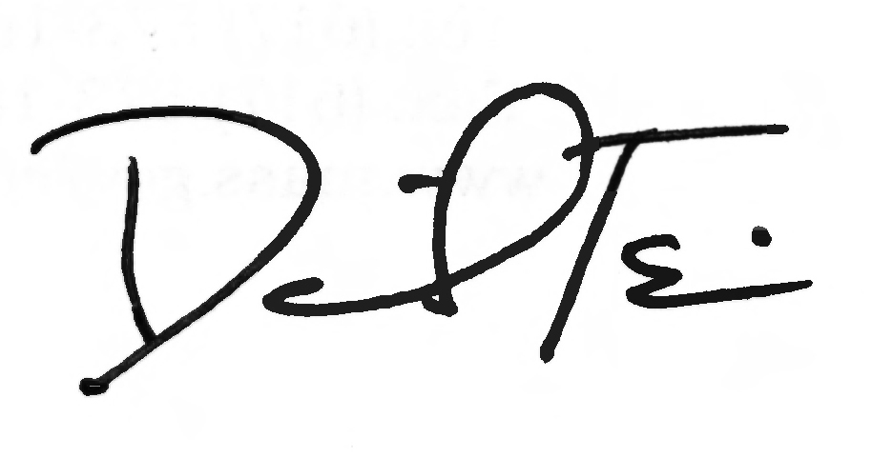
TO: Acute Outpatient Hospitals Participating in MassHealth

FROM: Daniel Tsai, Assistant Secretary for MassHealth

RE: Hospital Incentive–Accessible Equipment

Background

MassHealth has established a program of hospital incentive payments that all managed care organizations (MCOs) are required to implement. In MCO Contract Year 2017 (October 1, 2016, to September 30, 2017) MassHealth-contracted MCOs are required to make these payments to acute hospitals in their MCO networks if those hospitals meet certain performance measures set forth in in the MCO contract. Specifically, acute hospitals must report certain information related to access to medical and diagnostic equipment for MassHealth members with disabilities. MCOs will verify and report this information to EOHHS. New performance-based MCO hospital payments will be announced annually.

Payments

In the aggregate, MCOs are required to pay their contracted acute hospitals a total of
$265 million subject to successful completion of performance measures. Total payments to contracted acute hospitals will be determined by MassHealth based on each hospital’s pro-rata share of state-wide Medicaid managed and non-managed gross patient service revenue (GPSR) between October 1, 2016, and September 30, 2017. These payments will be made in proportion to the GPSR from MassHealth services under each MCO-hospital contract arrangement. Hospitals will receive a separate payment from each MCO with which they contract.

As an example, an acute hospital with managed and non-managed Medicaid GPSR that accounts for 10% of all acute hospitals’ Medicaid GPSR in the State between October 1, 2016, and September 30, 2017, would receive $26.5 million in total payments, or 10% of $265 million. If the hospital is contracted with two MassHealth MCOs, and the same GPSR is charged under each MCO contract between October 1, 2016, and September 30, 2017, then each MCO will be directed to make $13.25 million in payments to the hospital. All payments would be contingent on the hospital’s performance under the incentive program.

(continued on next page)

MassHealth

Acute Outpatient Hospital Bulletin 33

October 2016

Page 2

Payments (cont.)

MCOs will make interim payments to their contracted acute hospitals on a monthly basis. The amount paid each month may vary over the course of the performance period, based on updated forecasts of each hospital’s Medicaid gross patient service revenue and performance. Final payments are subject to annual reconciliation based on each hospital’s actual Medicaid gross patient service revenue and performance. EOHHS anticipates that hospitals, as a class, will receive 90% of expected total payments over the course of twelve monthly payments, with 10% reserved for the annual reconciliation; therefore, monthly payments to hospitals will equate to 5–10% of the total annual amount received by a hospital.

Performance Measures for MCO Contract Year 2017 (October 1, 2016, to September 30, 2017)

EOHHS continues to look for ways to improve access to care for MassHealth members with disabilities. Improving access to medical and diagnostic equipment is a critical component of these efforts and of MassHealth’s overall quality strategy moving forward. Consistent with these efforts and strategy, MCOs are required to provide the above-described payments to acute hospitals in their networks if those hospitals provide the MCOs with the following information:

- the hospital’s capacity to provide accessible medical and diagnostic equipment to individuals with disabilities;
- a detailed list of the hospital’s accessible medical and diagnostic equipment;
- the hospital’s plan to improve its provision of accessible medical and diagnostic equipment for individuals with disabilities; and
- the name and contact information for the hospital’s single point of contact for those with questions about access for individuals with disabilities (i.e., a Disability Access Key Contact, as described in the MCO Contract).

While incentive payments will be tied to reporting measures in early years of the program, the accountability framework will transition to performance metrics that are linked to existing access improvement initiatives in the Commonwealth. EOHHS will be engaging a variety of stakeholder groups to discuss performance measures further.

Tentative Timelines/Next Steps

11/15/2016 – MCOs make first monthly payment to all contract hospitals.
11/15/2016 – Hospitals provide MCOs with Medicaid GPSR during MCO Contract Year 2016 (October 1, 2015, to September 30, 2016) that were charged under contract with each MCO.
12/1/2016 – MassHealth provides reporting form for hospitals to submit to MCOs.

(continued on next page)

MassHealth

Acute Outpatient Hospital Bulletin 33

October 2016

Page 3

Tentative Timelines/Next Steps (cont.)

12/15/2016 – MCOs make second monthly payment to all contract hospitals.
1/15/2017 – MCOs make third monthly payments to all contract hospitals.
1/31/2017 – Hospitals report to MCOs on hospital access for members.
2/15/2017 – MCOs make fourth monthly payment to all contract hospitals.
3/15/2017 – MCOs make fifth monthly payment to all contract hospitals.
4/15/2017 – MCOs make sixth monthly payment to all contract hospitals.
5/15/2017 – MCOs make seventh monthly payment to all contract hospitals.
5/31/2017 – Hospitals report to MCOs on hospital access for members.
6/15/2017 – MCOs make eighth monthly payment to all contract hospitals.
7/15/2017 – MCOs make ninth monthly payment to all contract hospitals.
8/15/2017 – MCOs make tenth monthly payment to all contract hospitals.
9/15/2017 – MCOs make eleventh monthly payment to all contract hospitals.
9/30/2017 – Hospitals report to MCOs on hospital access for members.
10/15/2017 – MCOs make final monthly payment to all contract hospitals.
12/1/2017 – MCOs pay or seek remittance based on reconciliation schedule.

Questions

If you have any questions about the information in this bulletin, please contact the MassHealth Customer Service Center at 1-800-841-2900, e-mail your inquiry to providersupport@mahealth.net, or fax your inquiry to 617-988-8974.

