INDOOR AIR QUALITY ASSESSMENT

Adams Town Hall
8 Park Street
Adams, Massachusetts

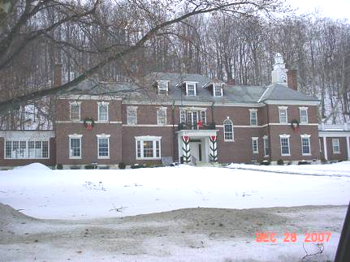

Prepared by:
Massachusetts Department of Public Health
Bureau of Environmental Health
Indoor Air Quality Program
March 2008

Background/Introduction
At the request of William Ketcham, Town Administrator for the Town of Adams, the Massachusetts Department of Public Health (MDPH), Bureau of Environmental Health (BEH) conducted an indoor air quality evaluation at the Adams Town Hall, 8 Park Street, Adams, Massachusetts. Concerns about indoor air quality and complaints regarding upper respiratory symptoms prompted the assessment.
On December 28, 2007 Michael Feeney, Director of Indoor Air Quality (IAQ), and Lisa Hébert, Regional Inspector for BEH’s IAQ Program, conducted an evaluation of the building. The Adams Town Hall (ATH) is a two story building originally built as a private mansion in 1907. In 1996, the building underwent extensive renovations, which included the following:
- Installation of a heating, ventilating and air-conditioning (HVAC) system in the original building;
- Conversion of the basement to office space, which included the addition of a separate HVAC system to service the Board of Health and Building Inspector’s offices; and
- Addition of a wing to the north side of the original building, which includes offices on the first floor, records storage in the basement and an elevator located within a clock tower.
Prior to this renovation, no mechanical HVAC system existed in the building. Heat was provided by radiators. Windows were openable throughout the building.

Methods
Air tests for carbon monoxide, carbon dioxide, temperature and relative humidity were taken with the TSI, Q-Trak ™, IAQ Monitor Model 8551. Moisture content of water-damaged building materials was measured with a Delmhorst, BD-2000 Model, Moisture Detector equipped with a Delmhorst Standard Probe.

Results
The ATH has a staff of 23 and can be visited by up to 20-30 people daily. The tests were taken under normal operating conditions. Test results appear in Table 1. Moisture and related temperature results for the Board of Health and Building Inspector’s offices appear in Table 2.

Discussion
Ventilation
It can be seen from Table 1 that carbon dioxide levels were below 800 parts per million (ppm) in most (26 of 29) of the areas surveyed, indicating adequate ventilation these areas (Table 1). It is important to note that several areas were empty/sparsely populated, which can greatly reduce carbon dioxide levels. With minimal occupancy and an adequate supply of fresh air by ventilation equipment, carbon dioxide levels in the building would be expected to be near outdoor levels. Carbon dioxide levels would be expected to be higher with increased occupancy.
The HVAC system for the ATH consists of four separate air handling units (AHUs); however, three of the four AHUs lack an adequate supply of fresh air. Each AHU is connected to ducts that supply air to rooms through ceiling mounted air diffusers, which create airflow by directing the air supply along the ceiling down the walls. Each AHU has a different design and services a specific location within the building complex. The four AHUs observed had the following configurations:
- 1907 Wing, First and Second Floors: The older portion of the building is served by two AHUs located in the attic. No fresh air intakes or exhaust vents could be identified for either AHU; therefore, air appears to be re-circulated only, in the main portion of the building. Fresh air is introduced through openable windows or by indirect means (see temperature discussion).
- 1907 Wing, Basement Level: The HVAC system in the basement (renovated in 1996) provides heat and air conditioning to the basement offices. No source or fresh air or exhaust ventilation could be readily identified on this AHU at the time of the assessment; therefore, this area also appears to have recirculated air.
- 1996 Wing: The HVAC system for the 1996 wing is located on the roof (Picture 1). This AHU does have a fresh air intake; however, it lacks a means of exhaust. It appears that exhaust ventilation was intended to be provided by bathroom vents. A bathroom exhaust vent was situated in close proximity to the fresh air intake for this AHU on the roof of the building. The building code requires that pollutant sources must be ten feet away from or two feet above fresh air intakes (BOCA, 1993, SBBRS, 1997). An extension several feet above the fresh air intake may be needed to prevent sewer gas from entering the AHU and distributed within the wing (called entrainment).
There is also an office space on the first floor of the 1907 wing and basement which lacks mechanical ventilation of any kind. The only means of air exchange is through openable windows.
With an inadequate supply and exhaust, normally occurring environmental pollutants that exist can build up and remain inside the building, leading to indoor air quality/comfort complaints. To maximize air exchange, BEH recommends that AHUs be provided with fresh air intakes and that all mechanical ventilation systems operate continuously during periods of occupancy.
In order to have proper ventilation with a mechanical supply and exhaust system, these systems must be balanced to provide an adequate amount of fresh air to the interior of a room while removing stale air from the room. According to an ATH official, it was unknown when the HVAC systems were last balanced. It is recommended that existing ventilation systems be re-balanced every five years to ensure adequate air systems function (SMACNA, 1994).
The Massachusetts Building Code requires that each room have a minimum ventilation rate of 20 cubic feet per minute (cfm) per occupant of fresh outside air or openable windows in (SBBRS, 1997; BOCA, 1993) in office space. The ventilation must be on at all times that the room is occupied. Providing adequate fresh air ventilation with open windows and maintaining the temperature in the comfort range during the cold weather season is impractical. Mechanical ventilation is usually required to provide adequate fresh air ventilation.
Carbon dioxide is not a problem in and of itself. It is used as an indicator of the adequacy of the fresh air ventilation. As carbon dioxide levels rise, it indicates that the ventilating system is malfunctioning or the design occupancy of the room is being exceeded. When this happens a buildup of common indoor air pollutants can occur, leading to discomfort or health complaints. The Occupational Safety and Health Administration (OSHA) standard for carbon dioxide is 5,000 parts per million parts of air (ppm). Workers may be exposed to this level for 40 hours/week (OSHA, 1997).
The MPDH uses a guideline of 800 ppm for publicly occupied buildings. A guideline of 600 ppm or less is preferred in schools due to the fact that the majority of occupants are young and considered to be a more sensitive population in the evaluation of environmental health status. Inadequate ventilation and/or elevated temperatures are major causes of complaints such as respiratory, eye, nose and throat irritation, lethargy and headaches. For more information concerning carbon dioxide, please consult Appendix A.
Temperature measurements ranged from 61º F to 73º F, which were below the MDPH recommended comfort range in a number of areas surveyed (Table 1). The MDPH recommends that indoor air temperatures be maintained in a range of 70º F to 78º F in order to provide for the comfort of building occupants. In many cases concerning indoor air quality, fluctuations of temperature in occupied spaces are typically experienced, even in a building with an adequate fresh air supply. In addition, it is difficult to control temperature and maintain comfort without operating the ventilation equipment as designed.
Please note that a number of occupants of the 1907 wing reported poor temperature control. These offices were provided fresh air supplies that consist of holes in the ceiling of each room that is roughly the diameter of PVC drain pipe (Picture 2). In each room with cold complaints, there were fireplaces that were originally used to heat rooms of the mansion. All of the fireplaces had either open (Picture 3) or slightly open flues, which allows cold air to enter these rooms. In addition, when retrofitting a building with an AHU with air-conditioning capability, pathways of hot, moist air in summer must be sealed to prevent condensation, which can provide a source of mold growth. Each fireplace chimney, with flues in the condition described, is equivalent to having an open window while operating air-conditioning. It is customary to seal chimney at both ends to prevent water accumulation and hot, moist air penetration if a mechanical air condition system is installed and fireplaces are not in use.
Also of note was the use of draft excluders along the baseboard of the 1996 wing east wall (Picture 4). An examination of the foundation wall found a number of areas that were sealed using a sealant compound, rather than flashing. The areas where sealant was damaged or missing roughly corresponds with the draft excluders; therefore, outdoor air may enter this section of the building through these breaches.
The relative humidity in the building ranged from 20 to 50 percent, which were below the MDPH recommended comfort range in all areas, with one exception, the Veterans Affairs Office (Table 1). The MDPH recommends a comfort range of 40 to 60 percent for indoor air relative humidity. Relative humidity levels would be expected to drop during the winter months, due to heating. The sensation of dryness and irritation is common in a low relative humidity environment. Low relative humidity is a very common problem during the heating season in the northeast part of the United States.

Microbial/Moisture Concerns
Mold/musty odors were reported in the basement office space created in the 1996 renovation. The following features appear to have been added as part of that project:
- Ground around the southwest corner was removed, exposing the flat stone foundation (Picture 5). Rock was added around the base of the foundation wall. No drainage could be identified in the rock;
- Parget (a cement mixture used to waterproof exterior surfaces) was applied to the outer face of the stone foundation to provide water proofing (Picture 6). This material was either missing or unevenly applied, likely providing minimal water proofing.
- A door was added to provide an exit from these offices to the outdoors (Picture 7); moisture sampling of the door threshold, doorframe and surrounding gypsum wallboard (GW) were found moistened. The last previous significant rain in the greater Adams area occurred five days prior to the assessment on December 23, 2008 (Weather Underground, 2007); and
- The interior office was created by installing GW over the parget foundation wall.
Repeated episodes of musty odors were reported in the southwest corner of the Board of Health/Building Inspector’s Offices. GW in this location had elevated moisture content when compared to other interior wall locations (Table 2). These results indicate that either rainwater is penetrating through the foundation [likely a seam in a stairway above this location that does not have a downspout (Picture 8)] or through the exposed, pargeted foundation wall (Picture 9). In either instance, reinstallation of GW and use of carpeting in these areas without remediating the conditions creating the moisture accumulation will likely lead to further moisture accumulation and musty odors. In addition, a water cooler located on carpeting was noted in one office space. The carpet below the water dispensing nozzles can become moistened by use of the cooler. Porous materials that are wet repeatedly can serve as media for mold growth.
Repeated water damage to porous building materials (e.g., GW, ceiling tiles, and carpeting) can result in microbial growth. The US Environmental Protection Agency (US EPA) and the American Conference of Governmental Industrial Hygienists (ACGIH) recommend that porous materials be dried with fans and heating within 24 to 48 hours of becoming wet (US EPA, 2001; ACGIH, 1989). If not dried within this time frame, mold growth may occur. Once mold has colonized porous materials, they are difficult to clean and should be removed/discarded.
Another potential source of moisture is the lack of gutters/downspouts along a significant area of the building, particularly the clock tower. Traditionally, clock towers are usually designed with either steep slopes of roofing material or sheer walls that aid in the quick shedding of rainwater (Pictures 10 through 15). The clock tower at the ATH is in the shape of a tall ziggurat, with roof surfaces perpendicular to the walls of the tower (Pictures 16 and 17). This design allows for rainwater to accumulate on the small horizontal roofs created by the design, which then exposes the vertical sections of the roof to rainwater, which takes the form of rotted wood (Pictures 17 through 19). This significant amount of water is directed onto the flat roof above the 1996 wing rest rooms, which has neither a roof drain or gutter/downspout system. Gutters and downspouts are needed to direct rainwater from exterior walls to prevent rot and eventual leaks inside the building. Other areas around the roof edge without gutters showed similar signs of water damage.
A dehumidifier was located in the basement records room. The dehumidifier drained into a vessel that was designed to pump the water through plastic tubing located above the ceiling, down the hallway to a sink located in the rear of the custodian’s room (B07). At the time of inspection, the pump did not appear to be functioning; therefore, water had presumably been simply evaporating back into the records room. Removing the pump and plastic tubing and instituting a schedule for regular emptying of the dehumidifier is recommended to alleviate this problem.
The Retirement office had plants located on a metal table. The table beneath the plants showed oxidation indicative of over-watering. Further, plant soil and drip pans can serve as a source of mold growth.

Other Concerns
Indoor air quality can be negatively influenced by the presence of respiratory irritants, such as products of combustion. The process of combustion produces a number of pollutants. Common combustion emissions include carbon monoxide, carbon dioxide, water vapor and smoke (fine airborne particle material). Of these materials, exposure to carbon monoxide can produce immediate, acute health effects upon exposure. To determine whether combustion products were present in the school environment, BEH staff obtained measurements for carbon monoxide.
Carbon monoxide is a by-product of incomplete combustion of organic matter (e.g., gasoline, wood and tobacco). Exposure to carbon monoxide can produce immediate and acute health affects. Several air quality standards have been established to address carbon monoxide and prevent symptoms from exposure to these substances. The MDPH established a corrective action level concerning carbon monoxide in ice skating rinks that use fossil-fueled ice resurfacing equipment. If an operator of an indoor ice rink measures a carbon monoxide level over 30 ppm, taken 20 minutes after resurfacing within a rink, that operator must take actions to reduce carbon monoxide levels (MDPH, 1997).
The American Society of Heating Refrigeration and Air-Conditioning Engineers (ASHRAE) has adopted the National Ambient Air Quality Standards (NAAQS) as one set of criteria for assessing indoor air quality and monitoring of fresh air introduced by HVAC systems (ASHRAE, 1989). The NAAQS are standards established by the US EPA to protect the public health from six criteria pollutants, including carbon monoxide and particulate matter (US EPA, 2006). As recommended by ASHRAE, pollutant levels of fresh air introduced to a building should not exceed the NAAQS levels (ASHRAE, 1989). The NAAQS were adopted by reference in the Building Officials & Code Administrators (BOCA) National Mechanical Code of 1993 (BOCA, 1993), which is now an HVAC standard included in the Massachusetts State Building Code (SBBRS, 1997). According to the NAAQS, carbon monoxide levels in outdoor air should not exceed 9 ppm in an eight-hour average (US EPA, 2006).
Carbon monoxide should not be present in a typical, indoor environment. If it is present, indoor carbon monoxide levels should be less than or equal to outdoor levels. On the day of assessment, outdoor carbon monoxide concentrations were non-detect (ND) (Table 1). Carbon monoxide levels measured in the building were also ND (Table 1).
Indoor air concentrations can also be greatly impacted by the use of products containing volatile organic compounds (VOCs). VOCs are carbon-containing substances that have the ability to evaporate at room temperature. Frequently, exposure to low levels of total VOCs (TVOCs) may produce eye, nose, throat and/or respiratory irritation in some sensitive individuals. For example, chemicals evaporating from a paint can stored at room temperature would most likely contain VOCs. In an effort to identify materials that can potentially increase indoor VOC concentrations, BEH staff examined rooms for products containing these respiratory irritants.
Since only one HVAC system can adequately provide fresh air, caution should be taken in the use of materials that contain respiratory irritants. A number of offices contain photocopiers. VOCs and ozone can be produced by photocopiers, particularly if the equipment is older and in frequent use. Ozone is a respiratory irritant (Schmidt Etkin, 1992). To help reduce excess heat and odors in these areas, ATH personnel should ensure that local exhaust ventilation is activated while equipment is in use. If local exhaust ventilation is not feasible, relocating photocopiers to areas with a large air volume to dilute pollutants produced by this equipment is recommended.
Cleaning products contain VOCs and other chemicals, and should be used in areas with adequate exhaust ventilation in order to remove odors. These chemicals can be irritating to the eyes, nose and throat. Materials such as dry erase markers and dry erase board cleaners may contain VOCs, such as methyl isobutyl ketone, n-butyl acetate and butyl-cellusolve (Sanford, 1999), which can be irritating to the eyes, nose and throat.
A scented odor was observed in the hallway adjacent to the retirement office. The source of this odor appeared to be a plug-in type air freshener located in a bathroom adjacent to the hallway. Air fresheners can contain chemicals that can be irritating to the eyes, nose and throat of sensitive individuals. Furthermore, air fresheners do not remove materials causing odors, but rather mask odors that may be present in the area.
Above the ceiling in the basement office Room 302, BEH staff observed a horizontal run of drain pipe that was pieced together with a minimum of 17 separate rubber gasket screw clamps within an 8 foot span (Picture 20). Rubber gasket screw clamps are used to join drain pipes, but are preferred for use in vertical runs of drain pipe because it is less likely that the gasket material would be continuously exposed to liquid. It is preferable that horizontal runs of drain pipes be continuous with as few joints as possible with the joints installed in a watertight fashion. In the experience of BEH staff, rubber gasket screw clamps are prone to developing openings that allows for liquids and air to escape from the drain pipe joint. This condition may occur due to degradation of the rubber, loosening of the clamp, degradation of pipe material or shifting of pipes due to building settling. A licensed plumber should be retained to examine and if necessary, repair the drain lines in the room, ensuring that no leaks and/or sewer gasses are allowed to enter the office space. Please be advised that the plumber is required by the State Plumbing Code to obtain a permit prior to commencing work on the system.
It was also noted that pipes were penetrating through the adjacent walls in a number of areas including:
- Room 302: The wall between Room 302 and the custodian’s room were not properly sealed. Although not in use at the time of inspection, a blueprint copy machine which utilizes ammonia compounds is located directly beneath these open penetrations. Therefore, there exists the potential for fumes from the machine to migrate through the penetrations into the space above the ceiling tiles in room 302. Prior to sealing the penetrations, the building inspector should be consulted regarding the type of sealant to be utilized in order to ensure that it meets the requirements of the building code. Additionally, a means of mechanical ventilation should be provided for this office space prior to re-occupancy.
- Community Development Office (B 16 – inner room on left): When ceiling panels were lifted by BEH staff, a noticeable movement of air was observed above the ceiling tiles, indicating pressurization of the ceiling plenum. The ceiling plenum in this building should be pressure neutral since it is not part of the HVAC system. This pressurization is likely the result of breaches or damage to the exterior wall in this area that requires repair. Additionally, a copper pipe of unknown purpose was found open above ceiling tile in this room (Picture 21). Pipes should be properly sealed if abandoned.
- Boiler Room: The exhaust vent from the AHU servicing the basement is a long run of ductwork that runs across the length of the boiler room parallel to the floor to a chimney. Exhaust duct seams were not sealed with mastic or other appropriate material. Seams should be properly sealed with duct mastic (Southface Energy Institute, 2002). AHUs should be retrofitted to supply fresh air from the air intake. Window adjacent to fresh air intake was open at the time of inspection.
All wall holes and pipe should be sealed to eliminate pathways for odors and particulates to move between rooms.

Conclusions/Recommendations
The conditions observed in the ATH raise a number of indoor air quality issues. In order to address the conditions listed, the recommendations made to improve indoor air quality in the building are divided into short-term and long-term corrective measures. The short-term recommendations can be implemented as soon as practicable. Long-term recommendations are more complex and will require planning and resources to adequately address the overall indoor air quality concerns within the building. In view of the findings at the time of the visit, the following conclusions and recommendations are made:

Short Term Recommendations
- Ensure that ventilation systems are operating at all times the building is occupied.
- Remove pump and plastic tubing and institute a routine schedule for emptying the dehumidifier in the basement records room.
- Remove air freshener from bathroom.
- Seal both ends of all chimneys in the 1907 building.
- In room 110, move heat sensor closer to the return vent.
- Reseal the exterior wall/foundation junction of the 1996 wing.
- Examine the exterior wall of the 1907 wing breaches. Seal these opening with an appropriate sealant.
- Seal the seam between the outside step and the building as depicted in Picture 8 with an appropriate sealant.
- Clean and repair existing gutters. Ensure water drains at least five feet from the foundation of the building.
- Seal seams of exhaust duct in boiler room with duct sealing mastic.
- Seal penetrations of pipes in custodian’s room.
- Remove debris/paper observed inside air diffuser in room 110 (inner room).
- Ensure plants have drip pans that are routinely cleaned, or remove plants from office spaces.
- For buildings in New England, periods of low relative humidity during the winter are often unavoidable. Therefore, scrupulous cleaning practices should be adopted to minimize common indoor air contaminants whose irritant effects can be enhanced when the relative humidity is low. To control for dusts, a high efficiency particulate arrestance (HEPA) filter equipped vacuum cleaner in conjunction with wet wiping of all surfaces is recommended. Drinking water during the day can help ease some symptoms associated with a dry environment (throat and sinus irritations).

Long Term Recommendations
- GW should be removed from all areas attached to the pargeted exterior wall in the 1907 wing basement level. The exterior walls in this area should be examined by a mason for the best methods to be used to reduce water penetration through the foundation section. GW should not be reinstalled. If the interior wall is replaced, consider using a material that does not contain paper or other materials that can sustain mold growth.
- Consideration should be give to replacing carpet in the 1907 wing basement level with tile or another material that is not prone to mold growth.
- An HVAC engineer should be consulted to determine the best methods for providing fresh air and exhaust ventilation for the 1907 wing basement level. Consider extending the terminus for the bathroom exhaust vent at a level above the fresh air intakes for AHU on roof. If not feasible, consider installing a solid barrier between fresh air intake and exhaust vent to direct bathroom exhaust odors away from the AHU fresh air intake.
- Consider consulting a licensed plumber concerning the drain system above room 302.
- Examine the feasibility of extending the basement HVAC system to include room 302.
- Examine the feasibility of adding gutters to the roof edges of the clock tower to reduce water damage. Replace water damaged wood once gutters are in place.
- Reexamine the feasibility of installing a roof drain in the flat roof beneath the clock tower.
References
ACGIH. 1989. Guidelines for the Assessment of Bioaerosols in the Indoor Environment. American Conference of Governmental Industrial Hygienists, Cincinnati, OH.
BOCA. 1993. The BOCA National Mechanical Code-1993. 8th ed. Building Officials & Code Administrators International, Inc., Country Club Hills, IL. M-308.1
MDPH. 1997. Requirements to Maintain Air Quality in Indoor Skating Rinks (State Sanitary Code, Chapter XI). 105 CMR 675.000. Massachusetts Department of Public Health, Boston, MA.
OSHA. 1997. Limits for Air Contaminants. Occupational Safety and Health Administration. Code of Federal Regulations. 29 C.F.R. 1910.1000 Table Z-1-A.
Sanford. 1999. Material Safety Data Sheet (MSDS No: 198-17). Expo® Dry Erase Markers Bullet, Chisel, and Ultra Fine Tip. Sanford Corporation. Bellwood, IL.
SBBRS. 1997. Mechanical Ventilation. State Board of Building Regulations and Standards. Code of Massachusetts Regulations. 780 CMR 1209.0
Schmidt Etkin. 1992. Office Furnishings/Equipment and Indoor Air Quality Health Impacts, Prevention and Mitigation. Cutter Information Corporation, Indoor Air Quality Update, Arlington, MA.
SMACNA. 1994. HVAC Systems Commissioning Manual. 1st ed. Sheet Metal and Air Conditioning Contractors’ National Association, Inc., Chantilly, VA.
Southface Energy Institute. 2002. Southface Energy Institute, 241 Pine St., Atlanta, GA. www.southface.org.
US EPA. 2001. “Mold Remediation in Schools and Commercial Buildings”. Office of Air and Radiation, Indoor Environments Division, Washington, DC. EPA 402-K-01-001. March 2001. Available at: http://www.epa.gov/iaq/molds/mold_remediation.html
US EPA. 2006. National Ambient Air Quality Standards (NAAQS). US Environmental Protection Agency, Office of Air Quality Planning and Standards, Washington, DC. http://www.epa.gov/air/criteria.html.
Weather Underground, The. 2008. Weather History for North Adams, Massachusetts, December 28, 2007. Available at: http://www.wunderground.com/history/airport/KAQW/2007/12/28/DailyHistory.html?req_city=NA&req_state=NA&req_statename=NA
Picture 1

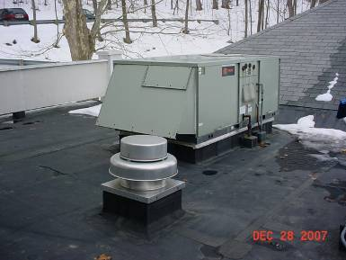

AHU for 1996 Wing, Note Exhaust Vent in Foreground

Picture 2

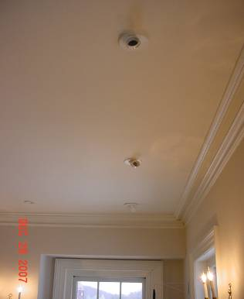

Fresh Air Diffusers, 1907 Wing

Picture 3

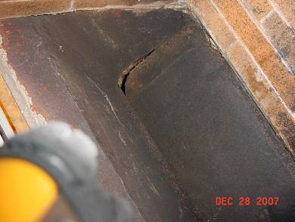

Fire Place Flue, Note Space

Picture 4

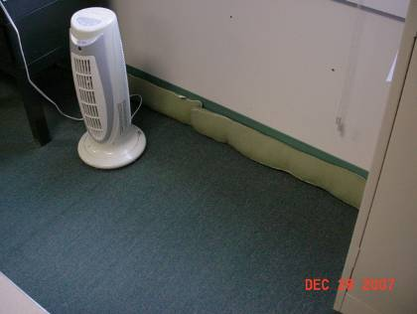

Draft Excluders along the Baseboard of the 1996 Wing

Picture 5

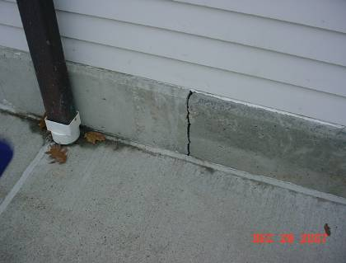

Space in Sealant of Outer Wall opposite Draft Excluders along the Baseboard
of the 1996 Wing

Picture 6

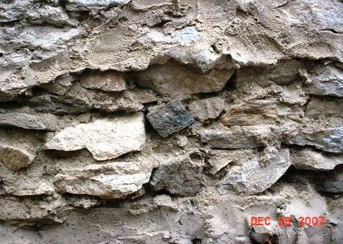

Parget was Applied to the Outer Face of the Stone Foundation,
Note Seams in Wall
Picture 7

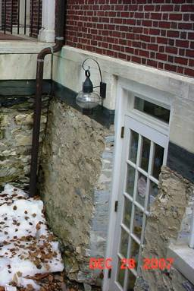

Door Added to Foundation

Picture 8

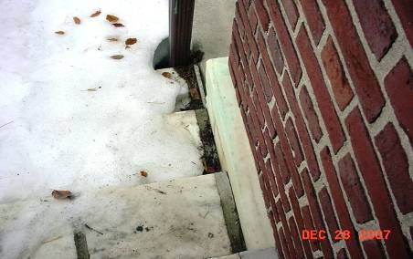

Seam between Wall and Stair above Building Inspector’s Office

Picture 9

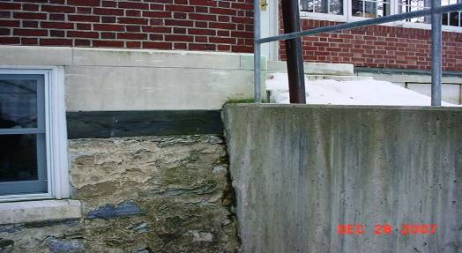

Exposed, Pargeted Foundation Wall outside Building Inspector’s Office,
Note Dampness on Wall

Picture 10 Through 12



Example Of A Sheer Wall Clock Tower (Chicopee City Hall, Chicopee, MA), A Pyramidic With Sloping Roof Clock Tower (Bernardston Town Hall, Bernardston, MA) And A Steeple Clock Tower (Merrimac Town Hall, Merrimac, MA)

Pictures 13 Through 15



Example Of Steeples (St. Mary’s, Northampton, MA; Helen Hills Chapel, Northampton, MA; The First Churches, Northampton, MA)

Picture 16

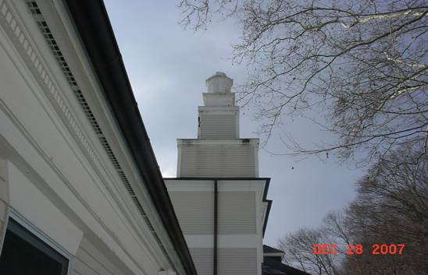

Adams Town Hall Clock Tower, Note Ziggurat Pattern of Flat Horizontal Roofs
(as well as rotted wood beneath each flat roof)

Picture 17

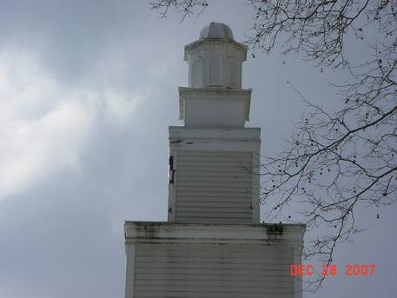

Close-Up of Damage to the Adams Town Hall Clock Tower

Picture 18

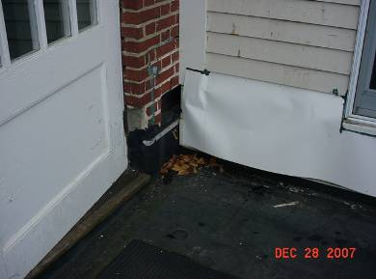

Water Damage to Exterior Wall of Adams Town Hall Clock Tower
(sheet metal covering rotted clapboard)
Picture 19

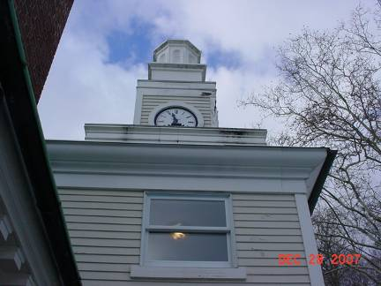

Water Damage to Exterior Wall, Adams Town Hall Clock Tower

Picture 20

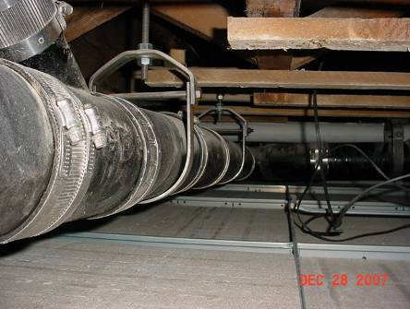

Drain Pipe above Room 302 Suspended Ceiling, Note 6 Gaskets/Clamps in Picture

Picture 21

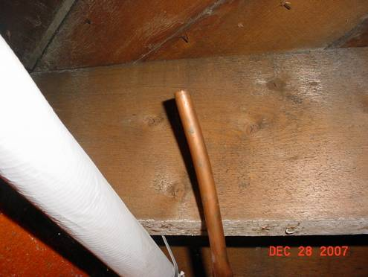

Open Pipe above Room B-16 Office

Location | Carbon  Dioxide  (ppm) | Carbon  Monoxide  (ppm) | Temp  °(F) | Relative  Humidity  (%) | Occupants  in Room | Windows  Openable | Ventilation |  | Remarks
 |  |  |  |  |  |  | Supply | Exhaust | Remarks
Background  Exterior, on roof | 390 | N/D | 50 | 27 |  |  |  |  | Gutters filled with leaves
Town Admin. Office | 797 | N/D | 67 | 32 | 1 | Y | Y | Y | DO, fireplace
Bathroom |  |  |  |  |  |  | N | N | DO
Town Admin Outer Office Rm 210 | 645 | N/D | 69 | 30 | 1 | Y | Y | Y | DO
Second Floor Balcony/Hall | 656 | N/D | 70 | 26 | 0 | Y | Y | Y | Photocopier
Room 207 | 648 | N/D | 71 | 26 | 1 | Y | Y | Y | Fireplace with open flue, Five plants noted in office, DO
Room 204 | 628 | N/D | 73 | 24 | 1 | Y | Y | N | DO
Room 203 | 650 | N/D | 73 | 23 | 1 | Y | Y | Y | DO, fireplace with open flue, window open
Room 216 | 624 | N/D | 72 | 23 | 1 | Y | Y | Y | DO, Fireplace
Veteran’s Office | 1332 | N/D | 61 | 50 | 1 | Y | Y | Y | DO
Room 113 | 525 | N/D | 70 | 26 | 0 | Y | N | N
Room 110 | 544 | N/D | 72 | 22 | 1 | Y | Y | Y | Copier, Ceiling Tile exhibits dust accumulation. Numerous quartz heaters and draft excluders noted. Cold air entering space at baseboard.
Room 110  (Inner Room) | 474 | N/D | 73 | 22 | 0 | Y | Y | N | DO, Noise emanating from diffuser possibly caused by a piece of paper – should be removed. Ceiling tile exhibits dust
Room 107  (Outer Room) | 458 | N/D | 72 | 20 | 1 | Y | Y | Y
Room 107  (Inner Room) | 458 | N/D | 72 | 20 | 1 | Y | Y | Y | DO
Room 302 (Basement room with former leaks) | 553 | N/D | 71 | 23 | 0 | Y | N | N | DO, Numerous clamps on drain lines (17 counted over a length of pipe approx. 8 feet long)
Retirement  (Storage Area) | 790 | N/D | 65 | 34 | 0 | N | N | N
Retirement (Office) | 1047 | N/D | 67 | 35 | 1 | Y | Y | N | Plants observed on rusted metal table (rusted areas possibly due to over watering)
Hallway | 1022 | N/D | 68 | 32 | 0 | Y | Y | Y | Scented odor observed – An air freshener was located in adjacent bathroom.
Sun Room | 386 | N/D | 66 | 27 | 0 | N* | N | N | *Windows are missing cranks
Meeting Room | 476 | N/D | 64 | 30 | 0 | Y | N | N | Fireplace with open flue
Room 117  (Outer office) | 623 | N/D | 68 | 31 | 1 | N | N | N
Room 117  (Inner office) | 573 | N/D | 68 | 30 | 0 | Y | Y | N | DO, Fireplace with flue open, Water cooler noted on carpeting
Room 117 (Storage) | 768 | N/D | 69 | 29 | 0 | N | N | Y | DO
First Floor Foyer | 521 | N/D | 69 | 26 | 0 | Y | N | N | DO, Fireplace, flue closed
Records Room (Basement) | 589 | N/D | 68 | 25 | 0 | 0 | N | Y | Pump for dehumidifier does not appear to be functioning.
B07  (Custodian’s Room) | 665 | N/D | 72 | 24 | 0 | Y | N | N | Blueprint machine observed which uses ammonia. Penetrations into wall are not properly sealed.
B16 (Health Dept) | 737 | N/D | 73 | 25 | 4 | Y | Y | Y
B16 (Building Insp.) | 667 | N/D | 71 | 24 | 1 | Y | Y | N
B16 (Community Development) | 648 | N/D | 72 | 25 | 0 | Y | Y | N | Breeze observed above ceiling panel. Open copper pipe observed above ceiling panel as well.

Room Number | Temp of Wall/Baseboard | Temp of Threshold/  Door Frame | Moisture of Wall/Baseboard | Moisture of Threshold
B 16 Board of Health * | 41° F – 45° F | 41° F – 45° F | 8.3 | 13.0
B 16 Building Inspector | 49° F | N/A | 7.1 | N/A
B 16 Comm. Development | 57° F | N/A | Dry | N/A
Hallway | 65° F | N/A | Dry | N/A

