


Toothbrush Adaptations

Oral Health in Massachusetts: A Fact Sheet
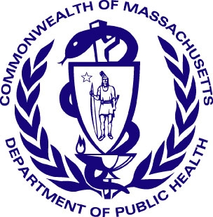
Why Is Dental Health So Important?
A healthy mouth is important for many aspects of life, including eating well, absence of dental pain, personal relationships and feeling good about your appearance. Older adults need to be especially concerned about their oral health due to its relationship with systemic diseases, such as heart disease and diabetes, and the effect of some medications on the oral cavity. Dental diseases like tooth decay, and oral diseases like gingivitis and periodontitis, cause pain difficulty in chewing, gums to bleed while brushing and bad breath, as well as teeth to loosen. Oral hygiene, medication use, and nutrition, in addition to accessing regular dental care, play a role in how healthy your teeth and mouth will be. Remember…there are significant links to dental health and overall health. According to Former US Surgeon General
Dr. C. Everett Koop, “You are not healthy without good oral health.”

What Can I Do If I’m Having Trouble Brushing My Teeth?
If you or someone you are caring for is having trouble brushing their teeth, there are many ways you can adapt the toothbrush to make it easier to hold. You can attach a toothbrush to a velcro strap (often used with food utensils) or use an elastic band to attach the toothbrush to the hand. Other ideas to make gripping the toothbrush easier include cutting a slit in a tennis ball and attaching the toothbrush or attaching a bicycle grip to the end of a toothbrush. Some people also find that using an electronic toothbrush improves brushing technique.
It is important to remember that flossing daily is also important and floss holders and other aids can be used.

For more information and ideas for adapting toothbrushes and other oral hygiene aids, you can search online using the search terms “toothbrush adaptations”.

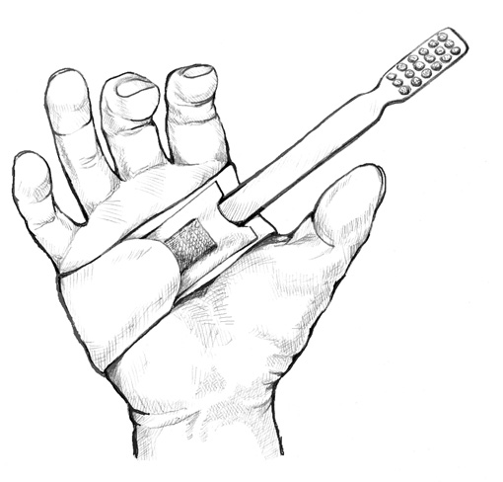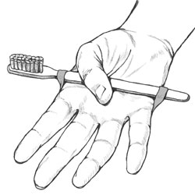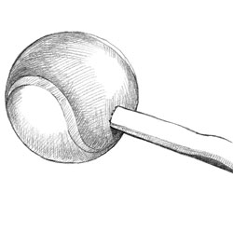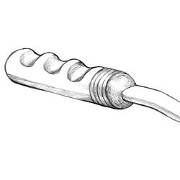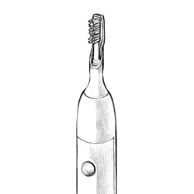

Source: U.S. Department of Health and Human Services. National Institute of Dental and Craniofacial Research (April, 2011). Dental Care Every Day: A Caregiver’s Guide.

For more information, contact:
Massachusetts Department of Public Health
Office of Oral Health at 617-624-5943 or at Oral.Health@state.ma.us

