+Manage Enrollment Locations (MEL) Overview
The Manage Enrollment Locations (MEL) functionality allows providers the ability to enter monthly SDR data more efficiently. Providers identify sites or locations within their organization where services are delivered to clients. These locations are set up in EIM so that client can be enrolled into the contracts.
The Manage Enrollment Location (MEL) functionality is two-fold:
- Add/Edit Participating Organization: Each fiscal year all providers must update the Participating Organization section of their contracts so that they can enroll and bill clients in EIM. If the ‘Billing’ and ‘Enrolling’ checkboxes are not checked for each location associated to the contract, providers cannot enroll clients and thus cannot bill for services. This is a beginning of the fiscal year task that all providers are responsible for.
- Assign Enrollment Locations: All interfaced client enrollment records (new or modified; providers who have contracts with DDS and DMH) from an agency enrollment systems (e.g., Meditech) appear in EIM at the parent level of the organization. If a provider organization wants a client enrollment record to specify the location that a client is receiving services at, they must assign the location to the client enrollment record in EIM. Providers who have EIM contracts with DPH, MRC, and/or DTA manually enroll their clients into ESM and assign the client to the location at the time of enrollment.
  - Provider Organizations who bill in a Centralized method this step is optional. Centralized billing is managed and processed at the parent level of the organization. Billing staff will see all client enrollments on the monthly SDR if they bill in this manner. Organizations who utilize Centralized billing have the ability to assign client enrollment records to specific locations, if desired.
  - Provider Organizations who bill in a Decentralized method, this step is very important. If the client enrollment is not assigned to a location, billing staff at the specified locations will not see the client on their monthly SDR due to how their security roles have been setup. Provider Organizations who bill in a decentralized method are not allowed to see the client enrollments for any location other than their own. So when client enrollment records come into EIM at the parent level of the organization only billing staff at the parent level can see those records unless the record is assigned to a specific location.
Search for Contract
- Select the Contracts module.

From the Contract Search page,

- Type [Vendor Contract Number] in the Vendor Contract Number field.
Reminder: You can search for a contract using the wildcard (%) symbol.
Note: Contracts must be in a status of “Active” before a Participating Organization can be added. You can also search for a contract by Status. Select “Active” from the drop-down menu.
- Select the [Search] button.

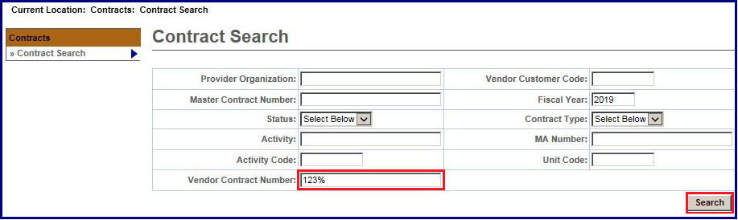
- To select the desired contract, click the [Contract Number] link.
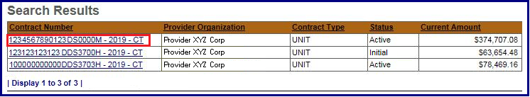
Note: Contracts must be in a status of “Active” before a Participating Organization can be added. Agency staff is responsible for activating contracts in EIM. If a contract is not in an “Active” status, contact your Agency Contract Manager.

Add/Edit Participating Organization
The Contract Number will display at the top of the page and allows a Provider Organization to view/assign Provider Locations to a contract.
From Contract Summary page,
  - Click [Participating Organizations] from the Navigation menu.
  - Click the [Add/Edit Organizations] button.
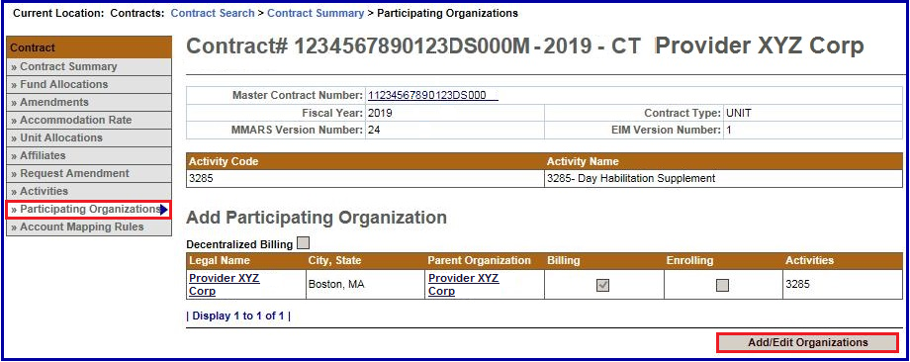
Note:
This is a Read-only page.
The Participating Organization page becomes editable once the [Add/Edit Organizations] button is selected.
The Participating Organization page displays two sections that provide additional descriptions of the fields on this page:
Activity Code: A listing of Activity Codes and Activity Names associated with this contract.
Keys: This key provides definitions that will assist users in understanding how to implement the participating organization roles for this contract.
- Decentralized Billing: By checking this box, you are restricting users at specific locations to only see clients on the SDR for their location.
- Billing: By checking this box, users at this location will have the ability to bill for services on SDRs and /or Invoices.
- Enrolling: By checking this box, this allows organizations to enter and enroll clients in ESM. It also allows users to assign locations to enrollments to facilitate decentralized billing or to sort an SDR by location.
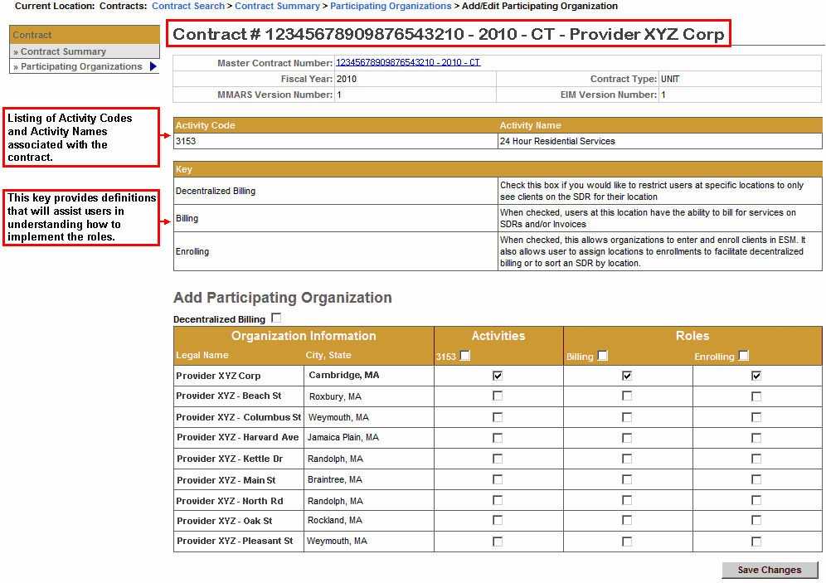
Add/Edit Participating Organization
- Check the [Decentralized Billing] checkbox.
Note: Centralized Organizations do not check this box.
- Check the [Activities] checkbox for the row(s) that are to be associated with this contract.
- Check the [Billing] checkbox for the row(s) that are to be associated with this contract.
- Check the [Enrolling] checkbox for the row(s) that are to be associated with this contract.
- Click the [Save Changes] button.
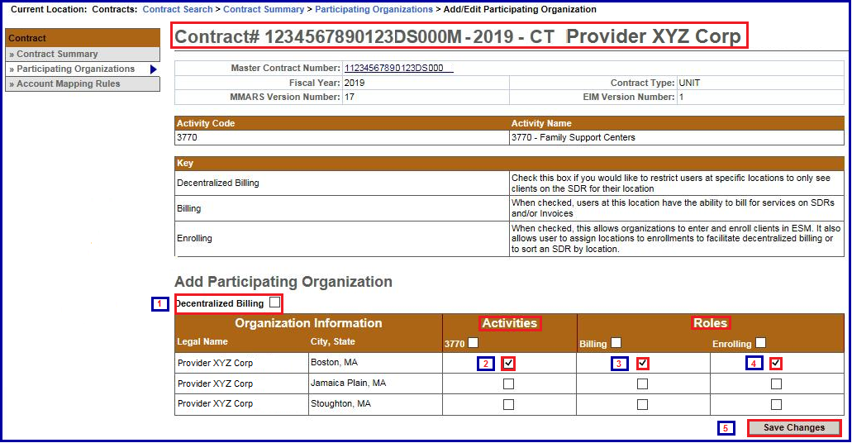
Note:
Follow steps 2-4 for each Provider Location that needs to be assigned to the contract.
Note: If a provider location is missing from the listing, your Access Administrator will need to send an updated Organization Management form to the Virtual Gateway. Once the provider location has been added by the Virtual Gateway, you can then update the Participating Organization page.

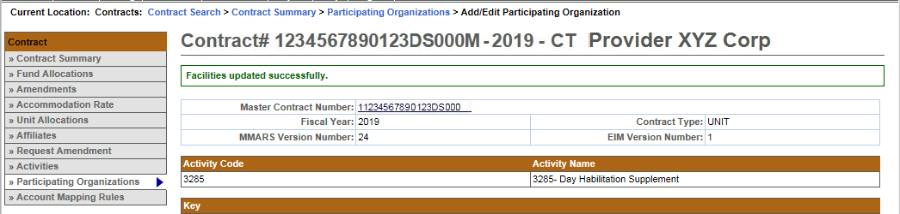
The message “Facilities updated successfully” will appear at the top of the Participating Organizations page.
Additional Learning Opportunities
- 159 Manage Enrollment Locations CBT – To take online course, log into PACE.
- See Assign Enrollment Locations Job Aid for instructions on assigning a client enrollment to a provider location. EIM/ESM Provider Job Aids are found under EIM/ESM Provider User Manuals and Instructional Materials
Questions or need assistance? Call Virtual Gateway Customer Service
1-800-421-0938 (617-847-6578 - TTY for the deaf and hard of hearing)
8:30 am to 5:00 pm Monday through Friday

