Addendum to BRC Manager User Guide for Programs

Background:

The Department of Early Education and Care’s (EEC) Background Record Check (BRC) Unit has developed a new process for EEC approved and/or licensed programs who work with contractors, vendors and/or medical providers that are exempt from EEC licensure but provide services directly to the children in the EEC licensed program in an unsupervised capacity.

All such affiliated business or individual your program works with will now have to register with EEC as an agency to submit background record check (CORI, DCF, SORI, and Fingerprint) for their employees/volunteers/interns having unsupervised contact with children in your program.

Licensee-Agency Affiliation (Only Reviewer)

The program needs to be affiliated with an agency to be able to view the fingerprint notification letters and suitability letters of the individual’s submitted by the agencies

- Licensee/Reviewers of the programs will have the option available on the homepage of BRC Manager to affiliate with an agency.

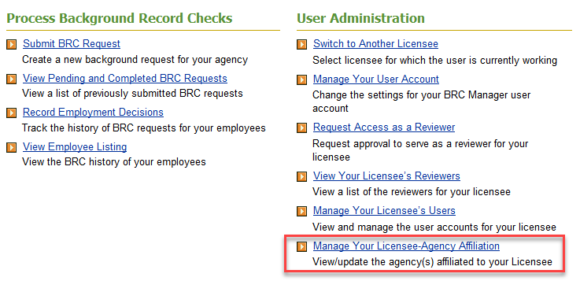

- On “Manage Your Licensee - Agency Affiliation” page, Licensee/Reviewer can do:

  - View a list of all existing affiliations with other Agency(s)

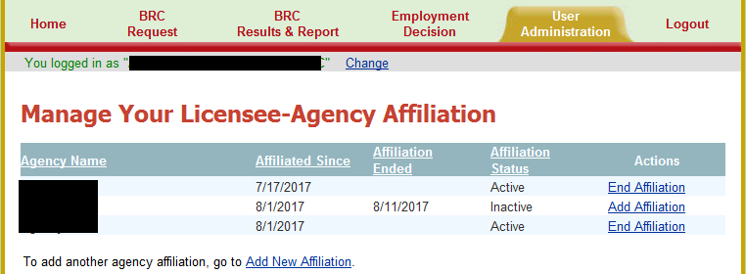

  - End an existing Licensee-agency affiliations by clicking on “End Affiliation” under Actions.
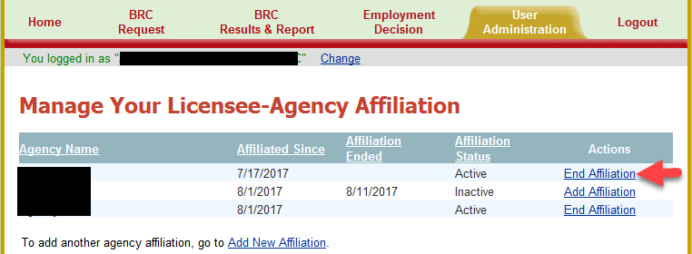

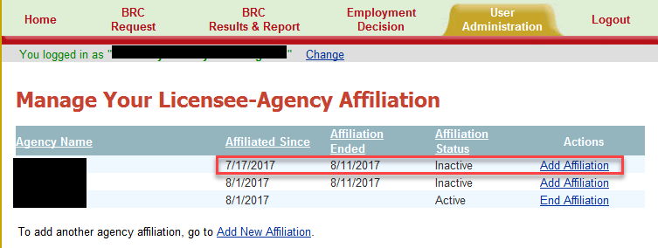
  - Add a new Licensee-agency affiliation by clicking on “Add New Affiliation” or add previously affiliated agency by clicking on “Add Affiliation” under Actions column.
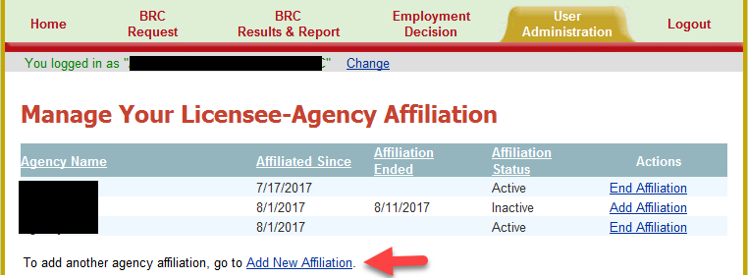

  - Select the agency you are affiliating with from the “Agency Name” dropdown and click on “Add Affiliation”.

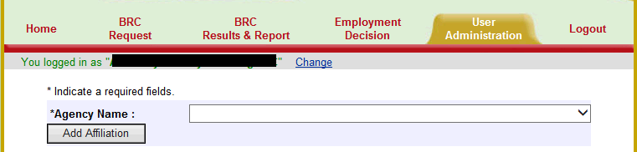

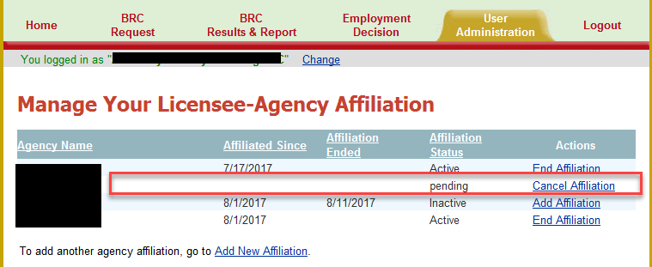

BRC Results of applicants submitted by agency(s) affiliated with Licensee (Only Reviewer)

- A link to a new report is available to Licensee/Reviewer to view the BRC results of all applicants submitted by affiliated Agency.

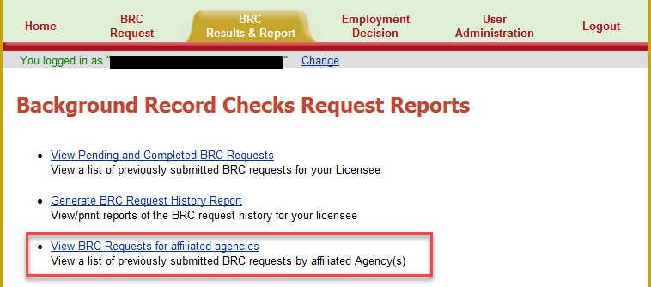

- Licensee/Reviewer can view/print only “Fingerprint Notification Letter” and “Suitability Letter” of the applicants submitted by the agency(s).

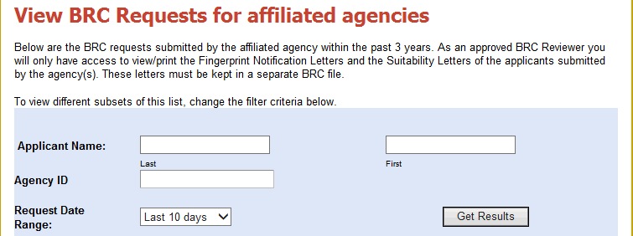
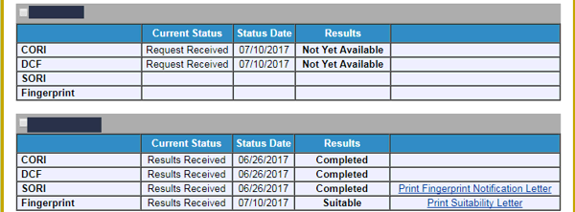

- Licensee/Reviewer can see a Status "Not Yet Available", or “Completed”, or “Suitable” / “Not Suitable” etc. for CORI, DCF, SORI and Fingerprint Results. Details are given below:

A: CORI Results
- “Not Yet Available” - The BRC request has been received and the CORI results are not yet available.
- “Completed” - The CORI was completed for the applicant entered
In order to proceed with the BRC process the final CORI results should be “Completed”.
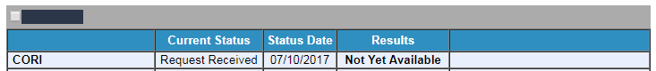
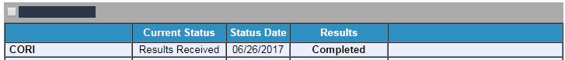

B: DCF Results
- “Not Yet Available” - The BRC request has been received and the DCF results are not yet available.
- “Completed” - The DCF was completed for the applicant entered
In order to proceed with the BRC process the final CORI results should be “Completed”.

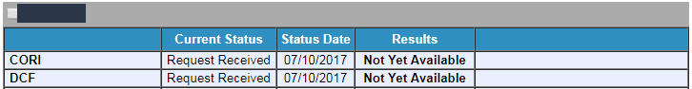

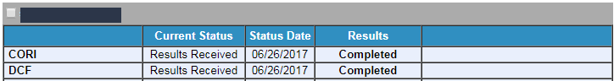

C: SORI Results
- “Not Yet Available” - The BRC request has been received and the SORI results are not yet available
- “Completed” - The SORI was completed for the applicant entered and the program can print the fingerprint notification letter by clicking on the link. This link will allow the program to print the fingerprint notification letter that advises them that the CORI, DCF and SORI was approved, the applicant can be conditionally hired and be fingerprinted. EEC will not mail this letter to the program. You must print and keep a hard copy of the notification letter in your BRC secure file.

In order for there to be a link to print the fingerprint notification letter, the CORI, DCF, and SORI must all be completed. FP Notification Letter will be displayed after 2 days from the SORI completion date. If there is no link after 2 days from SORI completion then you may contact the BRC Unit.

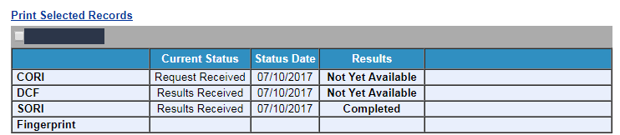

*Example of notification letter not available:
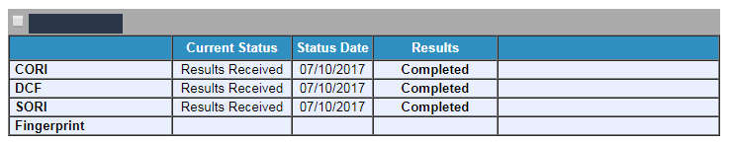

This example illustrates the situation where an applicant cannot be conditionally hired because there is no link to a notification letter. The link does not appear because the CORI is not completed yet. All three checks (CORI, DCF & SORI) must be completed before the applicant may be conditionally hired and sent for fingerprinting.

D: Fingerprint Results
- If there is no information provided (blank) this means the applicant has not registered or had a fingerprint appointment. The program must ensure applicants are scheduling fingerprinting appointments.
- Not yet available - The applicant has registered for fingerprinting but the appointment has not occurred or the results are still in process. The status date is the date the notification letter was sent.
- BRC to be resubmitted - The applicant's name, previous names, DOB, or SSN does not match what the applicant provided for fingerprinting. If this information is inaccurate, then the agency should obtain a new consent form and the agency should resubmit a BRC request. The applicant does not have a valid/completed BRC if there are discrepancies with information. An applicant cannot be conditionally hired until a new BRC request is completed with accurate information and a new fingerprint notification letter is received.
- Suitable - the applicant has been deemed suitable by EEC and the BRC is complete. The program can print the suitability letter by clicking on the link.
- Not Suitable - EEC deemed the applicant not suitable and should be removed from the program within 14 days unless EEC requires removal sooner. The program can print the suitability letter by clicking on the link.

