Presenter
2020-01-28 12:25:09
--------------------------------------------
Today’s presentation provides an integrated look at aspects of thedynamics of intimate partner violence (IPV; also called DV) and sexual violence (SV), of which we know many of you are aware because of your knowledge of the research literature this area and your many years of experience providing services to survivors, including adults and children, and/or to perpetrators.
This presentation will provide recent, MA-specific statistics, which can be a bonus in supporting this important work when you are interacting with other stakeholders. We are going to discuss this integrated look at violence dynamics and impacts with an emphasis on how they relate to certain RFR principles highlighted in other parts of today’s program and the DPH goal of achieving better integration and enhancement of services across the entire sexual and domestic violence services network in MA. The RFR Principles highlighted will be the Child Principle, the Prevention Principle, and the Perpetration Principle. Although this presentation is heavy on IPV dynamics and impacts, SV is also covered at multiple points during this presentation and work on sexual violence is just as valued.

Vera E. Mouradian & Caroline Stack

Addressing Intimate Partne r Violence and Sexual Violence: Upstre a m Work, Integrating RFR Principles, a n d Collaboration
Office of Statistics and Evaluation and Division of Sexual and Domestic Violence Prevention and Services
Massachusetts Department of Public Health

Presented at the MDPH Statewide SDV Provider Meeting, Marlborough, MA, November 18, 2019

Presenter
2020-01-28 12:25:10
-------------------------------------------
This part of the presentation will use MA-specific statistics to flesh out the model we will present on the interrelatedness and intergenerational transmission of violence. When we say interrelatedness of violence, we are acknowledging the fact that experiencing family violence is a risk factor for various other forms of violent victimization and that multiple forms of violence may be experienced and/or perpetrated by some of the same individuals.1 Intergenerational transmission of violence refers to the fact that exposure to violence in the home as a child, in turn, is a risk factor for violence perpetration in adolescence and adulthood; that is, especially for boys and men, the perpetuation of the use of violence by the next generation. Again, we want to emphasize that we all have a role to play in addressing all aspects of this complex dynamic, regardless of the main focus of the work of any particular organization.
There are some broad “buckets” of effort that we all can and may already be involved in providing, including mitigation of impacts, primary prevention, and intervention with people already using violence. Interventions that have the potential to change behavior, attitudes and beliefs among those already using violence are also a form of prevention. Interrupting this behavior can lead people who have behaved abusively to become better role models for the next generation and reduce risk for children and youth at all of the points on this pathway. Interruption of the use of violence is also important for the safety of the survivors with whom we currently work and any ADDITIONAL or FUTURE partners with whom someone may be or become involved.

…more likely to perpetrate violence …
…in multiple forms (polyperpetration)

- 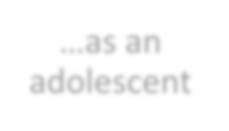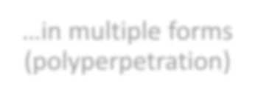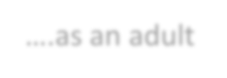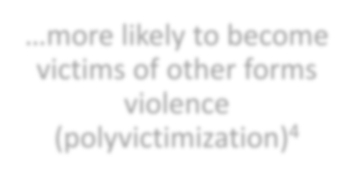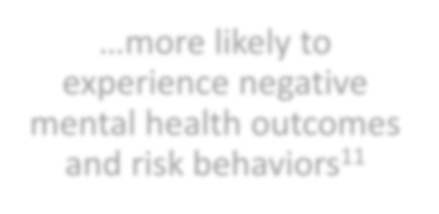Mitigation of impact among children, youth, and adults
…more likely to
experience negative mental health outcomes and risk behaviors11
…as an
adolescent
….as an adult
…more likely to become victims of other forms violence (polyvictimization)4
People who were exposed to family violence in their childhood home are…
- Primary prevention
- Intervention to address current and future perpetration

Presenter
2020-01-28 12:25:11
--------------------------------------------
Turning back to the components of this schematic to flesh them out with statistics. . .
We are defining family violence based on the questions that are available on this type of experience in the Massachusetts Middle School Youth Health Survey (MA YHS)4 as…
This definition is consistent with, although not identical to those used in national research (operational definitions vary in specificity and inclusiveness of experiences across studies). Exposure to violence in the home as a child is more common than many people realize. For example. . .
People who were exposed to family violence in their
childhood home are…
Exposure to family violence:
- Physical/sexual assault/abuse of a child/youth by someone in the home
and/or
- A child’s/youth’s exposure to violence committed by one adult against another adult in the home

13% of MA Middle School youth report experiencing family

violence (as defined in the slide) in just the past year.4

Nationally, up to 1 in 4 children are exposed to IPV by the ages of 14-175

Presenter
2020-01-28 12:25:11
--------------------------------------------
Compared to MA middle school youth who did not report having experienced family violence in the past year. . .
aTrue both overall and for any physical assault and any witnessing, separately, and for both males and females; bLifetime prevalence among those who had dated
Similarly, poly-victimization – a history of other types of victimization among those who have been identified as having experienced any one type – has been found in other studies.1 People who experience violence of one type may be at higher risk of experiencing other types of violence.
NOTE: Only the Middle school survey contains the family violence questions. However, it does not also contain any questions relating to sexuality, including unwanted sexual contact. This is the only reason that the comparative rate of experiencing sexual violence among middle school students exposed to family violence and comparisons of the percentages of youth affected do not appear with the other MA statistics on this slide.
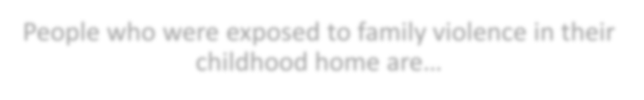
…more likely to become victims of other forms of violence (polyvictimization)4
People who were exposed to family violence in their childhood home are…

MA middle school youth exposed to violence in the home experienced up to 6 times the rate of being a victim of other types of violence.4

MA middle school students exposed to Family Violence reported experiencinga:
- 6x the rate of Physical/Sexual Dating Violenceb (12% vs. 2%)
- 2.4x the rate of Coercive Control by Dating Partnerb (28% vs. 12%)
- 2.2x the rate of Bullying > Once in Past Yr. (44% vs. 20%)
- 2.4x the rate of Cyber-Bullying in Past Yr. (29% vs. 12%)

Presenter
2020-01-28 12:25:12
--------------------------------------------
IPV & SV have both short- and long-term health effects for survivors, contributing to chronic disease, substance abuse, gynecological issues, and mental health issues.6-8
IPV, SV, and child abuse often lead to homelessness among survivors6,9,10 and homelessness, in turn, puts people at risk for (additional) sexual assault and sexual exploitation/trafficking.9,10 Similarly, compared to MA middle school youth who did not report having experienced family violence in the past year. . .
aTrue both overall and for any physical assault and any witnessing, separately.
In addition to the impacts captured here, children and youth exposed to family violence also experience short- and long-term physical health impacts, substance misuse, and impacts on school outcomes and family and peer relationships as well as mental health effects not portrayed on the present slide.8,12
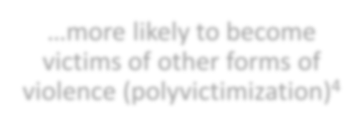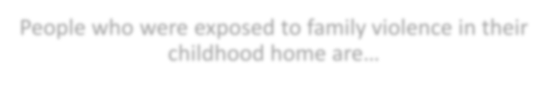
…more likely to experience negative mental health outcomes and risk behaviors11
…more likely to become victims of other forms of violence (polyvictimization)4
People who were exposed to family violence in their childhood home are…

Youth exposed to violence in the home experienced up to 8 times the rate of negative mental health and risky behavior outcomes11.

MA middle school students exposed to Family Violence were more likely to also reporta:
- 3x the rate of Symptoms of Depression in Past Year (40% vs. 13%)
- 5.2x the rate of Having Considered Suicide in Past Year (26% vs. 5%)
- 8x the rate of Having Attempted Suicide in Past Year (16% vs. 2%)
- 3.4x the rate of Engaging in Self Injury in Past Year (37% vs. 11%)
- 2.6x the rate of Risky Dieting Behaviors in Past 30 Days (21% vs. 8%)

Presenter
2020-01-28 12:25:13
--------------------------------------------
aTrue both overall and for any physical assault and any witnessing, separately.
Given that exposure to family violence in the home is an identified risk factor for SV perpetration as well as for IPV perpetration2, we would expect to also see a relationship between this type of experience and SV perpetration among MA middle school youth if we had the SV perpetration questions available to draw from in the Middle School survey.
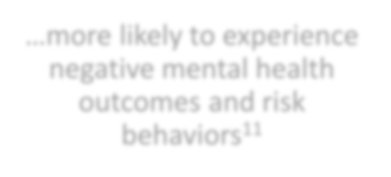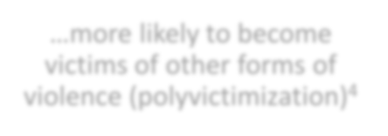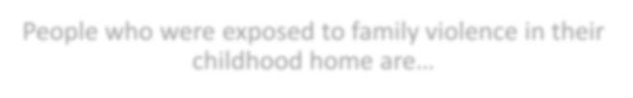
…as an adolescent
…more likely to perpetrate violence …
…more likely to experience negative mental health outcomes and risk behaviors11
…more likely to become victims of other forms of violence (polyvictimization)4
People who were exposed to family violence in their childhood home are…

MA Middle School students who experienced violence in the home exhibited
up to 6.2 times the rate of committing abusive/violent behavior.13 MA middle school students exposed to Family Violence were more likely to report past year perpetration ofa:
  - 3.6x the rate of Bullying (18% vs. 5%)
  - 4x the rate of Cyber-Bullying (12% vs. 3%)
  - 6.3x the rate of Dating Violence (5% vs. 0.8%)

Presenter
2020-01-28 12:25:14
--------------------------------------------
Perpetrating one form of violence is associated with perpetrating other forms of violence, both in MA14 and in national studies.15-17 For example. . .
In this slide, the direct correlation of poly-perpetration with exposure to family violence in the home is not illustrated using MA statistics because we do not have the family violence questions available in the MA High School YHS to analyze, and we do not have the Sexual Violence perpetration questions in the MA Middle School YHS where the exposure to family violence questions are asked.
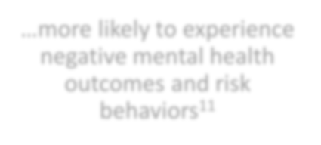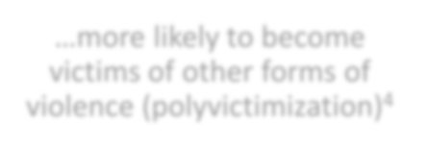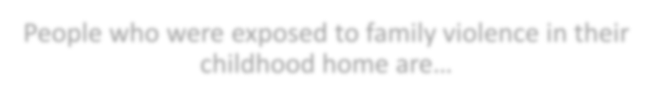
…in multiple forms
(polyperpetration)
…as an adolescent
…more likely to perpetrate violence …
…more likely to experience negative mental health outcomes and risk behaviors11
…more likely to become victims of other forms of violence (polyvictimization)4
People who were exposed to family violence in their childhood home are…
MA high school students who perpetrated SV in past year were more likely to report that in the past year they also had perpetrated14:
- 8.7x the rate of Bullying (52% vs. 6%)
- 9x the rate of Cyber-Bullying (45% vs. 5%)
- 40x the rate of Dating Violence (40% vs. 1%)

And they were also 7.5x more likely to have experienced unwanted sexual contact themselves (lifetime) (45% vs. 6%).14

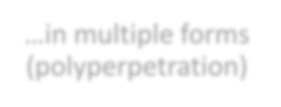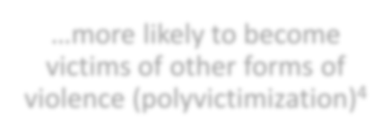
….as an adult
…in multiple forms (polyperpetration)
…as an adolescent
…more likely to perpetrate violence …
…more likely to experience negative mental health outcomes and risk behaviors11
…more likely to become victims of other forms of violence (polyvictimization)4
People who were exposed to family violence in their childhood home are…

National research indicates that men exposed to family violence as children are at 56% - 63% increased risk of engaging in IPV as adults.18

The CDC cites this type of experience as a risk factor for both SV & IPV perpetration.2

Presenter
2020-01-28 12:25:22
--------------------------------------------
Better integration and collaboration across the MA SDV service provider network can help to interrupt intergenerational transmission, address interrelationships of experiences of violence, mitigate negative health and social outcomes for both adult survivors and for children, and help people who are already engaging in violence become better partners and parents in order to promote safety and well-being of both adult and child survivors.
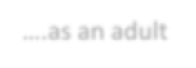
….as an adult
…as an adolescent
…more likely to perpetrate violence …
…in multiple forms (polyperpetration)
…more likely to experience negative mental health outcomes and risk behaviors11
…more likely to become victims of other forms of violence (polyvictimization)4
People who were exposed to family violence in their childhood home are…

- Mitigation of impact among youth and adults
- Primary prevention
- Intervention to address current and future perpetration

….as an adult
…as an adolescent
…more likely to perpetrate violence …
…in multiple forms (polyperpetration)
…more likely to experience negative mental health outcomes and risk behaviors11
…more likely to become victims of other forms of violence (polyvictimization)4
People who were exposed to family violence in their childhood home are…

Prevention and direct services affect all aspects of violence but often focus on specific areas of experience.

Presenter
2020-01-28 12:25:24
--------------------------------------------
For example, we may think of the first three service models listed on this slide as programs that exist specifically to address the needs of child survivors, but we know that other service models also work directly with children …
MDPH is committed to enhancing services to children as survivors over the course of the funding period across the whole SDV network – this goal is described more fully in the Child Principle, with which you are familiar and about which you’ll be hearing more later in today’s program.
….as an adult
…as an adolescent
…more likely to perpetrate violence …
…in multiple forms (polyperpetration)
…more likely to experience negative mental health outcomes and risk behaviors11
…more likely to become victims of other forms of violence (polyvictimization)4
People who were exposed to family violence in their
childhood home are…
  - Children Exposed to Domestic Violence
  - Supervised Visitation Services
  - Child Advocacy Centers
  - Rape Crisis Centers
  - Residential Services
  - General Community-Based Domestic Violence Services
  - SDV Services for Communities Experiencing Inequities

Presenter
2020-01-28 12:25:25
--------------------------------------------
Many of the MDPH-funded service models address sexual and/or intimate partner violence. The SANE program, which is also an MDPH program, works with sexual violence survivors across the lifespan, and the CACs work with child sexual abuse and physical abuse survivors. All of the listed models work to mitigate the impacts of violence victimization.
….as an adult
…as an adolescent
…more likely to perpetrate violence …
…in multiple forms (polyperpetration)
…more likely to experience negative mental health outcomes and risk behaviors11
…more likely to become victims of other forms of violence (polyvictimization)4
People who were exposed to family violence in their childhood home are…
  - Sexual Assault Nurse Examiner programs (SANE), Pedi-SANE, Tele-SANE
  - Children Exposed to Domestic Violence
  - Supervised Visitation Services
  - Child Advocacy Centers
  - Rape Crisis Centers
  - Residential Services
  - General Community-Based Domestic Violence Services
  - SDV Services for Communities Experiencing Inequities

Presenter
2020-01-28 12:25:26
--------------------------------------------
These are some of the MDPH-funded primary prevention initiatives and statewide primary prevention initiatives of which many of you have been a part or are currently or may be a part in the future. When we talk about primary prevention, we are emphasizing evidence-based strategies or evidence-informed strategies that encourage youth to engage in healthy relationship and healthy sexuality behaviors and to question problematic behaviors and beliefs before unhealthy relationship patterns are established, address social norms that support violence, teach and promote bystander intervention skills, and work to change environments and system/organization policies and practices to prevent and address SV and IPV. Some of you may be engaged in primary prevention work, even if your agency is not currently funded for this work by MDPH. MA certified IPAEPs work with people 17 and older to interrupt abusive behavior in intimate partner relationships, which is secondary and tertiary prevention, but they also make clients aware of the impact of their abusive behavior on children, and try help clients to become better role models for the next generation by ending their use of abusive behavior in their own lives. Because of the known risk for IPV perpetration of being exposed to family violence during childhood, the work of IPAEP s also could be considered a form of primary prevention.
DPH soon will be funding some of the MA Child Advocacy Centers to receive training on an evidence-based strategy for intervention with youth with problematic sexual behaviors, which they will then implement as a pilot test in MA.
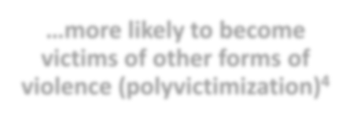
….as an adult
…in multiple forms
(polyperpetration)
…as an adolescent
…more likely to perpetrate violence …
…more likely to experience negative mental health outcomes and risk behaviors11
…more likely to become victims of other forms of violence (polyvictimization)4
People who were exposed to family violence in their childhood home are…
- Rape Prevention and Education Program
- Healthy Relationships Grant Program
- Intimate Partner Abuse Education Programs (IPAEP)
- RESPECTfully prevention and awareness campaign
- Additional prevention programming

Presenter
2020-01-28 12:25:27
--------------------------------------------
We’re going to talk about the MA certified IPAE programs in more detail now as an organizing point for bringing together the importance of the RFR principles that are being emphasized in this presentation and in some of today’s programming. This is NOT because IPAEPs are the sole service providers whose work can illustrate this point, nor is one service model responsible for achieving service integration enhancement in MA. However, the work of IPAEPs and recent and on-going TA work around the Perpetration Principle will be serving today as examples of some of the integration of RFR principles that is desirable and the capacity-building work that is meant to help us all get there.
….as an adult
…in multiple forms (polyperpetration)
…as an adolescent
…more likely to perpetrate violence …
…more likely to experience negative mental health outcomes and risk behaviors11
…more likely to become victims of other forms of violence (polyvictimization)4
People who were exposed to family violence in their childhood home are…

- Massachusetts-Certified Intimate Partner Abuse Education
Program (IPAEP) Services

Presenter
2020-01-28 12:25:27
--------------------------------------------
To learn more about what criteria Massachusetts Intimate Partner Abuse Education Programs (formerly known and Batterer Intervention Programs) must meet for certification by the Massachusetts Department of Public Health, please see the document, Guidelines and Standards for the Certification of Intimate Partner Abuse Education Programs.19 MA-certified IPAEPs work to increase safety for survivors and the community via work with perpetrators. In a group context, IPAEP participants are held accountable for their abusive behavior and for making positive change by trained facilitators and by their peers.
As an example of service integration which also respects the limits of the purpose or focus of a program model, MA-certified IPAEPs also make contact with participants’ partners to inform them that IPAEP services are being provided to the offender and explain the nature of the service, including its limitations, to reinforce or introduce the message that the offender is the one responsible for the abuse, and to connect the survivor to survivor services if they are not already receiving those services and if they are willing to consider seeking those services. As part of MA-certified IPAEP services, partners of clients are notified when information on particularly high risk indicators are uncovered in the course of program provision so that the survivor can make decisions/take action to protect themselves and anyone else who may be in danger (e.g., family members). Survivors detected to be at particular risk are strongly encouraged to talk to survivor services staff about safety planning and are provided with referrals if they are willing to receive them. Providing "warm referrals" is a requirement of MA certified IPAEPs as defined in the RFR 2.5 Service Components and Delivery Standards. Every decision an MA-certified IPAE program makes about a participant is driven by how it will impact the safety of the survivor.
Here are a few additional facts about MA-certified IPAEPs of which you may or may not already be aware. . .
Intimate Partner Abuse Education Program (IPAEP) Services

- MA-certified IPAE programs19
  - Promote examination of all forms of abusive behavior and their impacts on intimate partners and children
  - Promote examination of the cultural and social influences that contribute to violence
  - Encourage program participants to adopt respectful and non-abusive attitudes and behaviors toward their intimate partners and children
  - Employ specially trained facilitators to leverage the power of group dynamics to increase participant accountability for positive change
  - Provide confidential contact to participants’ partners to try to enhance survivor safety directly

MA certified IPAEPs serve over 2,000 people who have abused their intimate partners (participants) each fiscal year.20

- Most discharges from MA certified IPAEPs occur because participants have completed their 80 hours of intervention programming.21

Presenter
2020-01-28 12:25:27
--------------------------------------------
There is evidence that MA certified IPAEPs are effective22,23, just as there is evidence of BIP effectiveness from well-designed multi-site research in24,25 and across26 other states. Two recent meta-analyses also found support for the effectiveness of BIPs27,28 (NOTE: Where there were inconsistent findings in the Cheng et al. meta-analysis sub-analyses, this may be due to the small sample of studies (between one and three) which were used to do these sub-analyses27). Although we have not included any statistics or information in these slides on sexual violence perpetration-specific interventions, we want to acknowledge that there are evidence-based intervention services available for this type of behavior as well.
Research indicates that referring people who have been abusive to service types that are not specific to IPV or SV dynamics can be ineffective and dangerous. Couples counseling can put the survivor at increased risk for additional abuse based on what is discussed in sessions with the mental health specialist. It remains the case that both specialists providing individual counseling and individuals providing couples counseling are not required to obtain appropriate training on IPV and SV dynamics, so while individual counseling is a potentially important, additional intervention for perpetrators in need of mental health services, this service can become counter-productive to ending abuse unless the mental health professional also has obtained appropriate training and experience and/or consults with trained IPV/SV intervention specialists (survivor services or IPAEP). Substance misuse services are needed for people with substance misuse problems, which frequently co-occur with violence dynamics, but substance misuse-focused services do not address the reasons why people engage in intimate partner violence or sexual violence.
Intimate Partner Abuse Education Program (IPAEP) Services

Studies of MA-certified IPAEPs have found that:
- Men who complete these programs are less likely than men who have not to recidivate22,23 for:
  - violent offenses
  - IPV-specific violent offenses (e.g., restraining order violations)

This effect was not found for men court-referred to anger management, substance abuse services, or individual counseling.22

Presenter
2020-01-28 12:25:27
--------------------------------------------
IPAEP is a form of secondary and tertiary prevention. It is designed to help (mostly men) address the impacts of their use of abusive behavior for survivors, including children, and for themselves and other members of their social network, and it is designed to try to prevent further violence against a current (or most recent) partner and others connected with that partner. It also is meant to prevent violence against concurrent and future partners, a goal which also could be considered a form of primary prevention.
These are important points because a prison/jail sentence only indicates that there’s something an offender has done that is objectionable without addressing what the offender should do differently. Many survivors will return to their partners, sometimes many times, for any number of practical and safety-driven reasons of which most of us in this room are aware.
Some survivors also want their relationship with the partner to continue – albeit without the abuse.
Even if we are successful in helping a particular survivor to attain safety, there may be concurrent partners who remain at risk and there likely will be future partners who will be at risk if we don’t address the abusive partner’s beliefs and attitudes and direct him toward better behavioral choices. Those future partners may have children already or may have children with that offender at some future time – children who also will then be exposed to his abusive, controlling, violent behavior and the beliefs he uses to support them. In addition to achieving safety for the adult survivor of IPV, we want to reduce the likelihood of continued abusive behavior in order to reduce and/or prevent the exposure of children and youth to family violence, which puts them at risk of experiencing other forms of violence, as well as variety of negative health, educational, and social outcomes only a sampling of which have been covered in this presentation, and for boys and men in particular, puts them at risk of perpetrating violence themselves.
Intimate Partner Abuse Education Program (IPAEP) Services

Perpetration intervention is necessary to reduce the risk of:
- Additional perpetration against the referral incident survivor

- Perpetration against other partners

Estimated 25-43% of people who use violence in relationships reoffend against other partners22,29

- Exposure of children and youth to family violence
- Polyvictimization
- Negative health outcomes
- Risk factor for IPV perpetration in adolescence and adulthood (males)

Presenter
2020-01-28 12:25:27
--------------------------------------------
29% is obviously an under-report given the nature of the population in question, the timing of their being asked the question (before attending group intervention), and the fact that parents generally underestimate what their children see, hear, or infer about what goes on in their families.
As an example of the integration of the Child Principle, IPAE Programs understand the impact of IPV on children and view children, along with the adult victim, as primary survivors. IPAE participants are expected to examine the impact of their behavior and choices on their children as well as on their partners. Helping participants to understand how their IPV impacts their children can be a major a motivator for working on changing how they treat their partners.

MDPH and certain IPAEP staff have provided training on the dynamics of perpetration during FY19 for CEDV and SVS programs to increase their understanding of perpetration dynamics so they can more effectively work with the whole family. Other community-based models will have the opportunity to access this capacity-building training during FY20. The goal of these trainings is better outcomes for survivors and their children.
Intimate Partner Abuse Education Program (IPAEP) Services

Perpetration intervention is necessary to reduce the risk of:
- Exposure of children and youth to family violence

29% of FY18 IPAEP clients who were in a parental relationship to a child under age 18 at the time of program intake admitted a child has been exposed to something abusive they have done to an intimate partner.30

Key Takeaways and Next Steps
Presenter
2020-01-28 12:25:27
--------------------------------------------
aCAC pilot program – clinical intervention for children with problematic sexual behaviors
MA used to have youth IPAEP services – no longer funded due to fiscal cutbacks, but guidelines exist
bThis can mean, for example, DV survivor services programs making survivors aware of the availability of MA-certified IPAEPs to which their abusive partners can be referred as part of a court sentence or a condition of probation or by DCF or another intervention system. If the survivor feels safe doing so, the survivor themself can ask their partner to attend an IPAEP to address their abusive behavior. Although currently, the majority of MA-certified IPAEP participants are referred by intervention systems like the courts or DCF, some are “self-referred” at their partner’s request.

Continue support of:
  - Addressing upstream risk factors and treatment of early trauma in youth in addition to providing survivor services to victims of IPV and sexual violence
  - Developing interventions with youth exhibiting problematic inter-personal behaviorsa
  - Increasing understanding of intersectionality of all aspects of the work and the need to collaborate in meaningful ways across service models to promote safety
- Connecting people to services within the network of SDV services to help survivors and children attain safetyb

Improving integration of the principles of primary prevention, understanding perpetration, and attending to the needs of children as primary survivors

References

1Preventing Multiple Forms of Violence: A Strategic Vision for Connecting the Dots. Atlanta, GA: Division of Violence Prevention, National Center for Injury Prevention and Control, Centers for Disease Control and Prevention, 2016.

2Centers for Disease Control and Prevention, National Center for Injury Prevention and Control, Division of Violence Prevention https://www.cdc.gov/violenceprevention/intimatepartnerviolence/riskprotectivefactors.html https://www.cdc.gov/violenceprevention/sexualviolence/riskprotectivefactors.html

3Fleming PJ, McCleary-Sills J, Morton M, Levtov R, Heilman B, Barker G (2015). Risk Factors for Men’s Lifetime Perpetration of Physical Violence against Intimate Partners: Results from the International Men and Gender Equality Survey (IMAGES) in Eight Countries. PLoS ONE 10(3): e0118639. doi:10.1371/journal.pone.0118639

4Previously unpublished statistics from a combined data file consisting of the 2015 and 2017 Massachusetts Middle School Youth Health Survey. Source: Massachusetts Department of Public Health, Office of Data Management, Outcomes, and Analysis, Health Survey Program. Statistical analysis conducted by Vera Mouradian, senior violence epidemiologist, Massachusetts Department of Public Health, Bureau of Community Health and Prevention, Office of Statistics and Evaluation, August 2019.

5Hamby, S., Finkelhor, D., Turner, H., & Ormrod, R. (2011). Children’s Exposure to Intimate Partner Violence and Other Family Violence. Juvenile Justice Bulletin (NCJ 232272). Washington, DC: U.S. Department of Justice, Office of Justice Programs, Office of Juvenile Justice and Delinquency Prevention.

6Breiding, M.J., Chen J., & Black, M.C. (2014). Intimate Partner Violence in the United States — 2010. Atlanta, GA: National Center for Injury Prevention and Control, Centers for Disease Control and Prevention.

7Smith, S.G., Chen, J., Basile, K.C., Gilbert, L.K., Merrick, M.T., Patel, N., Walling, M., & Jain, A. (2017). The National Intimate Partner and Sexual Violence Survey (NISVS): 2010-2012 State Report. Atlanta, GA: National Center for Injury Prevention and Control, Centers for Disease Control and Prevention; accessed at: https://www.cdc.gov/violenceprevention/pdf/NISVS-StateReportBook.pdf

8United States Department of Justice, Office on Violence Against Women (2016). The 2016 Biennial Report to Congress on the Effectiveness of Grant Programs Under the Violence Against Women Act. Available at: https://www.vawamei.org/wp-content/uploads/2018/01/2016RTC_MASTER_12.19.16.pdf

9Jasinski, J. L., Wesely, J. K., Mustaine, E., & Wright, J. D. (2005). The experience of violence in the lives of homeless women: A research report (Document No. 211976). Retrieved from the U.S. Department of Justice, Office of Justice Programs: http://www.ncjrs.gov/pdffiles1/nij/grants/211976.pdf

10Tyler, K. A, Whitbeck, L. B., Hoyt, D. R. & Cauce, A. M. (2004). Risk Factors for Sexual Victimization Among Male and Female Homeless and Runaway Youth. Journal of Interpersonal Violence, 19, 503-520. https://doi.org/10.1177/0886260504262961

11Previously unpublished statistics from a combined data file consisting of the 2009, 2011, 2013, 2015, and 2017 Massachusetts Middle School Youth Health Survey. Source: Massachusetts Department of Public Health, Office of Data Management, Outcomes, and Analysis, Health Survey Program. Statistical analysis conducted by Vera Mouradian, senior violence epidemiologist, the Massachusetts Department of Public Health, Bureau of Community Health and Prevention, Office of Statistics and Evaluation, August 2019.

12Evans, S. E., Davies, C., & DiLillo, D. (2008) .Exposure to domestic violence: A meta-analysis of child and adolescent outcomes . Aggression and Violent Behavior ,13, 131–140.

13Previously unpublished statistics from a combined data file consisting of the 2011, 2013, 2015, and 2017 Massachusetts Middle School Youth Health Survey. Source: Massachusetts Department of Public Health, Office of Data Management, Outcomes, and Analysis, Health Survey Program. Statistical analysis conducted by Vera Mouradian, senior violence epidemiologist, Massachusetts Department of Public Health, Bureau of Community Health and Prevention, Office of Statistics and Evaluation, August 2019.

14Mouradian, V. E., Stack, C., & Bergeron-Naper, M. (2019, April). Measuring Sexual Violence Perpetration & Victimization through Statewide Population Surveys and Incident Reports. Poster presented at the 21st Annual MASOC/MATSA Joint Conference, Marlborough, MA.

15Espelage, D L., Basile, K. C., De La Rue, L., & Hamburger, M. E. (2015). Longitudinal Associations Among Bullying, Homophobic Teasing, and Sexual Violence Perpetration Among Middle School Students Journal of Interpersonal Violence. 30 (14), 2541–2561. https://doi.org/10.1177/0886260514553113

16Hamby, S., & Grych, J. (2013). Springer briefs in sociology. The web of violence: Exploring connections among different forms of interpersonal violence and abuse. New York, NY, US: Springer Science + Business Media. http://dx.doi.org/10.1007/978-94-007-5596-3

17Yahner, J., Dank, M., Zweig, J., & Lachman, P. (2015). The Co-Occurrence of Physical and Cyber Dating Violence and Bullying Among Teens. Journal of Interpersonal Violence. 30 (7), 1079–1089. https://journals.sagepub.com/doi/10.1177/0886260514540324

18Roberts, A. L., Gilman, S. E., Fitzmaurice, G., Decker, M. R. , & Koenen, K. C. (2010). Witness of Intimate Partner Violence in Childhood and Perpetration of Intimate Partner Violence in Adulthood. Epidemiology, 21(6), 809–818. doi:10.1097/EDE.0b013e3181f39f03.

19The Commonwealth of Massachusetts, Executive Office of Health and Human Services, Department of Public Health (2015). Guidelines and Standards for the Certification of Intimate Partner Abuse Education Programs. https://www.mass.gov/doc/massachusetts-guidelines-and-standards-for- the-certification-of-intimate-partner-abuse-0/download

20Massachusetts Department of Public Health, Bureau of Community Health and Prevention, Division of Sexual and Domestic Violence Prevention and Services, Intimate Partner Abuse Education Program Services, Enrollment Assessment Data FY2015 -FY2019.
21Massachusetts Department of Public Health, Bureau of Community Health and Prevention, Division of Sexual and Domestic Violence Prevention and Services, Intimate Partner Abuse Education Program Services, Discharge Data and Disenrollment Assessment Data FY2009-FY2019.

22Bocko, S., Cicchetti, C. A., Lempicki, L., & Powell, A. (2004). Restraining Order Violators, Corrective Programming, and Recidivism. Boston, MA: Massachusetts Trial Court, Office of the Commissioner of Probation.
23Mazzola, M. (2015, May). Breaking the Cycle: The Effects of Batterer Intervention Programs on Domestic Violence Recidivism in Massachusetts. Policy Analysis Study submitted to Harvard University John F. Kennedy School of Government in fulfillment of requirements for the Master in Public Policy degree. Available at: https://ash.harvard.edu/files/ash/files/breaking_the_cycle_maryrose_mazzola_pae_march_2015.pdf

24Bennett, L. W., Stoops, C., Call, C. & Flett, H. (2007). Program Completion and Re-Arrest in a Batterer Intervention System. Research on Social Work Practice, 17, 42-54.

25Richards, T.N. & Murphy, C. (2018). An Examination of Maryland Abuser Intervention Programs’ (AIPs) Impact on Domestic Violence Recidivism. Baltimore, MD: Governor’s Office of Crime Control and Prevention. Approved by Governor’s Office of Crime Control and Prevention (BJAG-2016- 0005).

26Gondolf, E.W. (2004). Evaluating batterer counseling programs: A difficult task showing some effects and implications. Aggression and Violent Behavior, 9, 605–631. doi:10.1016/j.avb.2003.06.001

27Cheng, S., Davis, M., Jonson-Reid, M., & Yaeger, L. (2019). Compared to What? A Meta-Analysis of Batterer Intervention Studies Using Nontreated Controls or Comparisons. Trauma, Violence, & Abuse (on-line first).https://doi.org/10.1177/1524838019865927

28Gannon, T.A., Olver, M. E., Malliona, J. S., & James, M. (2019). Does specialized psychological treatment for offending reduce recidivism? A meta-analysis examining staff and program variables as predictors of treatment effectiveness. Clinical Psychology Review, 73, 101752. https://doi.org/10.1016/j.cpr.2019.101752

29Klein, A. R. (2009). Practical Implications of Current Domestic Violence Research: For Law Enforcement, Prosecutors, and Judges. Washington, DC: U.S. Department of Justice, Office of Justice Programs, National Institute of Justice. NCJ 225722

30Massachusetts Department of Public Health, Bureau of Community Health and Prevention, Division of Sexual and Domestic and Sexual Violence, Intimate Partner Abuse Education Program Services. Previously unpublished statistic from the FY2018 Intimate Partner Abuse Education Program Services Enrollment Assessment data. Statistical analysis conducted by Vera Mouradian, senior violence epidemiologist, Massachusetts Department of Public Health, Bureau of Community Health and Prevention, Office of Statistics and Evaluation, August 2019.

