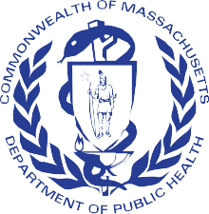
Massachusetts Department of Public Health

The Care of Residents with Opioid and/or Stimulant Use Disorder in Long-Term Care Settings
Addressing Stigma, Harm Reduction and Trauma-Informed Care

1

Welcome & Purpose

- To support long-term care facilities (LTCFs) in effectively caring for residents diagnosed with opioid use disorder (OUD) and/or Stimulant Use Disorder (StUD).
- As a result of today’s discussion, you will:
  - Recognize and address stigma related to OUD and/or StUD in LTCFs
  - Define and use motivational interviewing
  - Understand core principles of Trauma-Informed Care

Call to Action

MA DPH Circular Letter

- Issued 11/15/2016 by the Bureau of Health Care Safety and Quality (BHCSQ)
  - Provides guidance for LTCFs that admit residents for skilled needs who are also being treated with medication for opioid use disorder (MOUD).
  - DPH does not expect LTCFs to provide recovery services to those who are actively using opioids, but they do expect LTCFs to admit and care for those in recovery.
  - Failing to admit residents with a secondary diagnosis of OUD and/or StUd is considered a violation of the Americans with Disabilities Act (ADA).

Circular Letter: DHCQ 16-11-662 - Admission of Residents on Medication Assisted Treatment for Opioid Use Disorder HOUSING DISCRIMINATION UNDER THE FAIR HOUSING ACT
Legal Action Center on SUD

Addressing Stigma
Karen D’Antonio

STIGMA

How stigma is defined?
Stigma is a social process in which people are labeled, set apart, and linked to undesirable characteristics, and rationales are constructed for devaluing, rejection and exclusion.

Can we advance the SCIENCE and erase the STIGMA?

Stigma leads to significant mental, physical, and social consequences for affected patients.
Patients report experiencing blame, judgement, and discrimination from health care professionals.
This stigma/discrimination impedes our ability to address health deficiencies.

Impact of Health-Related Stigma

“Stigma is rarely based on facts, but rather on assumptions, preconceptions, and generalizations; therefore, its negative impact can be prevented or lessened through education.”
Fear and
Shame
Rejection
Stigma
Social
Isolation
Avoidance

Source: Grayken Center for Addiction and RIZE Massachusetts

Provider Health-Related Stigma

Provider Health-related stigma can lead to:
Providing suboptimal care
Providing only task -oriented care
Demonstrating diminished empathy
Being less personally engaged
Having more intolerant judgments
Source: PTTC Preventing and Reducing Stigma: Healthcare

Discussion

Why is it socially “ok” to express stigma
towards those who use drugs, but not so much towards conditions such as disabilities?

Mentimeter Poll

Go to https://www.menti.com/

Enter the code: 7150 8207

What are some examples of stigmatizing
language used about people who have substance use disorders?

11

Stigmatizing Language

- “Substance Abuser” vs. “Substance Use Disorder”
- Example:
  - Mr. Williams is a substance abuser and is attending a treatment program through court…
  - Mr. Williams has a substance use disorder and is attending a treatment program through the court…

Source: Kelly JR, 2010, Int J Drug Policy, adapted from Grayken Center for Addiction and RIZE Massachusetts

Words Matter - Avoid Stigmatizing Language

The language we choose shapes the way we treat our residents…
Instead of: | You can say….
“drug abuse” | Substance use disorder
“addict” or “junkie” | Person with a substance use disorder
“alcoholic” | Person with alcohol use disorder
“dirty urine” | Abnormal, positive, or unexpected urine test result
“clean urine” | Normal or negative urine test result
“clean” (referring to a person) | Abstinent, in remission, or in recovery
“dirty” (referring to a person) | In a period of disease exacerbation, or relapse
“shooting up” | Injecting
“shooter” | Person who injects drugs
SOURCE: Boston Medical Center- https://www.bmc.org/addiction/reducing-stigma

Case Study/Discussion

65-year-old resident admitted to a skilled nursing facility with
right femur fracture and secondary diagnosis of OUD. Resident is alert and oriented x3, admitted for short-term rehabilitation.
At the most recent care planning meeting the resident requested a therapeutic leave to get a hair cut. The resident is ambulating with a cane and will take a taxi back and forth to the barber.
How does your current Leave of Absence (LOA) Policy support the above scenario?

Harm Reduction

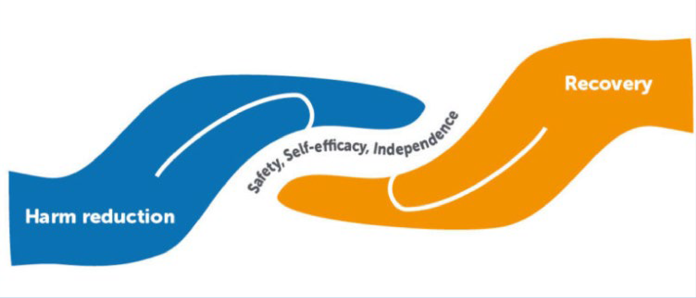

Harm Reduction Principles

Accepts that drug use is part of our world
Ensures residents with a history of drug use have a real voice
Establishes quality of individual and community life and well-being
Does not minimize or ignore real & tragic harm & danger associated with drug use.

Adapted from: Principles of Harm Reduction. Harm Reduction Coalition 2020

Harm Reduction Principles

Recognizes realities of poverty, racism, past trauma, and other social inequalities
Affirms people who use drugs (PWUD) themselves as primary agents
Understands drug use is complex
Calls for non-judgmental, non-coercive provisions of services and resources

Adapted from: Principles of Harm Reduction. Harm Reduction Coalition 2020

Principles of Trauma-Informed Care

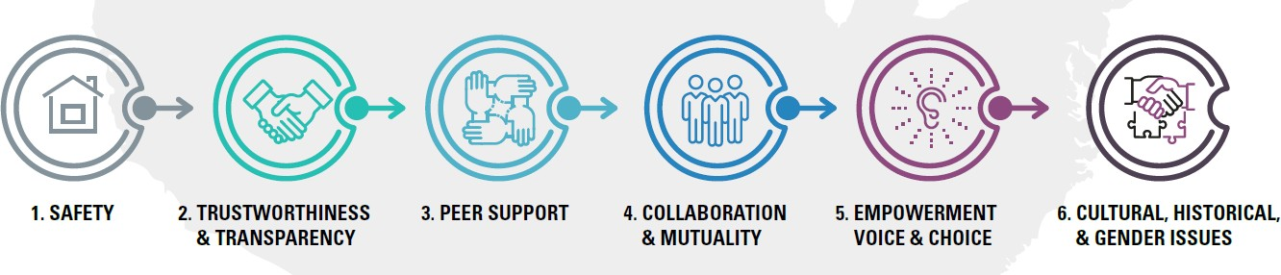

Source: CDC’s Office of Public Health Preparedness and Response 6 Guiding Principles to a Trauma-Informed Approach

Complete an organization assessment and develop an action plan
Educate staff to attain a sustainable trauma- informed workforce
Change organizational culture to highlight role of trauma

Design a clearly
articulated trauma screening process
Driven by the voices and choices of residents to create a setting that adapts to their needs
Ensure environment is safe, nurturing, and empowering

Source: Trauma-Informed Care: Change Package for Nursing Centers

Cultural competency is a developmental process in which one achieves increasing levels of awareness, knowledge, attitudes, and skills along a continuum, improving one’s capacity to work and communicate effectively in cross-cultural situations.
Attitudes
Strategies for practicing cultural competency include:
- Learning about your own and others’ cultural identities
- Combating bias and stereotypes
- Respecting others’ beliefs, values, and communication preferences
- Adapting your services to each resident’s unique needs
- Gaining new cultural experiences

Awareness Knowledge
Cultural Competence

Skills

Cultural humility is a reflective process of understanding one’s biases and privileges, managing power imbalances, and maintaining openness to others in relation to aspects of their cultural identity that are most important to them.
Cultural Humility
Strategies for practicing cultural humility include:
- Practicing self-reflection, including awareness of your beliefs, values, and implicit biases
- Recognizing what you don’t know and being open to learning as much as you can
- Being open to other people’s identities and empathizing with their life experiences
- Acknowledging that the resident is their own best authority, not you
- Learning and growing from people whose beliefs, values, and worldviews differ from yours

Discussion Questions

Why is it important to strive for both
cultural competency and cultural humility?

World Café
Interactive Activity

Directions

  - There are (three) 3 tables for our World Café
  - Each table will address different discussion questions
  - You will have time to participate in the discussions sequentially at three (3) of the tables
  - Each discussion will last 10-15 minutes
  - Following the table discussion, the moderator at each table will report out to the group

Table Discussions

- Stigma
  - What can healthcare workers do to reduce stigma?
  - Have any of these approaches been implemented at your organization?
  - If not, are these things you think your organization can work toward in the future? What kinds of challenges do you anticipate? Have other participants found solutions to these challenges or other lessons learned to share?
- 2. Harm Reduction
  - What are some of the misconceptions about harm reduction strategies and programs and how do you negate these misconceptions?
  - What are some of the harm reduction strategies in your organization?
3. Trauma-Informed Care
- Trauma – what do you think of when you hear this word?
- What are some challenges you might face in providing Trauma-Informed Care?
- How is your organization educating staff on Trauma-Informed Care?

World Café

5 minutes remaining

World Café

Change Tables

Table Moderators Report Out

3-5 minutes per table

Brief Negotiated Interviewing (BNI)

- A specialized intervention that has foundations in motivational interviewing techniques
- Intended to elicit a person’s motivation to either make changes or continue healthier choices

https://www.mass.gov/info-details/screening-brief-intervention-and-referral-to-treatment-sbirt#learn-about-brief-intervention- (bi)-
https://www.bu.edu/bniart/sbirt-in-health-care/sbirt-brief-negotiated-interview-bni/

Build Rapport
Steps in BNI
Provide Feedback
Readiness to Change
Plan for Change

BNI Algorithm

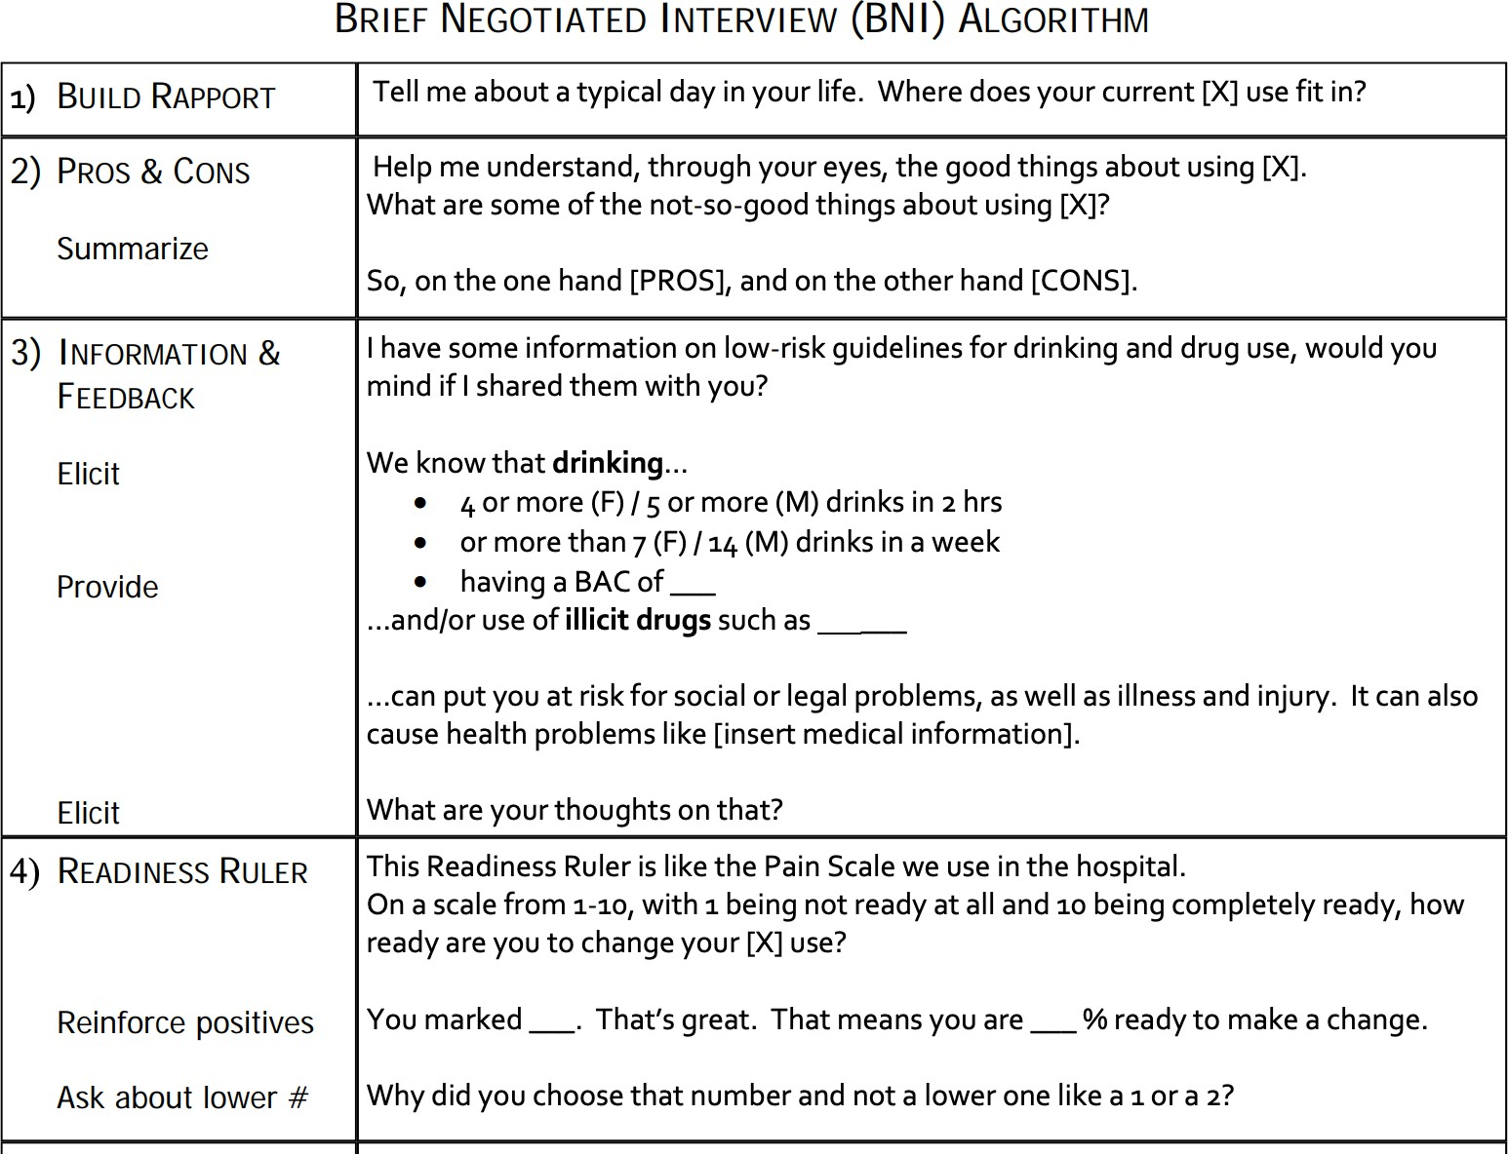
Boston University School of Public Health The BNI ART Institute/

Reflection and Leaving in
Action

Reflection

What strategies has your facility
learned today that could help overcome current challenges and lead to successful care for residents with OUD/StUD?

Future Plans

What are your plans/strategies to
continue to improve care for residents with OUD and/or StUD?

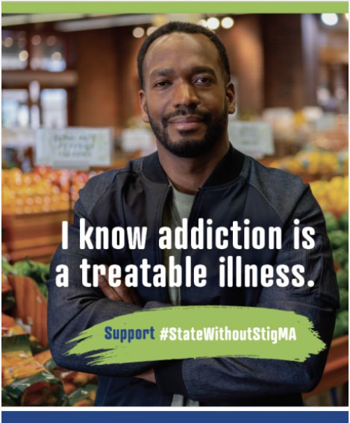

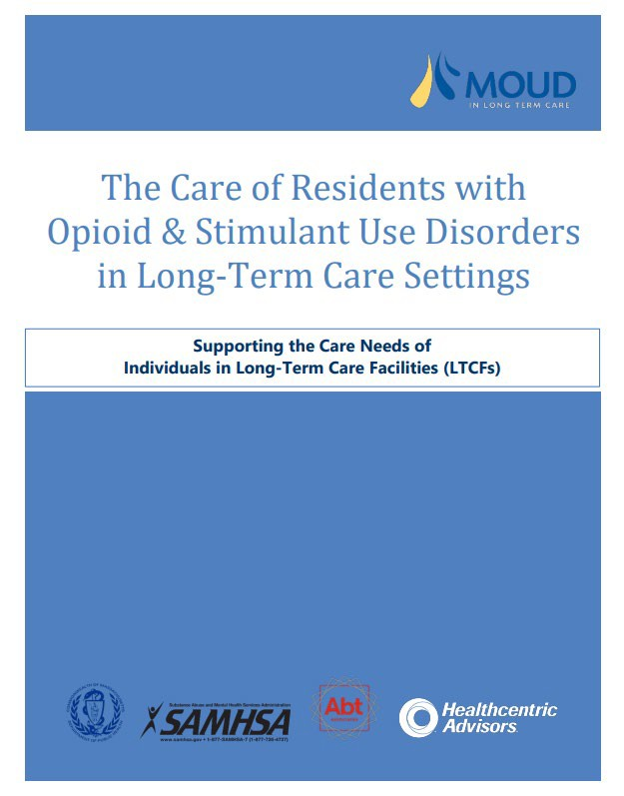
The Care of Residents with Opioid Use & Stimulant Use Disorders in Long-Term Care Settings
Support #StateWithoutStigMA

Resources

Massachusetts Department of Public Health

Thank you!

36

Connect with DPH
37

@MassDPH

Massachusetts Department of Public Health
DPH blog https://blog.mass.gov/publichealth

www.mass.gov/dph

