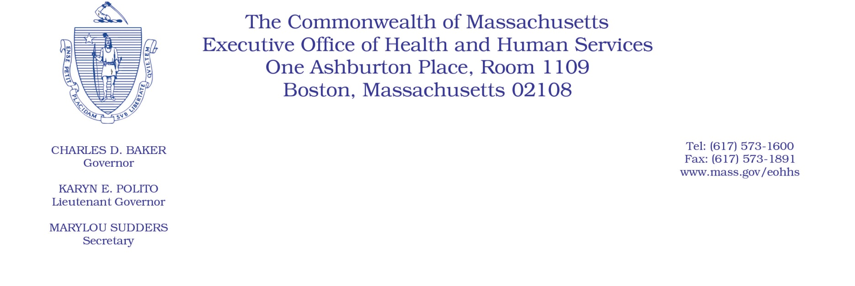

Administrative Bulletin 19-08
101 CMR 346.00: Rates for Certain Substance-Related and Addictive Disorders Programs
Effective January 1, 2019
Codes for Group Counseling Billing
Under the authority of regulation of 101 CMR 346.00, the Executive Office of Health and Human Services (EOHHS) is revising the descriptions for existing Healthcare Common Procedure Coding System (HCPCS) codes for the billing of substance use disorder (SUD) 45-minute group counseling services and adding updated HCPCS codes for the billing of SUD 90-minute group counseling services. Pursuant to these changes, providers may bill only one 45-minute or one 90-minute SUD group counseling service per member per day.
The following codes and rates will be effective for services provided on or after January 1, 2019.
Code Description Revisions
The following codes have revised descriptions. The codes and payment rates remain unchanged.
Code | Rate | Old Description | New Description
H0005 | $16.84 | Alcohol and/or drug services; group counseling by a clinician (per 45 minutes) | Alcohol and/or drug services; group counseling by a clinician (per 45-minute unit) (one unit maximum per day)
H0005-HD | $16.84 | Alcohol and/or drug services; group counseling by a clinician (pregnant/parenting women’s program) (per 45 minutes) | Alcohol and/or drug services; group counseling by a clinician (pregnant/parenting women’s program) (per 45-minute unit) (one unit maximum per day)

Code | Rate | Old Description | New Description
H0005-HQ | $16.84 | Alcohol and/or drug services; group counseling by a clinician (group setting) (per 45 minutes, opioid group counseling, two units max per day) | Alcohol and/or drug services; group counseling by a clinician (group setting) (methadone/opioid counseling) (per 45-minute unit) (one unit maximum per day)
Code Updates
The following updates to the group counseling codes add the 90-minute service units.
Code | Rate | Description
H0005-HF | $33.68 | Alcohol and/or drug services; group counseling by a clinician (per 90-minute unit) (one unit maximum per day)
H0005-TH | $33.68 | Alcohol and/or drug services; group counseling by a clinician (pregnant/parenting women’s program) (per 90-minute unit) (one unit maximum per day)
H0005-HG | $33.68 | Alcohol and/or drug service; group counseling by a clinician (methadone/opioid counseling) (per 90-minute unit) (one unit maximum per day)

