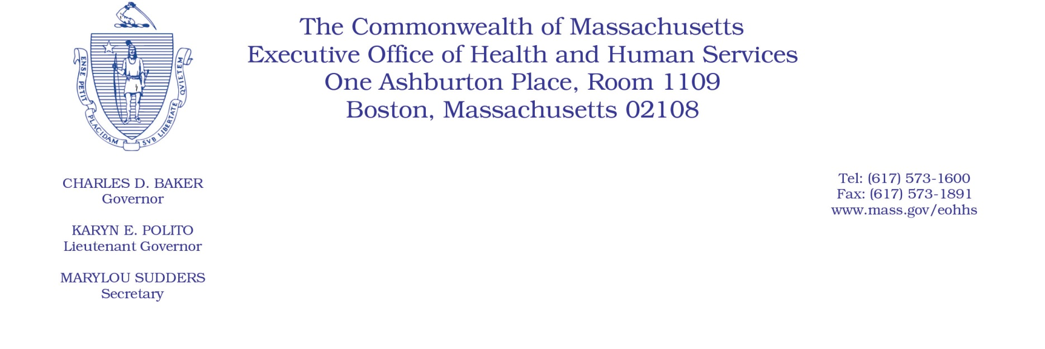
Administrative Bulletin 19-09

101 CMR 353.00: Payment for Primary Care Clinician Plan Services

Effective March 1, 2018
Clarification on the Enhanced Payment for Certain Primary Care Provider Services
In accordance with 101 CMR 353.01(3) and its predecessor regulation 114.3 CMR 53.00, the Executive Office of Health and Human Services (EOHHS) is providing the following clarification: An enhancement of $10 for each procedure code included in the program may be payable to Primary Care Accountable Care Organizations’ (ACOs) participating primary care providers (participating PCPs) for certain eligible PCP services provided to members enrolled in MassHealth Primary Care ACOs. The details of eligibility for the add-on are specified under MassHealth’s contracts with participating PCPs.

