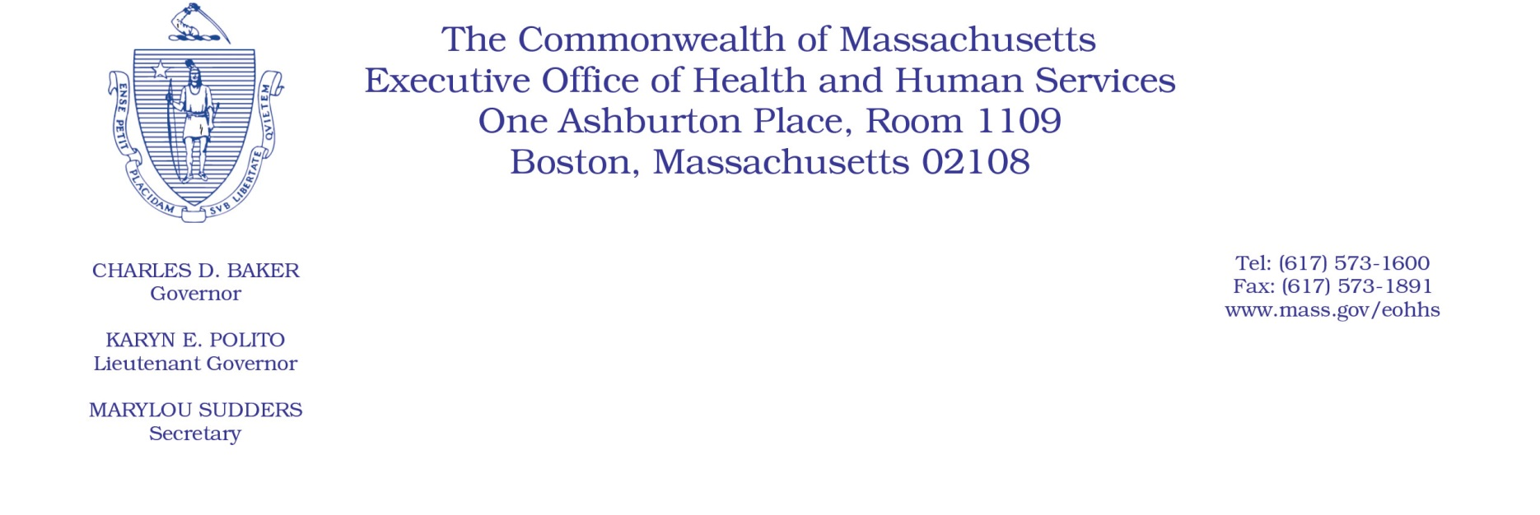

Administrative Bulletin 19-14

101 CMR 309.00: Rates for Certain Services for the Personal Care Attendant Program

Effective July 1, 2019

Update to the Personal Care Attendant Services Rates

The Executive Office of Health and Human Services (EOHHS) is issuing this Administrative Bulletin pursuant to 101 CMR 309.01(6) to clarify the substantive provisions of the rates for personal care attendant (PCA) services contained in 101 CMR 309.03(5) provided to MassHealth members. Specifically, the rates for PCA services are being updated in accordance with 101 CMR 309.03(5)(a) to align with the provisions of the collective bargaining agreement effective July 1, 2019.

Below are the rates of payment for PCA services, inclusive of the wage component and the employer expense component, effective on July 1, 2019.

PCA Rates Effective July 1, 2019:
Code | Modifier | Rate | Unit | Service Description
T1019 |  | $4.36 | 15 minutes | Personal care services, per 15 minutes, not for an inpatient or resident of a hospital, nursing facility, ICF/ID or IMD, part of the individualized plan of treatment (code may not be used to identify services provided by home health aide or certified nurse assistant) (P.A.) (Use this code to bill for PCA services provided during day or night.)
T1019 | TU | $2.18 | 15 minutes | Personal care services, per 15 minutes, not for an inpatient or resident of a hospital, nursing facility, ICF/ID or IMD, part of the individualized plan of treatment (code may not be used to identify services provided by home health aide or certified nurse assistant) Special payment rate, overtime (P.A.) (Use this code and modifier to bill for premium pay for overtime.)
T1019 | TV | $2.18 | 15 minutes | Personal care services, per 15 minutes, not for an inpatient or resident of a hospital, nursing facility, ICF/ID, or IMD, part of the individualized plan of treatment (code may not be used to identify services provided by home health aide or certified nurse assistant) Special payment rate, holidays (P.A.) (Use this code and modifier to bill for premium pay for holidays.)
99509 | U1 | $4.25 | 15 minutes | Home visit for assistance with activities of daily living and personal care. (personal care services, per 15 minutes) (Use this code and modifier to bill for PCA sick time for dates of services from January 1, 2016, through June 30, 2019.) (Current P.A. for PCA services required for each member.)
99509 | U2 | $4.36 | 15 minutes | Home visit for assistance with activities of daily living and personal care. (personal care services, per 15 minutes) (Use this code and modifier to bill for PCA paid earned time.) (Current P.A. for PCA services required for each member.)
99509 | U3 | $52.36 | Per diem | Home visit for assistance with activities of daily living and personal care. (personal care services) (Use this code and modifier to bill for PCA new hire orientation, per diem, per eligible PCA.)
99509 | TU | $0.15 | 1 minute | Home visit for assistance with activities of daily living and personal care. (personal care services) (Use this code and modifier to bill for overtime, per 1 minute, special payment rate.) (Current P.A. for PCA services required for each member.)
A0170 |  | $0.29 | 1 minute | Transportation ancillary: parking fees, tolls, other. (Use this code to bill for travel time for PCA services, per 1 minute.) (Current P.A. for PCA services required for each member.)

Explanation of PCA Rates Effective July 1, 2019:
PCA Rate Component | PCA Rate (Hourly) | Premium Pay Rate for Overtime and Premium Holiday Rate (Hourly)
PCA Wage Component | $15.40 | $23.10
Employer Expense Component | $2.05 | $3.08
Total PCA Rate | $17.45 | $26.18

