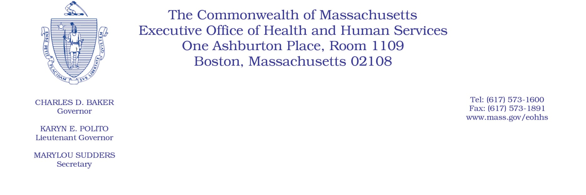

Administrative Bulletin 19-15

114.1 CMR 41.00: Rates of Payment for Services Provided to
Industrial Accident Patients by Hospitals

Effective July 1, 2019
Publication of Payment on Account Factors (PAFs) for Hospital Services

The Executive Office of Health and Human Services (EOHHS), pursuant to 114.1 CMR 41.05(1) and (3) and in accordance with Section 123 of Chapter 224 of the Acts of 2012, is publishing the Payment on Account Factors (PAFs) for acute and nonacute hospital services rendered to industrial accident patients. The PAF was computed using data from each hospital’s most recent complete fiscal year. The application of the PAF to all billed charges payable pursuant to 114.1 CMR 41.00 results in the payment of the average percentage of charges paid by the private sector to each hospital for its services. This payment calculation is deemed to meet the test of reasonable cost of medical services prescribed by M.G.L. c. 152, the Workers’ Compensation Act. No lesser amount will be paid unless agreed to by the provider, insurer, and employer.

Provided below are the PAFs for acute and nonacute hospital services rendered on or after
July 1, 2019.
Acute Hospitals | PAF
Anna Jaques Hospital | 55.36%
Athol Memorial Hospital | 32.89%
Baystate Franklin Medical Center | 48.52%
Baystate Medical Center | 54.80%
Baystate Noble Hospital | 41.98%
Baystate Wing Hospital | 45.35%
Berkshire Medical Center | 65.36%
Beth Israel Deaconess Hospital - Milton | 46.56%
Beth Israel Deaconess Hospital - Needham | 55.83%
Beth Israel Deaconess Hospital - Plymouth | 50.66%
Beth Israel Deaconess Medical Center | 57.99%
Boston Medical Center | 35.77%
Brigham and Women's Faulkner Hospital | 43.75%
Brigham and Women's Hospital | 43.28%
Cambridge Health Alliance | 50.76%
Cape Cod Hospital | 65.18%
Cooley Dickinson Hospital | 54.33%
Dana-Farber Cancer Institute | 38.40%
Emerson Hospital | 46.85%
Fairview Hospital | 69.62%
Falmouth Hospital | 65.81%
Harrington Memorial Hospital | 34.18%
Heywood Hospital | 47.16%
Holyoke Medical Center | 48.09%
Lahey Health - Winchester Hospital | 57.79%
Lahey Hospital and Medical Center | 54.42%
Lawrence General Hospital | 42.71%
Lowell General Hospital | 48.00%
Marlborough Hospital - A member of the UMass Memorial Health Center | 29.58%
Martha's Vineyard Hospital | 65.17%
Massachusetts Eye and Ear Infirmary | 46.01%
Massachusetts General Hospital | 43.96%
MelroseWakefield Healthcare | 52.86%
Mercy Medical Center | 57.50%
MetroWest Medical Center | 36.00%
Milford Regional Medical Center | 51.74%
Morton Hospital - A Steward Family Hospital Inc. | 69.71%
Mount Auburn Hospital | 62.12%
Nantucket Cottage Hospital | 75.38%
Nashoba Valley Medical Center - A Steward Family Hospital Inc. | 41.49%
New England Baptist Hospital | 57.99%
Newton-Wellesley Hospital | 43.10%
North Shore Medical Center | 46.03%
Northeast Hospital | 51.72%
Saint Vincent Hospital | 41.21%
Signature Healthcare Brockton Hospital | 41.35%
South Shore Hospital | 57.17%
Southcoast Hospitals Group | 50.75%
Steward Carney Hospital Inc. | 63.90%
Steward Good Samaritan Medical Center | 66.63%
Steward Holy Family Hospital Inc. | 61.24%
Steward Norwood Hospital Inc. | 64.14%
Steward Saint Anne's Hospital Inc. | 52.98%
Steward St. Elizabeth's Medical Center | 76.36%
Sturdy Memorial Hospital | 73.69%
Tufts Medical Center | 46.00%
UMass Memorial HealthAlliance - Clinton Hospital (Previously HealthAlliance Hospital) | 33.71%
UMass Memorial Medical Center | 39.31%
Acute Hospital Median PAF for  Out-of-State and New Hospitals | 50.75%

Nonacute Hospitals | PAF
Curahealth Stoughton | Median
Fairlawn Rehabilitation Hospital | 53.49%
HealthSouth Braintree Rehabilitation Hospital | 43.47%
HealthSouth New England Rehabilitation Hospital | 54.05%
HealthSouth Rehabilitation Hospital of Western Massachusetts | 51.21%
McLean Hospital | 49.18%
Spaulding Hospital Cambridge | 49.54%
Spaulding Rehabilitation Hospital - Cape Cod | 48.61%
Spaulding Rehabilitation Hospital | 45.14%
Vibra Hospital of Western Massachusetts | Median
Whittier Rehab Hospital Bradford | 37.85%
Whittier Rehab Hospital Westborough | 33.23%
Nonacute Hospital Median PAF for  Out-of-State and New Hospitals | 48.90%

