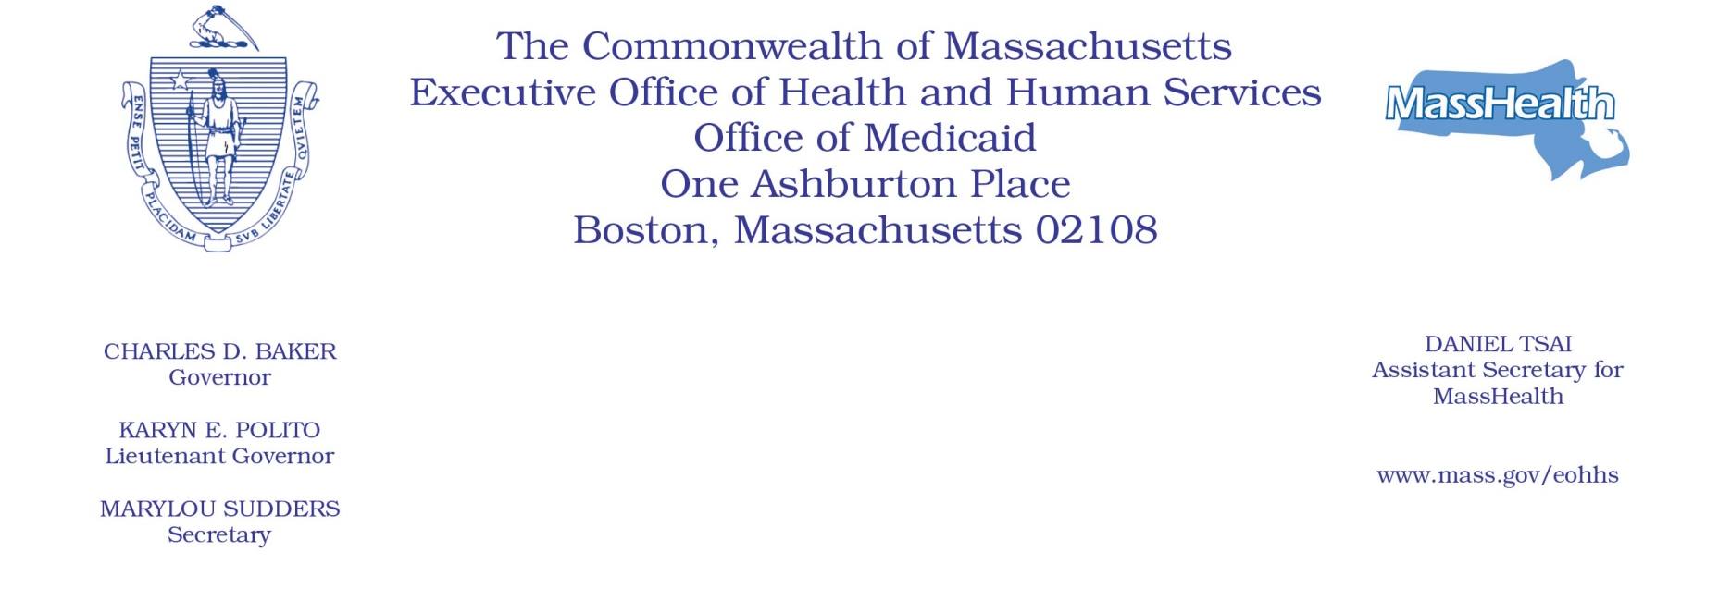

Administrative Bulletin 19-19
101 CMR 322.00: Durable Medical Equipment, Oxygen and Respiratory Therapy Equipment
Effective November 15, 2019

Direct Service Components RE1 through RE23
Under the authority of 101 CMR 322.01(5), 322.03(2), 322.03(13) and 322.06, the Executive Office of Health and Human Services (EOHHS) is issuing this bulletin to publish a new modifier and to identify the code and modifier combination to be used for the Direct Service Component, RE1 through RE23, for evaluation of complex mobility systems, installation of custom movable and fixed patient lift systems, and installation of pediatric/turned adult safety beds. The following new modifier, and code and modifier combination will be effective for dates of service on or after November 15, 2019.
New Modifier

New Modifier | Description
U5 | Direct Service Component (RE units) for evaluation of complex mobility systems, installation of custom movable and fixed patient lift systems, and installation of pediatric/turned adult safety beds. One RE unit equals 1 hour.

New Code and Modifier Combination

The following code and modifier combination is new and does not crosswalk to an existing modifier or code.

New Combination | Rate | Description
K0739 U5 | $46.33 | Direct Service Component (RE) units for evaluation of complex mobility systems, for installation of custom movable and fixed patient lift systems RE1–RE23, and installation of pediatric/turned adult safety beds RE1–RE5. One RE unit equals 1 hour

