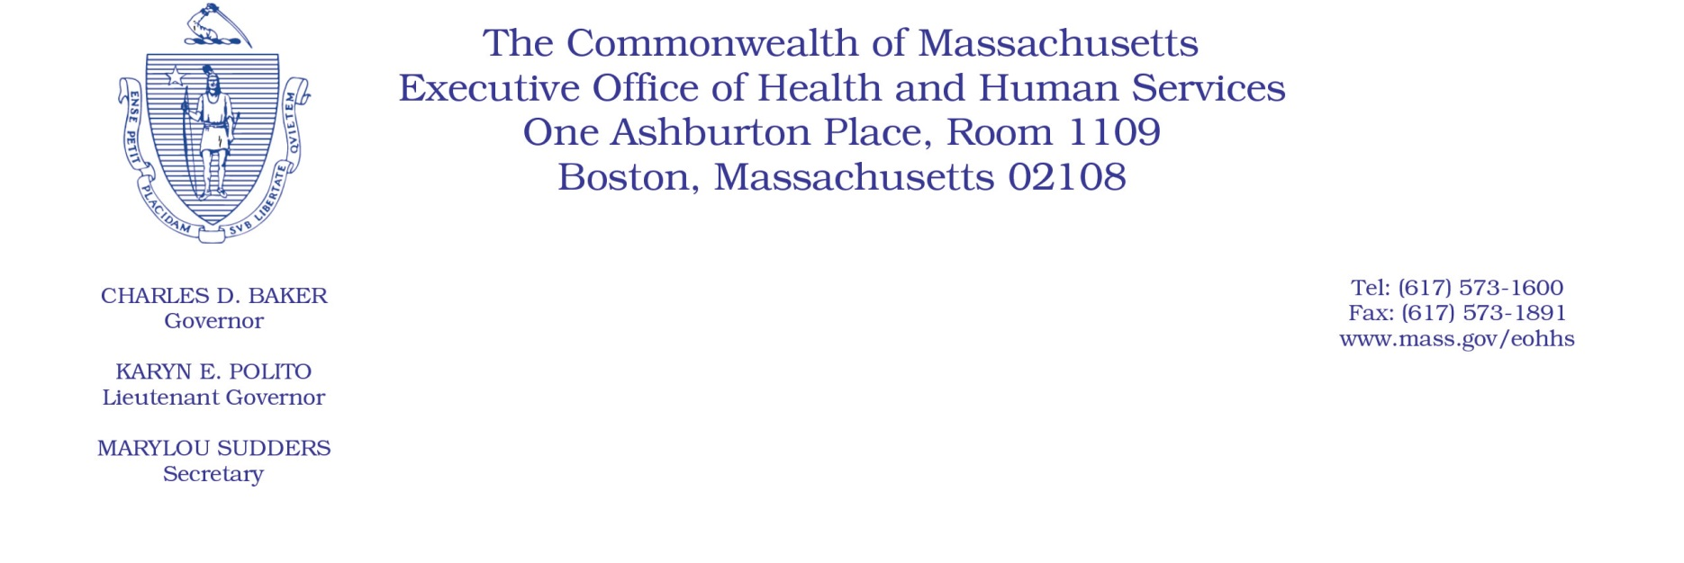

Administrative Bulletin 19-20

101 CMR 20.00: Health Information Exchange

Effective November 25, 2019
Delay of Effective Date for Acute Care Hospitals to Submit Admit, Discharge, and Transfer (ADT) Feeds to the Statewide Event Notification Service (ENS) Framework

The Executive Office of Health and Human Services (EOHHS), including the Massachusetts Health Information Highway, is issuing this bulletin to delay the effective date for implementing the requirements of 101 CMR 20.08(4), which describes when acute care hospitals have to submit ADT feeds to the statewide ENS framework. The regulation 101 CMR 20.08(4)(b) requires acute care hospitals to submit ADT feeds to the statewide ENS framework beginning January 1, 2020. In addition, 101 CMR 20.08(4)(d) states that penalties for noncompliance begin on July 1, 2020, and acute care hospitals that do not meet the requirement to submit ADT feeds by this date may be subject to the penalties found in 101 CMR 20.13 and 20.14.
EOHHS will delay the effective date for implementing the requirements of each of 101 CMR 20.08(4)(b) and 101 CMR 20.08(4)(d) by three months. Therefore, the effective date for implementing the requirements under 101 CMR 20.08(4)(b) will be April 1, 2020, and the effective date for implementing the requirements under 101 CMR 20.08(4)(d) will be October 1, 2020.
If you have any questions about this bulletin, please contact Karbert Ng, Mass HIway Program Director, at
(617) 849-3158 or Karbert.S.Ng@MassMail.State.ma.us.

