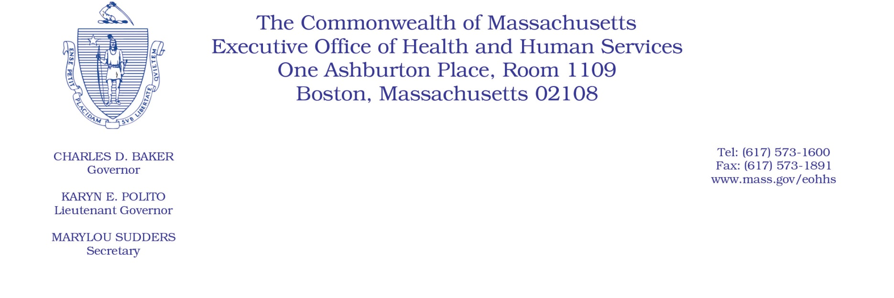

Administrative Bulletin 20-04

101 CMR 414.00: Rates for Family Stabilization Services

Effective January 1, 2020

Clarification to Certain Family Stabilization Services Rates

The Executive Office of Health and Human Services is issuing this administrative bulletin under the authority of 101 CMR 414.01(5) to clarify certain family stabilization services rates established in 101 CMR 414.03(5).

The unit of service for the following rates in 101 CMR 414.03(5) are being updated to a 15-minute unit. The chart below reflects the 15-minute unit rate for these services, effective January 1, 2020.

Service | Unit of Service | Agency Rate
Family Training | 15 minutes | $8.74
Family Training Group of 2 | 15 minutes | $4.37
Family Training Group of 5 | 15 minutes | $1.76
…
Peer Support | 15 minutes | $7.59
Peer Support Group of 2 | 15 minutes | $3.80
Peer Support Group of 5 | 15 minutes | $1.53
…
Respite in Recipient’s Home, 1:1 | 15 minutes | $6.82
Respite in Recipient’s Home, 1:2 | 15 minutes | $3.41
Respite in Recipient’s Home, 1:3 | 15 minutes | $2.28

