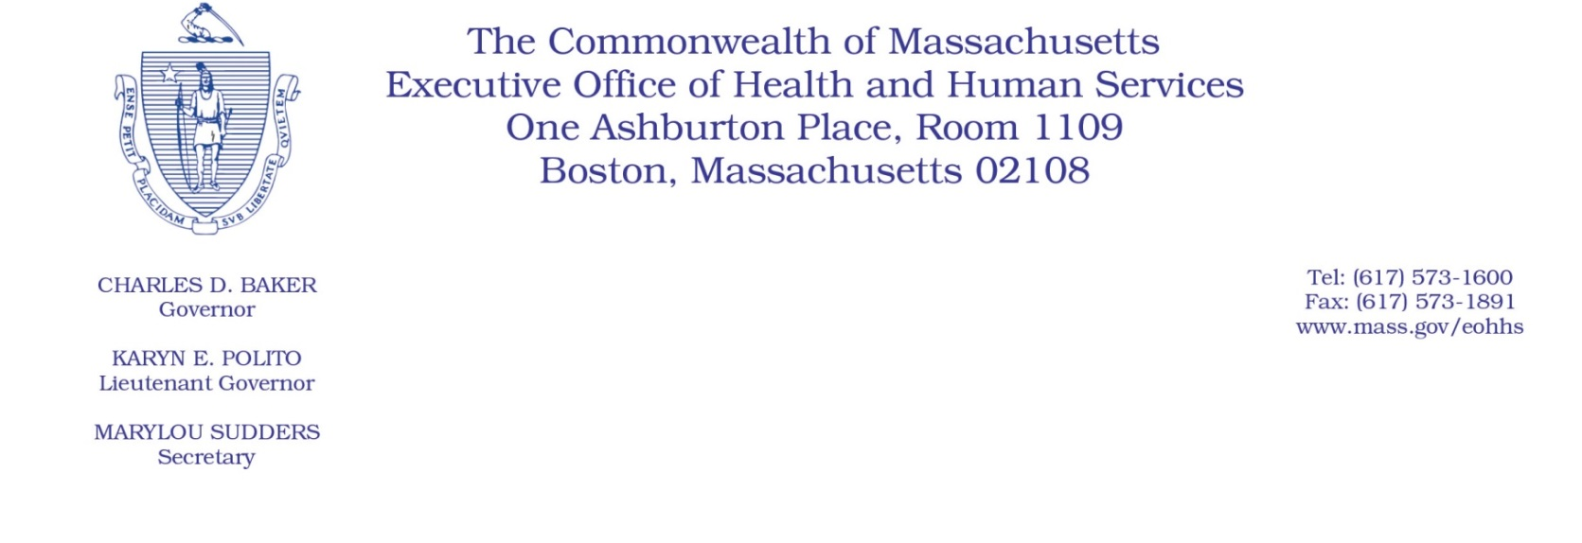
Administrative Bulletin 20-14
101 CMR 430.00: Rates for Program of Assertive Community Treatment Services
Effective 04-16-2020

Rate Update Applicable to Certain Program for Assertive Community Treatment Services During the Coronavirus Disease 2019 (COVID-19) Public Health Emergency

Purpose, Scope, and Effective Period
The Executive Office of Health and Human Services (EOHHS) is issuing this bulletin pursuant to the authority of COVID-19 Order No. 20: Order Authorizing the Executive Office of Health and Human Services to Adjust Essential Provider Rates During the COVID-19 Public Health Emergency and Executive Order 591: Declaration of State of Emergency to Respond to COVID-19. In light of the state of emergency declared in the Commonwealth due to COVID-19, EOHHS, which administers the Massachusetts Medicaid program and Children’s Health Insurance Program (CHIP) known as “MassHealth,” is establishing increased rates for certain MassHealth-covered Program of Assertive Community Treatment Services (PACT) services established in 101 CMR 430.00: Rates for Program of Assertive Community Treatment Services and as further described in this bulletin. If a rate is not being updated pursuant to this bulletin, the rate remains at the currently established rate.
This administrative bulletin is effective for dates of service from April 1, 2020, through July 31, 2020.
Disclaimer: This bulletin is not authorization for a provider’s use of the updated rate or service. Authorization for the provision of, and billing and payment for, PACT services are pursuant to the applicable MassHealth programmatic requirements.

Background
PACT services are provided to MassHealth members with serious mental illness who may benefit from intensive coordinated services and who have not responded well to program or office-based interventions. PACT uses a multi-disciplinary team approach to providing acute, active, ongoing, and long-term community-based psychiatric treatment, assertive outreach, rehabilitation and support that are critical parts of the MassHealth behavioral health delivery system. As a result of the COVID-19 public health emergency, EOHHS recognizes there are concerns about the cost to PACT providers in continuing to provide PACT services to MassHealth members. These concerns include the potential for increased staffing costs, equipment and other costs, including costs associated with the expansion of delivery of services via telehealth to support access in the communities PACT providers serve, and other concerns resulting from the COVID-19 emergency. EOHHS seeks to promote continued delivery of these critical services to MassHealth members through providing additional financial support to PACT providers for these additional costs and concerns. Accordingly, EOHHS is establishing updated rates as described below.

Updated Rates for Certain PACT Services to Address Concerns Related to COVID-19
To support PACT providers during the COVID-19 emergency, for dates of service from April 1, 2020, through July 31, 2020, EOHHS will increase rates for certain MassHealth-covered PACT services by 10% above current rates.
The following fee schedule identifies the services and new rates:

Code | Modifier | Rate |  | Unit | Service Description
H0040 |  | $55.14 |  | Per Diem | Assertive community treatment program, per diem (PACT programs with 50 slots)
H0040 |  | $50.91 |  | Per Diem | Assertive community treatment program, per diem (PACT programs with 80 slots)
H0040 |  | $78.91 |  | Per Diem | Assertive community treatment program, per diem (Forensic program)

Public Comment
EOHHS will accept comments on the rate established via this bulletin through April 30, 2020. Individuals may submit written comments by emailing
ehs-regulations@state.ma.us. Please submit written comments as an attached Word document or as text within the body of the email with the name of this bulletin in the subject line. All submissions of comments must include the sender’s full name, mailing address, and organization or affiliation, if any. Individuals who are unable to submit comments by email may mail written comments to EOHHS, c/o D. Briggs, Executive Office of Health and Human Services, 100 Hancock Street, 6th Floor, Quincy, MA 02171.
EOHHS may adopt a revised version of this bulletin taking into account relevant comments and any other practical alternatives that come to its attention.

