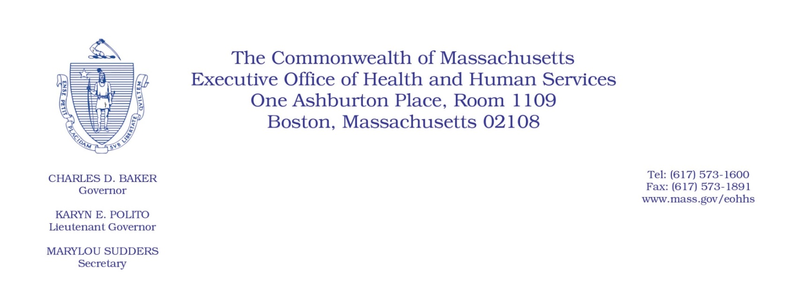
Administrative Bulletin 20-17
101 CMR 346.00: Rates for Certain Substance-Related and Addictive Disorders Programs
Effective April 16, 2020

Rate Update Applicable to Certain Substance Use Disorder Outpatient Services During the Coronavirus Disease 2019 (COVID-19) Public Health Emergency

Purpose, Scope, and Effective Period
The Executive Office of Health and Human Services (EOHHS) is issuing this bulletin pursuant to the authority of COVID-19 Order No. 20: Order Authorizing the Executive Office of Health and Human Services to Adjust Essential Provider Rates During the COVID-19 Public Health Emergency and Executive Order 591: Declaration of State of Emergency to Respond to COVID-19. In light of the state of emergency declared in the Commonwealth due to COVID-19, EOHHS, which administers the Massachusetts Medicaid program and the Children’s Health Insurance Program (CHIP) known as “MassHealth,” is establishing increased rates for certain MassHealth-covered Substance Use Disorder (SUD) Outpatient services established in 101 CMR 346.00: Rates for Certain Substance-Related and Addictive Disorders Programs and as further described in this bulletin. If a rate is not being updated pursuant to this bulletin, the rate remains at the currently established rate.
This administrative bulletin is effective for dates of services from April 1, 2020, through July 31, 2020.
Disclaimer: This administrative bulletin is not authorization for a provider’s use of the updated rate or service. Authorization for the provision of, and billing and payment for, SUD Outpatient services are pursuant to the applicable MassHealth programmatic requirements.

Background
SUD Outpatient providers deliver critical outpatient services such as case consultation, assessment, and individual, group, and family/couples counseling services. As a result of the COVID-19 public health emergency, EOHHS recognizes there are concerns about the cost to SUD Outpatient providers in continuing to provide services to MassHealth members.

These concerns include the potential for increased staffing costs, equipment and other costs, including costs associated with the expansion of delivery of services via telehealth to support access in the communities SUD Outpatient providers serve, and other concerns resulting from the COVID-19 emergency. EOHHS seeks to promote continued delivery of these critical services to MassHealth members through providing additional financial support to SUD Outpatient providers for these additional costs and concerns. Accordingly, EOHHS is establishing updated rates as described below.

Updated Rates for Certain Substance Use Disorder Outpatient Services to Address Concerns Related to COVID-19
To support SUD Outpatient providers during the COVID-19 emergency, for dates of service from April 1, 2020, through July 31, 2020, EOHHS will increase rates for certain MassHealth-covered SUD Outpatient services by 10% above current rates. The following fee schedule identifies the services and new rates:
Code | Modifier | Rate | Unit | Service Description
90882 | HF | $41.17 | per 30 minutes | Environmental intervention for medical management purposes on a psychiatric patient’s behalf with agencies, employers, or institutions (substance abuse program) (case consultation, per 30 minutes)
H0001 |  | $20.58 | per 15 minutes | Alcohol and/or drug assessment (per 15 minutes)
H0004 |  | $20.58 | per 15 minutes | Behavioral health counseling and therapy, per 15 minutes (individual counseling)
H0005 |  | $18.52 | per 45 minutes | Alcohol and/or drug services; group counseling by a clinician (per 45 minutes, group counseling, one unit maximum per day)
H0005 | HG | $37.05 | per 90 minutes | Alcohol and/or drug services; group counseling by a clinician (methadone/opioid counseling) (per 90-minute unit) (one unit maximum per day)
T1006 |  | $42.37 | per 30 minutes | Alcohol and/or substance abuse services; family/couple counseling (per 30 minutes, one unit maximum per day)
T1006 | HF | $84.74 | per 60 minutes | Alcohol and/or substance abuse services; family/couple counseling (per 60 minutes, one unit maximum per day)

Public Comment
EOHHS will accept comments on the rate(s) established via this administrative bulletin through April 30, 2020. Individuals may submit written comments by emailing: ehs-regulations@state.ma.us. Please submit written comments as an attached Word document or as text within the body of the email with the name of this bulletin in the subject line. All submissions of comments must include the sender’s full name, mailing address, and organization or affiliation, if any. Individuals who are unable to submit comments by email may mail written comments to EOHHS, c/o D. Briggs, 6th Floor, 100 Hancock Street, Quincy, MA 02171.
EOHHS may adopt a revised version of this bulletin taking into account relevant comments and any other practical alternatives that come to its attention.

