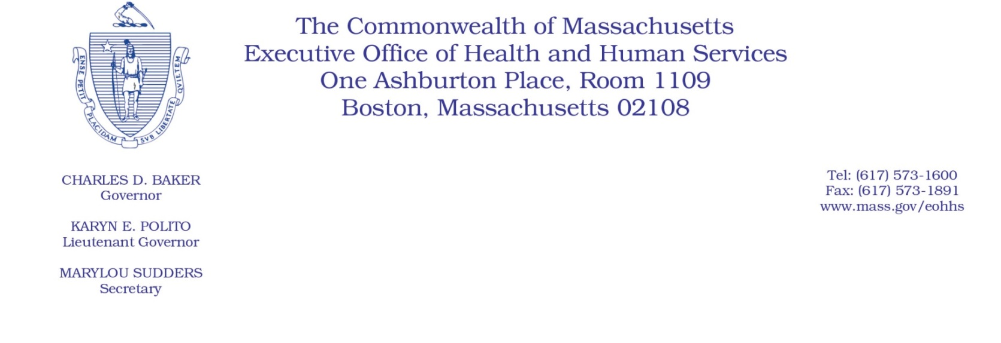
Administrative Bulletin 20-20
101 CMR 206.00: Standard Payments to Nursing Facilities
Effective April 16, 2020

Supplemental Payment Methodology Applicable to Nursing Facilities
During the COVID-19 Public Health Emergency

Purpose, Scope, and Effective Period
The Executive Office of Health and Human Services (EOHHS) is issuing this administrative bulletin pursuant to the authority of COVID-19 Order No. 20: Order Authorizing the Executive Office of Health and Human Services to Adjust Essential Provider Rates During the COVID-19 Public Health Emergency and Executive Order 591: Declaration of State of Emergency to Respond to COVID-19. In light of the state of emergency declared in the Commonwealth due to COVID-19, EOHHS, which administers the Massachusetts Medicaid program known as “MassHealth,” is establishing supplemental payments for certain MassHealth-covered nursing facility services, notwithstanding 101 CMR 206.00: Standard Payments to Nursing Facilities, as further described in this administrative bulletin. If a rate or payment methodology is not being updated pursuant to this administrative bulletin, the rate or payment methodology remains as established.
This administrative bulletin is effective for dates of service from April 1, 2020, through July 31, 2020.
Disclaimer: This administrative bulletin is not authorization for a provider’s use of the updated rate or service. Authorization for the provision of, and billing and payment for, nursing facility services are pursuant to the MassHealth nursing facility regulations at 130 CMR 450.000: Administration and Billing Regulations and 130 CMR 456.000: Long Term Care Services.

Background
As a result of the COVID-19 public health emergency, EOHHS recognizes there are concerns regarding nursing facility providers’ financial stability as they implement heightened screening processes for staff and other individuals entering their facilities, face staff and equipment shortages, and take extra precautions to protect their at-risk populations. EOHHS seeks to provide financial support to nursing facility providers to offset the additional costs associated with these factors resulting from the COVID-19 public health emergency and maintain continued access to care for MassHealth members. Accordingly, EOHHS is establishing supplemental payments to nursing facilities, as described below.

Calculation of Supplemental Payments
- EOHHS will calculate the payment for each nursing facility provider as follows:
  - Divide the number of Massachusetts Medicaid Days as reported by each nursing facility provider on their Quarterly User Fee Assessment Form for the period of October 1, 2018, through September 30, 2019, by the total number of Massachusetts Medicaid Days, including Fee-For-Service and Managed Care bed days, across all nursing facility providers, as reported by all nursing facility providers on the Quarterly User Fee Assessment Form for the same period.
  - Multiply the quotient calculated in Section 1.a., above, by 10 percent of the average monthly MassHealth Fee-For-Service payments made to all Nursing Facilities from October 1, 2018, through September 30, 2019 or, if the amount of additional funding for the month is insufficient to make such payments to all nursing facilities, by the amount of additional funding available for a given payment month.

Distribution of Supplemental Payments.
  - MassHealth will pay each nursing facility provider a monthly supplemental payment for four consecutive calendar months, beginning April 2020.
  - Providers do not need to request supplemental payments; all eligible providers will automatically receive these payments and such payments will be distributed by the fifteenth calendar day of each month.
  - EOHHS will use the nursing facility provider’s current bank information on file to distribute supplemental payments.

Public Comment
EOHHS will accept comments on the payment methodologies established via this administrative bulletin through April 30, 2020. Individuals may submit written comments by emailing: ehs-regulations@state.ma.us. Please submit written comments as an attached Word document or as text within the body of the email with the name of this administrative bulletin in the subject line. All submissions of comments must include the sender’s full name, mailing address, and organization or affiliation, if any. Individuals who are unable to submit comments by email may mail written comments to EOHHS, c/o D. Briggs, 100 Hancock Street, 6th Floor, Quincy, MA 02171.
EOHHS may adopt a revised version of this administrative bulletin taking into account relevant comments and any other practical alternatives that come to its attention.

