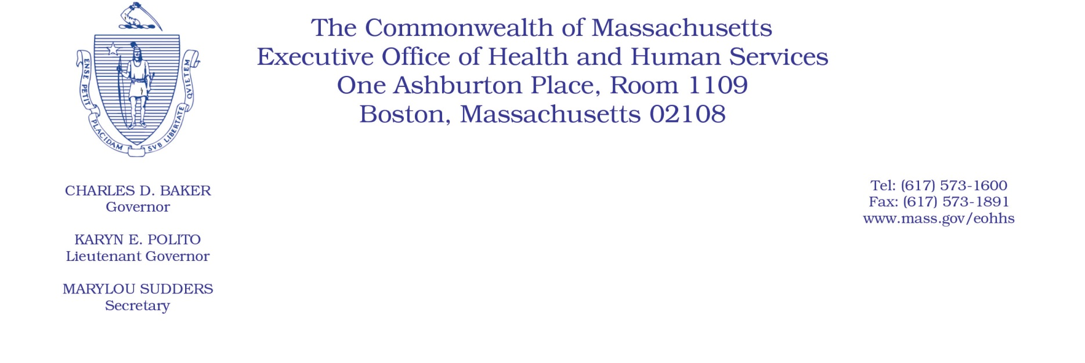

Administrative Bulletin 20-21

101 CMR 346.00: Rates for Certain Substance-Related and Addictive Disorders Programs

Effective April 16, 2020
Rate Update Applicable to Certain Acute Treatment Services and Clinical Stabilization Services During the COVID-19 Public Health Emergency
Purpose, Scope, and Effective Period
The Executive Office of Health and Human Services (EOHHS) is issuing this administrative bulletin pursuant to the authority of COVID-19 Order No. 20: Order Authorizing the Executive Office of Health and Human Services to Adjust Essential Provider Rates During the COVID-19 Public Health Emergency and Executive Order 591: Declaration of State of Emergency to Respond to COVID-19. In light of the state of emergency declared in the Commonwealth due to COVID-19, EOHHS, which administers the Massachusetts Medicaid program and Children’s Health Insurance Program (CHIP) known as “MassHealth,” is establishing increased rates for certain MassHealth-covered acute treatment services (ATS) and clinical stabilization Services (CSS) established in 101 CMR 346.00: Rates for Certain Substance-Related and Addictive Disorders Programs and as further described in this administrative bulletin. If a rate is not being updated pursuant to this administrative bulletin, the rate remains at the currently established rate.
This administrative bulletin is effective for dates of service from April 1, 2020, through July 31, 2020.
Disclaimer: This administrative bulletin is not authorization for a provider’s use of the updated rate or service. Authorization for the provision of, and billing and payment for, ATS and CSS are pursuant to the applicable MassHealth programmatic requirements.
Background
Acute treatment services (ATS) consist of 24-hour, seven-day-per-week, medically monitored treatment for substance use disorder that provides evaluation and withdrawal management. Clinical stabilization services (CSS) consist of 24-hour, clinically managed stabilization services, including intensive education and counseling; outreach to families and significant others; and aftercare planning for individuals beginning to engage in recovery from addiction.
As a result of the COVID-19 public health emergency, EOHHS recognizes there are concerns about the cost to ATS and CSS providers in continuing to provide ATS and CSS to MassHealth members. These concerns include the potential for increased staffing costs, equipment and other costs, including costs resulting from the need to modify existing physical space to address social isolation requirements, and other concerns resulting from the COVID-19 emergency. EOHHS seeks to promote continued delivery of these critical services to MassHealth members through providing additional financial support to ATS and CSS providers for these additional costs and concerns. Accordingly, EOHHS is establishing updated rates as described below.
Updated Rates for ATS and CSS to Address Concerns Related to COVID-19
To support ATS and CSS providers during the COVID-19 emergency, for dates of service from April 1, 2020, through July 31, 2020, EOHHS will increase rates for MassHealth-covered ATS and CSS by 10% above current rates.
The following fee scheduled identifies the services and the new rates:
 | Code | Rate | Unit | Service Description
Acute Treatment Services | H0011 | $382.84 | Per Diem | Alcohol and/or drug services; acute detoxification (residential addiction program inpatient) (Medically Monitored Inpatient Detoxification Services, Facility)
Clinical Stabilization Services | H0010 | $278.61 | Per Diem | Alcohol and/or drug services; subacute detoxification (residential addiction program inpatient) (Clinically Managed Detoxification Services)
Public Comment
EOHHS will accept comments on the rates established via this administrative bulletin through April 30, 2020.
Individuals may submit written comments by emailing: ehs-regulations@state.ma.us. Please submit written comments as an attached Word document or as text within the body of the email with the name of this administrative bulletin in the subject line. All submissions of comments must include the sender’s full name, mailing address, and organization or affiliation, if any. Individuals who are unable to submit comments by email may mail written comments to EOHHS, c/o D. Briggs, 100 Hancock Street, 6th Floor, Quincy, MA 02171.
EOHHS may adopt a revised version of this administrative bulletin taking into account relevant comments and any other practical alternatives that come to its attention.

