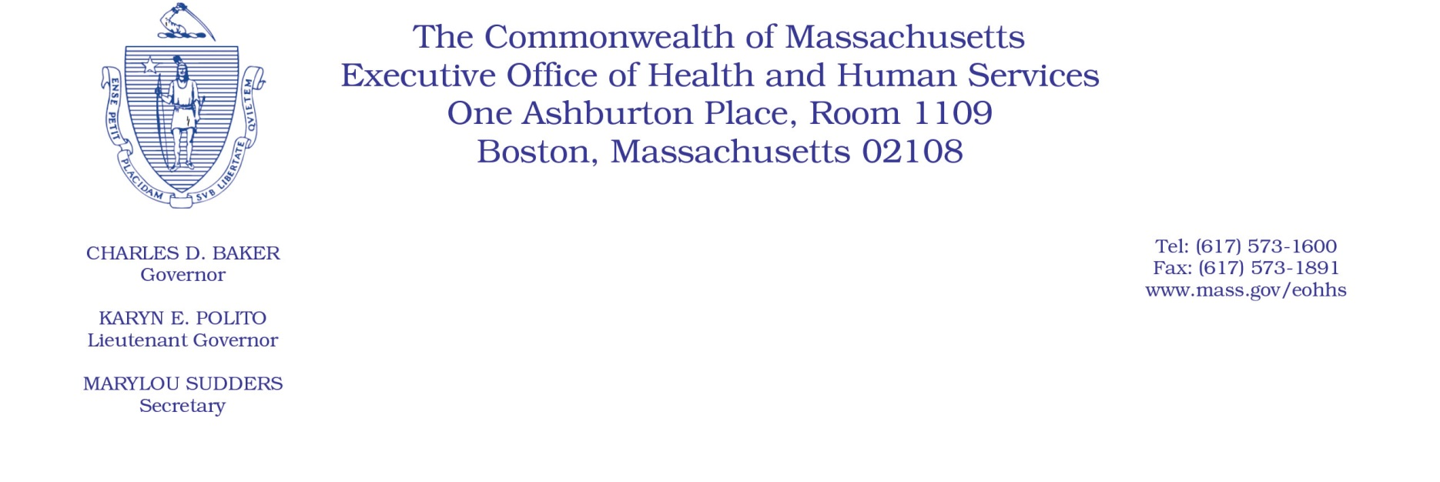

Administrative Bulletin 20-22

101 CMR 349.00: Rates for Early Intervention Program Services

Effective April 16, 2020
Rate Update Applicable to Certain Early Intervention Program Services During the COVID-19 Public Health Emergency
Purpose, Scope, and Effective Period
The Executive Office of Health and Human Services (EOHHS) is issuing this administrative bulletin pursuant to the authority of COVID-19 Order No. 20: Order Authorizing the Executive Office of Health and Human Services to Adjust Essential Provider Rates During the COVID-19 Public Health Emergency and Executive Order 591: Declaration of State of Emergency to Respond to COVID-19. In light of the state of emergency declared in the Commonwealth due to COVID-19, EOHHS, which administers the Massachusetts Medicaid program and Children’s Health Insurance Program (CHIP) known as “MassHealth,” is establishing increased rates for certain MassHealth-covered Early Intervention Program (EI) services established in 101 CMR 349.00: Rates for Early Intervention Program Services, as further described in this administrative bulletin. If a rate is not being updated pursuant to this administrative bulletin, the rate remains at the currently established rate.
This administrative bulletin is effective for dates of service from April 1, 2020, through July 31, 2020.
Disclaimer: This administrative bulletin is not authorization for a provider’s use of the updated rates or services. Authorization for the provision of, and billing and payment for, EI services are pursuant to the applicable MassHealth programmatic requirements.
Background
Early Intervention is a crucial service that provides comprehensive, integrated services to facilitate the developmental progress of eligible MassHealth members between the ages of birth and three years old. As a result of the COVID-19 public health emergency, EOHHS recognizes there are concerns about the cost to EI providers in continuing to provide EI services to MassHealth members. These concerns include the potential for increased staffing costs, equipment, and other costs, including costs associated with the expansion of delivery of services via telehealth to support access in the communities EI providers serve, and other concerns resulting from the COVID-19 emergency. EOHHS seeks to promote continued delivery of these critical services to MassHealth members through providing additional financial support to EI providers for these additional costs and concerns. Accordingly, EOHHS is establishing updated rates as described below.

Updated Rates for Certain EI Services to Address Concerns Related to COVID-19
To support EI providers during the COVID-19 emergency, for dates of service from April 1, 2020, through July 31, 2020, EOHHS will increase rates for certain MassHealth-covered EI services by 10% above current rates.
The following fee schedule identifies the services and new rates:
Service Code | Service Description | Per Unit
H2015 | Child visit – day care | $25.85
H2015 | Child visit – hospital | $25.85
H2015 | Child visit | $25.85
T1015 | Center-based individual | $21.63
96165-U1 | EI-only child group (15 minutes) | $7.54
96164-U1 | EI-only child group (30 minutes) | $15.07
96165-U2 | Community child group (15 minutes) | $9.90
96164-U2 | Community child group (30 minutes) | $19.80
T1027 | Parent-focused group | $9.67
T1023 | Screening | $30.15
T1024 | Assessment | $34.61
If updated rates are promulgated during the pendency of the COVID-19 public health emergency, those rates will be increased by 10% for the duration of the emergency.
Public Comment
EOHHS will accept comments on the rates established via this administrative bulletin through April 30, 2020. Individuals may submit written comments by emailing: ehs-regulations@state.ma.us. Please submit written comments as an attached Word document or as text within the body of the email with the name of this administrative bulletin in the subject line. All submissions of comments must include the sender’s full name, mailing address, and organization or affiliation, if any. Individuals who are unable to submit comments by email may mail written comments to EOHHS, c/o D. Briggs, 100 Hancock Street, 6th Floor, Quincy, MA 02171.
EOHHS may adopt a revised version of this administrative bulletin taking into account relevant comments and any other practical alternatives that come to its attention.

