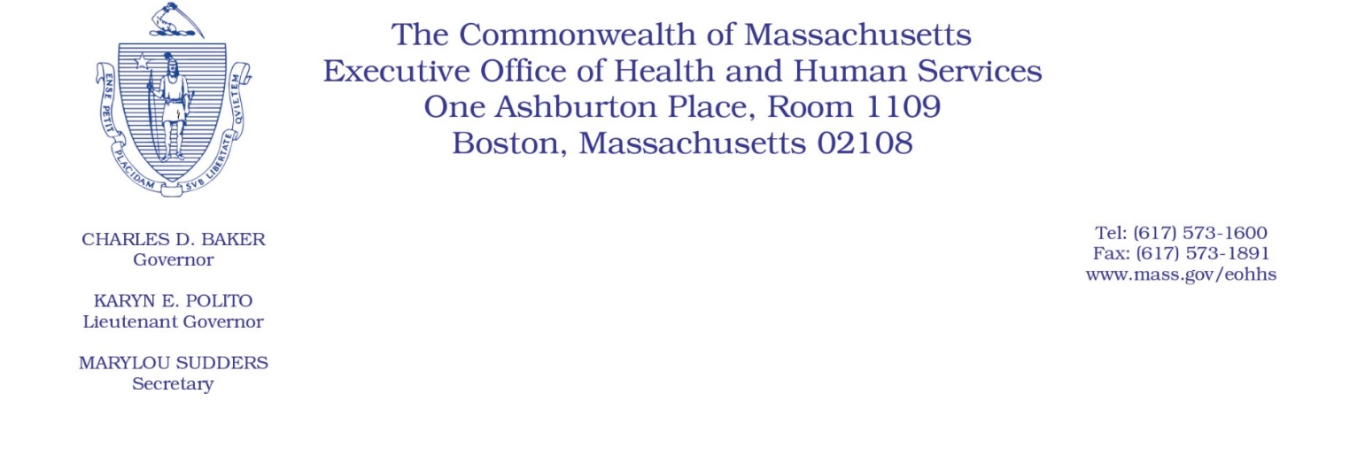

Administrative Bulletin 20-25

101 CMR 309.00: Rate for Certain Services for the Personal Care Attendant Program

Eff. April 16, 2020

Rate Adjustment Applicable to Certain Personal Care Attendant Services to Address Costs

Associated with COVID-19 Public Health Emergency

Purpose, Scope, and Effective Period

The Executive Office of Health and Human Services (EOHHS) is issuing this administrative bulletin pursuant to the authority of COVID-19 Order No. 20: Order Authorizing the Executive Office of Health and Human Services to Adjust Essential Provider Rates During the COVID-19 Public Health Emergency and Executive Order 591: Declaration of State of Emergency to Respond to COVID-19. In light of the state of emergency declared in the Commonwealth due to COVID-19, EOHHS, which administers the Massachusetts Medicaid program known as “MassHealth,” is temporarily adjusting rates for certain MassHealth-covered Personal Care Attendant (PCA) services established in 101 CMR 309.00, as amended pursuant to the authority of Administrative Bulletin 19-14, and as further described in this administrative bulletin. If a rate is not being updated pursuant to this administrative bulletin, the rate remains at the currently established rate.

This administrative bulletin is effective for dates of service from April 1, 2020, through July 31, 2020.

Disclaimer: This administrative bulletin is not authorization for a provider’s use of the adjusted rate or service. Authorization for the provision of, and billing and payment for, PCA services are pursuant to the MassHealth PCA Program regulations at 130 CMR 422.000.

Background
The COVID-19 public health emergency has unexpectedly increased the need for PCA services and has also made the delivery of these service more difficult and costly. Existing service rates do not contemplate these increased costs and changes in utilization patterns. Accordingly, EOHHS is establishing adjusted rates as described below that address the increased costs related to COVID-19 and to ensure the continued delivery of these critical services.

Updated Rates for Certain PCA Services to Address Costs Associated with COVID-19

Code | Modifier | Current Rate | Updated Rate | Unit | Service Description
T1019 |  | $4.36 | $4.75 | 15 minutes | Personal care services, per 15 minutes, not for an inpatient or resident of a hospital, nursing facility, ICF/ID or IMD, part of the individualized plan of treatment (code may not be used to identify services provided by home health aide or certified nurse assistant) (PA) (Use this code to bill for PCA services provided during day or night.)
T1019 | TU | $2.18 | $2.37 | 15 minutes | Personal care services, per 15 minutes, not for an inpatient or resident of a hospital, nursing facility, ICF/ID or IMD, part of the individualized plan of treatment (code may not be used to identify services provided by home health aide or certified nurse assistant) Special payment rate, overtime (PA) (Use this code and modifier to bill for premium pay for overtime.)
T1019 | TV | $2.18 | $2.37 | 15 minutes | Personal care services, per 15 minutes, not for an inpatient or resident of a hospital, nursing facility, ICF/ID, or IMD, part of the individualized plan of treatment (code may not be used to identify services provided by home health aide or certified nurse assistant) Special payment rate, holidays (PA) (Use this code and modifier to bill for premium pay for holidays.)
99509 | U2 | $4.36 | $4.75 | 15 minutes | Home visit for assistance with activities of daily living and personal care (personal care services, per 15 minutes) (Use this code and modifier to bill for PCA paid earned time.) (Current PA for PCA services required for each member.)
99509 | U3 | $52.36 | $57.60 | Per diem | Home visit for assistance with activities of daily living and personal care (personal care services) (Use this code and modifier to bill for PCA new hire orientation, per diem, per eligible PCA.)
99509 | TU | $0.15 | $0.16 | 1 minute | Home visit for assistance with activities of daily living and personal care (personal care services) (Use this code and modifier to bill for overtime, per 1 minute, special payment rate.) (Current PA for PCA services required for each member.)
A0170 |  | $0.29 | $0.32 | 1 minute | Transportation ancillary: parking fees, tolls, other (Use this code to bill for travel time for PCA services, per 1 minute.) (Current PA for PCA services required for each member.)

Breakout of PCA rate adjustment pursuant to this administrative bulletin:

PCA Rate Component | PCA Rate (Hourly) | Premium Pay Rate for Overtime and Premium Holiday Rate (Hourly)
PCA Wage Component | $16.94 | $25.41
Employer Expense Component | $2.05 | $3.08
Total PCA Rate | $18.99 | $28.49

Public Comment
EOHHS will accept comments on the rate established via this administrative bulletin through April 30, 2020. Individuals may submit written comments by emailing ehs-regulations@state.ma.us. Please submit written comments as an attached Word document or as text within the body of the email with the name of this administrative bulletin in the subject line. All submissions of comments must include the sender’s full name, mailing address, and organization or affiliation, if any. Individuals who are unable to submit comments by email may mail written comments to EOHHS, c/o D. Briggs, 100 Hancock Street, 6th Floor, Quincy, MA 02171.
EOHHS may adopt a revised version of this administrative bulletin taking into account relevant comments and any other practical alternatives that come to its attention.

