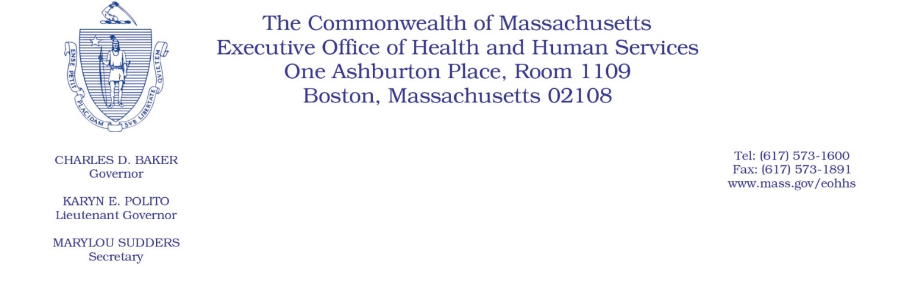

Administrative Bulletin 20-26

101 CMR 304.00: Rates for Community Health Centers

Eff. April 16, 2020

Supplemental Payment Methodology Applicable to Community Health Centers During the

COVID-19 Public Health Emergency

Purpose, Scope, and Effective Period

The Executive Office of Health and Human Services (EOHHS) is issuing this administrative bulletin pursuant to the authority of COVID-19 Order No. 20: Order Authorizing the Executive Office of Health and Human Services to Adjust Essential Provider Rates During the COVID-19 Public Health Emergency and Executive Order 591: Declaration of State of Emergency to Respond to COVID-19. In light of the state of emergency declared in the Commonwealth due to COVID-19, EOHHS, which administers the Massachusetts Medicaid program known as “MassHealth,” is establishing supplemental payments for community health centers, notwithstanding 101 CMR 304.00: Rates for Community Health Centers, as further described in this administrative bulletin. If a rate or payment methodology is not being updated pursuant to this administrative bulletin, the rate or payment methodology remains as established.

This administrative bulletin is effective for dates of service from April 1, 2020, through July 31, 2020.

Disclaimer: This administrative bulletin is not authorization for a provider’s use of the updated rate or service. Authorization for the provision of, and billing and payment for, community health center services are pursuant to the MassHealth community health center regulations at 130 CMR 405.00: Community Health Center Services, and other applicable MassHealth provider regulations.

Background
Community health centers provide essential services to members, including primary and preventative physical and mental health care services, in community settings. As a result of the COVID-19 public health emergency, EOHHS recognizes that necessary social distancing protocols have caused community health centers to modify the manner in which they deliver services, and have caused disruption to their normal course of operation.

These changes in utilization patterns and the need for alternative methods of care delivery have resulted in fiscal distress for many community health centers. Accordingly, EOHHS is establishing supplemental payments, as described below, to help maintain continued access to care at community health centers as they adjust to these changes resulting from the COVID-19 public health emergency.

Supplemental Payment Methodology

MassHealth will pay each community health center a monthly supplemental payment for four consecutive calendar months, beginning April 2020. A community health center’s monthly supplemental payment will be equal to a portion of that community health center’s average monthly claims paid by MassHealth and MassHealth Managed Care Entities, as determined by EOHHS, for dates of service beginning July 1, 2018, through June 30, 2019 (collectively, “fiscal year 2019 MassHealth payments”). Specifically, each community health center will receive facility-specific supplemental payments equal to the sum of the following:

- 43% of the community health center’s average monthly fiscal year 2019 MassHealth payments for the following services: Individual medical visit (T1015); Group medical visit (T1015-HQ); Nurse-midwife medical visit (T1015-TH); Child individual mental health visits by new and established patients (G0469); Adult mental health visits by new and established patients (G0470); Early and Periodic Screening, Diagnosis and Treatment Services (99281-99395); Urgent care visits (99050); and Pharmacy and outpatient behavioral health services covered under 130 CMR 405.000; and

- 80% of the community health center’s average monthly fiscal year 2019 MassHealth payments for all other services covered under 130 CMR 405.000.

Public Comment
EOHHS will accept comments on the rate methodology established via this administrative bulletin through April 30, 2020. Individuals may submit written comments by emailing ehs-regulations@state.ma.us. Please submit written comments as an attached Word document or as text within the body of the email with the name of this administrative bulletin in the subject line. All submissions of comments must include the sender’s full name, mailing address, and organization or affiliation, if any. Individuals who are unable to submit comments by email may mail written comments to EOHHS, c/o D. Briggs,100 Hancock Street, 6th Floor, Quincy, MA 02171.
EOHHS may adopt a revised version of this administrative bulletin taking into account relevant comments and any other practical alternatives that come to its attention.

