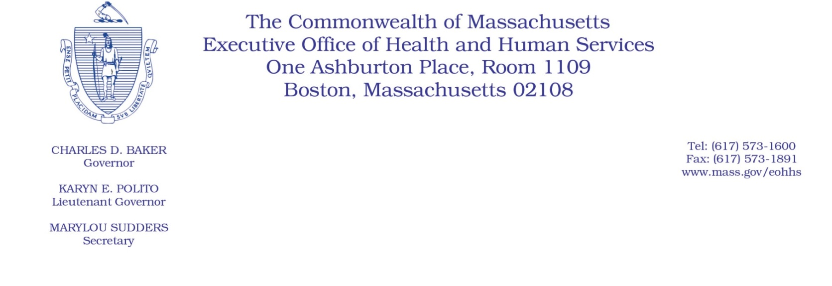
Administrative Bulletin 20-28
101 CMR 358.00: Rates of Payment for Applied Behavior Analysis
Effective April 16, 2020

Rate Update Applicable to Certain Applied Behavior Analysis Services During the Coronavirus Disease 2019 (COVID-19) Public Health Emergency

Purpose, Scope, and Effective Period
The Executive Office of Health and Human Services (EOHHS) is issuing this administrative bulletin pursuant to the authority of COVID-19 Order No. 20: Order Authorizing the Executive Office of Health and Human Services to Adjust Essential Provider Rates During the COVID-19 Public Health Emergency and Executive Order 591: Declaration of State of Emergency to Respond to COVID-19. In light of the state of emergency declared in the Commonwealth due to COVID-19, EOHHS, which administers the Massachusetts Medicaid and Children’s Health Insurance Program (CHIP) known as “MassHealth,” is establishing increased rates for certain MassHealth-covered Applied Behavior Analysis (ABA) services established in 101 CMR 358.00: Rates of Payment for Applied Behavior Analysis and as further described in this administrative bulletin. If a rate is not being updated pursuant to this administrative bulletin, the rate remains at the currently established rate.
This administrative bulletin is effective for dates of service from April 1, 2020, through July 31, 2020.
Disclaimer: This administrative bulletin is not authorization for a provider’s use of the updated rates or services. Authorization for the provision of, and billing and payment for, ABA services are pursuant to the applicable MassHealth programmatic requirements.

Background
ABA services are provided to MassHealth members under the age of 21 with Autism Spectrum Disorder. ABA providers use a multi-pronged approach to treat challenging behaviors that interfere with successful functioning for these members. As a result of the COVID-19 public health emergency, EOHHS recognizes there are concerns about the cost to ABA providers in continuing to provide ABA services to MassHealth members. These concerns include the potential for increased staffing costs, equipment, and other costs, including costs associated with the expansion of delivery of services via telehealth to support access in the communities the ABA providers serve, and other concerns resulting from the COVID-19 emergency.
EOHHS seeks to promote continued delivery of these critical services to MassHealth members through providing additional financial support to ABA providers for these additional costs and concerns. Accordingly, EOHHS is establishing updated rates as described below.

Updated Rates for Certain ABA Services to Address Concerns Related to COVID-19
To support ABA providers during the COVID-19 emergency, for dates of service from April 1, 2020, through July 31, 2020, EOHHS will increase rates for certain MassHealth-covered ABA services by 10% above current rates.
The following fee schedule identifies the services and new rates:
Code | Payment Rate | Service Description
H2019-U2 | $16.20 | Therapeutic behavioral services, per 15 minutes (Direct instruction by a paraprofessional working under the supervision of a licensed professional.)
H2012-U2 | $122.50 | Behavioral health day treatment, per hour (Direct instruction by a licensed professional/parent training for home services by a licensed professional.)
H0031-U2 | $30.62 | Mental health assessment, by nonprofessional (Assessment and case planning for home services by a licensed professional. 15-minute rate.)
H0032-U2 | $30.62 | Mental health service plan development by nonphysician (Supervision for home services by a licensed professional. 15-minute rate.)

Public Comment
EOHHS will accept comments on the rates established via this administrative bulletin through April 30, 2020. Individuals may submit written comments by emailing: ehs-regulations@state.ma.us. Please submit written comments as an attached Word document or as text within the body of the email with the name of this administrative bulletin in the subject line. All submissions of comments must include the sender’s full name, mailing address, and organization or affiliation, if any. Individuals who are unable to submit comments by email may mail written comments to EOHHS, c/o D. Briggs, 6th Floor, 100 Hancock Street, Quincy, MA 02171.
EOHHS may adopt a revised version of this administrative bulletin taking into account relevant comments and any other practical alternatives that come to its attention.

