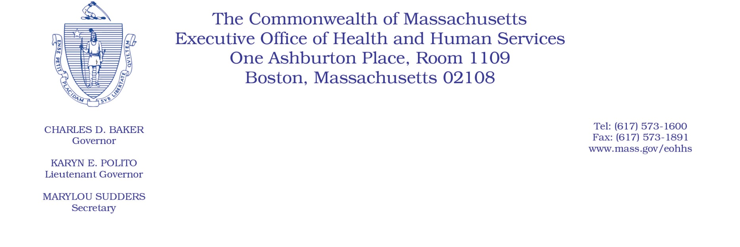

Administrative Bulletin 20-32

101 CMR 329.00: Psychological Testing, Treatment, and Related Services

Effective April 23, 2020
Rate Update Applicable to Certain Psychological Services During the Coronavirus Disease 2019
(COVID-19) Public Health Emergency

Purpose, Scope, and Effective Period
The Executive Office of Health and Human Services (EOHHS) is issuing this administrative bulletin pursuant to the authority of COVID-19 Order No. 20: Order Authorizing the Executive Office of Health and Human Services to Adjust Essential Provider Rates During the COVID-19 Public Health Emergency and Executive Order 591: Declaration of State of Emergency to Respond to COVID-19. In light of the state of emergency declared in the Commonwealth due to COVID-19, EOHHS, which administers the Massachusetts Medicaid program and Children’s Health Insurance Program (CHIP) known as “MassHealth,” is establishing increased rates for certain MassHealth-covered psychological services established in 101 CMR 329.00: Psychological Testing, Treatment, and Related Services and as further described in this administrative bulletin. If a rate is not being updated pursuant to this administrative bulletin, the rate remains at the currently established rate.
This administrative bulletin is effective for dates of service from April 1, 2020, through July 31, 2020.
Disclaimer: This administrative bulletin is not authorization for a provider’s use of the updated rate or service. Authorization for the provision of, and billing and payment for, psychological services is pursuant to the applicable MassHealth programmatic requirements.
Background
Psychologists provide critical services to MassHealth members, including evaluation of aspects of a member’s functioning, including aptitudes, educational achievements, cognitive processes, emotional conflicts, and type and degree of psychopathology. As a result of the COVID-19 public health emergency, EOHHS recognizes there are concerns about the cost to psychologists in continuing to provide services to MassHealth members. These concerns include the capacity for MassHealth psychologists to meet increased referral demand that may occur during the COVID-19 emergency. In the face of higher demand and in order to support access in the communities they serve, psychologists may face increased costs, including costs associated with the expansion of delivery of services via telehealth and other concerns resulting from the COVID-19 emergency. EOHHS seeks to promote continued delivery of these critical services to MassHealth members through providing additional financial support to psychologists for these additional costs and concerns. Accordingly, EOHHS is establishing updated rates as described below.
Updated Rates for Certain Psychological Services to Address Concerns Related to COVID-19
To support psychologists during the COVID-19 emergency, for dates of service from April 1, 2020, through July 31, 2020, EOHHS will increase rates for certain MassHealth-covered psychological services by 10% above current rates.
The following fee schedule identifies the services and new rates.
Code | Rate | Unit | Service Description
96130 | $116.35 | 1 | Psychological testing evaluation services by physician or other qualified health care professional, including integration of patient data, interpretation of standardized test results and clinical data, clinical decision making, treatment planning and report and interactive feedback to the patient, family member(s) or caregiver(s), when performed; first hour. (not to exceed one unit)
96131 | $88.46 | 1-7 | Each additional hour. (List separately in addition to code for primary procedure.) (Add-on code to 96130 – not to exceed seven one-hour units)
96132 | $131.88 | 1 | Neuropsychological testing evaluation services by physician or other qualified health care professional, including integration of patient data, interpretation of standardized test results and clinical data, clinical decision making, treatment planning and report and interactive feedback to the patient, family member(s) or caregiver(s), when performed; first hour (not to exceed one unit)
96133 | $100.57 | 1-7 | Each additional hour. (List separately in addition to code for primary procedures.) (Add-on code to 96132 – not to exceed seven one hour units)
96136 | $48.48 | 1 | Psychological or neuropsychological test administration and scoring by physician or other qualified health care professional, two or more tests, any method; first 30 minutes (not to exceed one thirty-minute unit).
96137 | $45.00 | 1-11 | Each additional 30 minutes. (List separately in addition to code for primary procedure.) (Add-on code to 96136 – not to exceed eleven thirty-minute units)
96138 | $40.85 | 1 | Psychological or neuropsychological test administration and scoring by technician, two or more tests, any method; first 30 minutes – not to exceed one thirty-minute unit)
96139 | $40.85 | 1-11 | Psychological or neuropsychological test administration and scoring by technician, two or more tests, any method; each additional 30 minutes. (List separately in addition to code for primary procedure.) (Add-on code to 96138 – not to exceed eleven thirty minute units)
Public Comment
EOHHS will accept comments on the rate established via this administrative bulletin through May 7, 2020.
Individuals may submit written comments by emailing them to ehs-regulations@state.ma.us. Please submit written comments as an attached Word document or as text within the body of the email with the name of this administrative bulletin in the subject line. All submissions of comments must include the sender’s full name, mailing address, and organization or affiliation, if any. Individuals who are unable to submit comments by email may mail written comments to EOHHS, c/o D. Briggs, 100 Hancock Street, 6th Floor, Quincy, MA 02171.
EOHHS may adopt a revised version of this administrative bulletin, taking into account relevant comments and any other practical alternatives that come to its attention.

