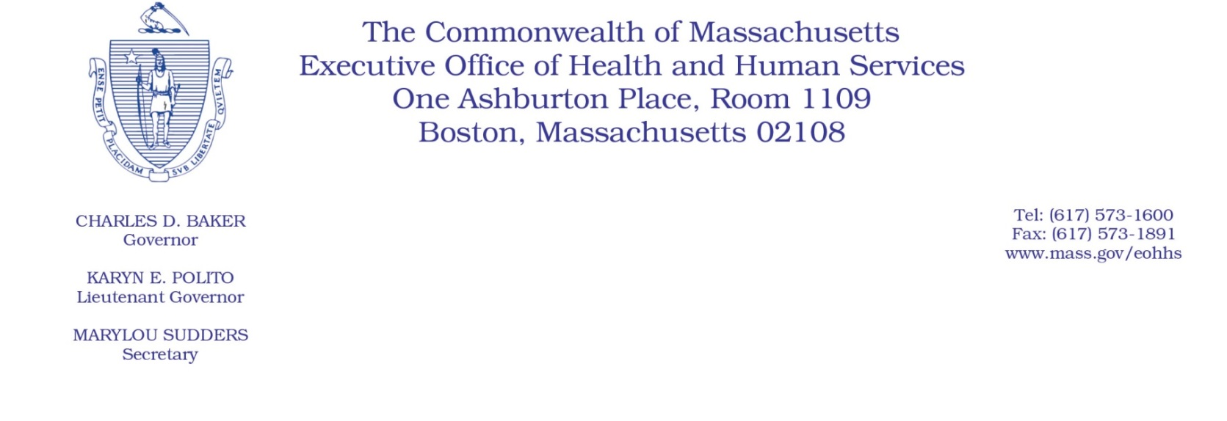
Administrative Bulletin 20-34
101 CMR 348.00: Day Habilitation Program Services
Effective April 23, 2020

Additional Rate Provisions Applicable to Certain Day Habilitation Program Providers to Compensate for Costs Associated with Coronavirus Disease 2019 (COVID-19)

Purpose, Scope, and Effective Period
The Executive Office of Health and Human Services (EOHHS) is issuing this administrative bulletin pursuant to the authority of COVID-19 Order No. 20: Order Authorizing the Executive Office of Health and Human Services to Adjust Essential Provider Rates During the COVID-19 Public Health Emergency and Executive Order 591: Declaration of State of Emergency to Respond to COVID-19. In light of the state of emergency declared in the Commonwealth due to COVID-19, EOHHS, which administers the Massachusetts Medicaid program known as “MassHealth,” is establishing additional rate provisions under 101 CMR 310: Rates for Day Habilitation Services that address on-going fixed costs, retention of staff and required changes in service modalities for the provision of Day Habilitation services due to COVID-19, and as further described in this administrative bulletin.
This administrative bulletin is effective as of April 23, 2020, and shall apply to dates of services April 1, 2020, through June 30, 2020.
Disclaimer: This administrative bulletin is not authorization for a provider’s use of the adjusted rate or service. Authorization for the provision of, and billing and payment for, Day Habilitation services are pursuant to the MassHealth Day Habilitation regulations at 130 CMR 404.000.

Background
The COVID-19 public health emergency has required the temporary closure of Day Habilitation program sites and forced providers of Day Habilitation services to modify both the manner in which they deliver services and the hours and scope of their services. These changes in modality are not contemplated in the current rate methodologies and structures for Day Habilitation services under 101 CMR 310.00. Accordingly, EOHHS is establishing additional rate provisions under 101 CMR 310.00 that address on-going fixed costs, retention of staff and the changes in modality associated with COVID-19 and which will ensure the continued delivery of these critical services.

Additional Rate Provisions to Address COVID-19
The regulation at 101 CMR 310.03 is being temporarily expanded to include the following provisions, which are intended to address the required changes in service modality for Day Habilitation services as a result of COVID-19.
Note: Providers may have submitted claims prior to the issuance of formal guidance around retainer payments. For claims that were submitted for dates of service on or after April 1st, providers are required to void those claims and resubmit claims based on the guidance outlined in this administrative bulletin. Providers should no longer submit 15-minute unit claims for services provided via telehealth for dates of service April 1, 2020 through June 30, 2020.

- CMR 310.03 (d): Coronavirus Disease 2019 (COVID-19) Retainer Payments.
- Payment Methodology
- Retainer payments will be reimbursed on a per member, per day basis at 100% of the current per diem rate for Day Habilitation (DH) services.

- Providers should submit a per diem claim for a member for each day in which that member would have been scheduled to attend the provider’s DH program. Claims should be submitted using the modifier U7. For example, if a member was scheduled to attend a provider’s DH program on Mondays, Wednesdays, and Fridays, the provider should submit a per diem claim for Monday, Wednesday and Friday using the retainer modifier.
- Providers should submit claims for retainer payments to the appropriate payor.

- Retainer payments will be provided for claims dated April 1, 2020 – June 30, 2020.

- Eligibility for Retainer Payments
  - Providers are required to develop or amend day habilitation service plans (DHSPs) to meet the members’ needs while they remain home. The care plans must identify the types and anticipated frequency of engagements being provided by DH staff to the member during the COVID-19 public health emergency
  - A provider is eligible for retainer payments for a member during each month the provider engages with the member at least, but not limited to, once per week and where the provider retains sufficient staff to fulfill the requirements.

  - Engagements with members should ensure the on-going health and safety of members in their homes and minimize risk of decompensation and emergency service utilization. Member engagements may include, but are not limited to:
      - Checking for COVID-19 symptoms and triaging, as needed;
      - Coordinating care and activities of daily living (ADL), as well as instrumental activities of daily living (IADL) for members without formal supports at home;
      - Conducting mental and emotional wellness checks and supports;
      - Employing interventions to promote member orientation of person, place and time;
      - Monitoring and encouraging progress towards member’s day habilitation service plan goals;
      - Evaluate service need areas, such as self-help, sensory motor skills, communication, independent living, affective development, social and behavior development and wellness;
      - Providing caregiver support, especially for informal caregivers supporting the member
      - Providing caregiver support and supplying positive behavior support strategies.
  - For MassHealth Fee for Service (FFS) members: MassHealth will supply DH providers with a monthly form to be completed by the provider outlining when and how the provider engaged with each member for whom the provider submitted claims for retainer payments during that month. DH providers will be required to complete and submit the form to MassHealth each month and no later than 15 days after the end of the month.

Public Comment
EOHHS will accept comments on the rate established via this bulletin through May 7, 2020 Individuals may submit written comments by emailing: ehs-regulations@state.ma.us. Please submit written comments as an attached Word document or as text within the body of the email with the name of this bulletin in the subject line. All submissions of comments must include the sender’s full name, mailing address, and organization or affiliation, if any. Individuals who are unable to submit comments by email may mail written comments to EOHHS, c/o D. Briggs, 100 Hancock Street, Quincy, MA 02171.
EOHHS may adopt a revised version of this administrative bulletin taking into account relevant comments and any other practical alternatives that come to its attention.

