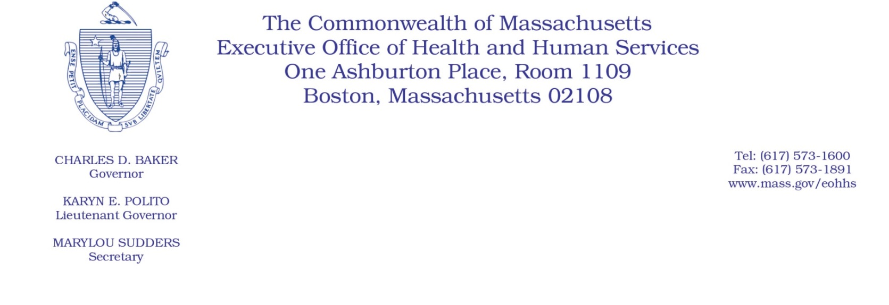
Administrative Bulletin 20-36
101 CMR 327.00: Rates of Payment for Ambulance and Wheelchair Van Services

Effective April 23, 2020

Procedure Code Update During the

Coronavirus Disease 2019 (COVID-19) Public Health Emergency

Purpose, Scope, and Effective Period
The Executive Office of Health and Human Services (EOHHS) is issuing this administrative bulletin pursuant to the authority of COVID-19 Order #20: Order Authorizing the Executive Office of Health and Human Services to Adjust Essential Provider Rates During the COVID-19 Public Health Emergency and Executive Order 591: Declaration of State of Emergency to Respond to COVID-19 and 101 CMR 327.01(5). EOHHS is adding a procedure code for non-emergency wheelchair van transport for a person under investigation or known to have COVID-19 at the rate set forth below. This rate will apply for individuals who can be safely transported in a wheelchair van regardless of whether or not they have mobility disability or are using a wheelchair.
This administrative bulletin is effective for dates of service from April 1, 2020, through July 31, 2020.
Disclaimer: This administrative bulletin is not authorization for a provider’s use of the new code. Authorization for the provision of, and billing and payment for, wheelchair van services are pursuant to the MassHealth transportation services regulations at 130 CMR 407.000: Transportation Services, and other applicable MassHealth provider regulations.

Background
Transportation providers will incur additional expenses to transport persons under investigation or known to have COVID-19, including providing drivers with personal protective equipment, cleaning and decontaminating vehicles, and compensating drivers. During the public health emergency it is critical that persons under investigation or known to have COVID-19 have access to medically necessary appointments. Accordingly, EOHHS is adding a new procedure code at the rate set forth below for non-emergency wheelchair van transport for a person under investigation or known to have COVID-19.

New Procedure Code and Rate
For dates of service from April 1, 2020, through July 31, 2020, the following billing code is added under “Allowable Trip Fees for Wheelchair Van Services”
Code | Description | Rate Effective for April 1, 2020, through July 31, 2020
A0120 | Nonemergency transportation: mini-bus, mountain area transports, or other transportation systems. (Each way. Used only for non-emergency wheelchair van transport for a person under investigation or known to have COVID-19.) | $100.00

Public Comment
EOHHS will accept comments on the payment rate established via this administrative bulletin through May 7, 2020. Individuals may submit written comments by emailing ehs-regulations@state.ma.us. Please submit written comments as an attached Word document or as text within the body of the email with the name of this administrative bulletin in the subject line. All submissions of comments must include the sender’s full name, mailing address, and organization or affiliation, if any. Individuals who are unable to submit comments by email may mail written comments to EOHHS, c/o D. Briggs, 100 Hancock Street, Quincy, MA 02171.
EOHHS may adopt a revised version of this administrative bulletin taking into account relevant comments and any other practical alternatives that come to its attention.

