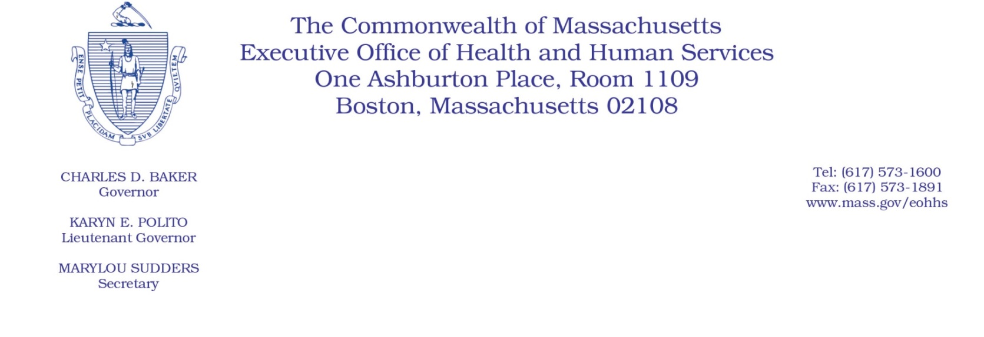
Administrative Bulletin 20-37
101 CMR 206.00: Standard Payments to Nursing Facilities
Effective April 24, 2020

Supplemental Payment Methodology Applicable to Certain Nursing Facilities During the Coronavirus Disease 2019 (COVID-19) Public Health Emergency

Purpose, Scope, and Effective Period
The Executive Office of Health and Human Services (EOHHS) is issuing this administrative bulletin pursuant to the authority of COVID-19 Order No. 20: Order Authorizing the Executive Office of Health and Human Services to Adjust Essential Provider Rates During the COVID-19 Public Health Emergency and Executive Order 591: Declaration of State of Emergency to Respond to COVID-19. In light of the state of emergency declared in the Commonwealth due to COVID-19, EOHHS, which administers the Massachusetts Medicaid program known as “MassHealth,” is establishing supplemental payments for certain MassHealth-covered nursing facility services, notwithstanding 101 CMR 206.00: Standard Payments to Nursing Facilities, as further described in this administrative bulletin.
The supplemental payments established by this administrative bulletin will remain effective for the duration of COVID-19 Order No. 20, provided that notwithstanding the expiration of COVID-19 Order No. 20, the supplemental payments described in this administrative bulletin will continue to be paid to eligible nursing facilities in accordance with the methodology described herein.
Disclaimer: This administrative bulletin is not authorization for a provider’s use of the updated rate or service. Authorization for the provision of, and billing and payment for, nursing facility services provided in isolation spaces are pursuant to MassHealth Nursing Facility Bulletin 144: Isolated Spaces for Nursing Facility Residents with a Positive Coronavirus Disease 2019 (COVID-19) Diagnosis.

Background
As a result of the COVID-19 public health emergency, MassHealth is implementing measures to expand access to nursing facility care for individuals diagnosed with COVID-19 and prevent the spread of the virus. Specifically, MassHealth established criteria, through MassHealth Nursing Facility Bulletin 144, for qualifying nursing facilities to designate wings, units, or floors as “isolation spaces.” Such isolation spaces are intended to provide nursing facility services to COVID-19 positive residents, while ensuring all necessary precautions are taken to protect nursing facility residents without a positive diagnosis from exposure. In order to qualify to operate such an isolation space and receive the associated monthly supplemental payments under this administrative bulletin, a nursing facility provider must meet the substantive criteria established and submit an attestation of compliance with those criteria in the form and manner specified in MassHealth Nursing Facility Bulletin 144.
EOHHS recognizes the additional cost of care associated with establishing dedicated isolation spaces in nursing facilities, such as hiring additional staff, implementing additional screening and sanitation measures, or caring for residents with higher acuity. Accordingly, EOHHS is establishing monthly supplemental payments to eligible nursing facilities that have established qualifying isolation spaces, as described below.

Calculation and Distribution of Supplemental Payments
EOHHS will calculate the payment for each qualifying nursing facility provider as follows:
- An eligible nursing facility’s monthly supplemental payment will be based on the nursing facility’s average daily number of Massachusetts Medicaid Days, as reported by the nursing facility on their Quarterly User Fee Assessment Forms for the period of October 1, 2018, through September 30, 2019, and the number of days in the previous month that the nursing facility operated an isolation space. A nursing facility will be deemed to operate an isolation space beginning on the day the nursing facility submits the attestation of compliance to MassHealth (assuming such attestation is ultimately accepted by MassHealth), until the earlier of one month after the last day of the state of emergency or the day that the nursing facility ceases to meet the substantive requirements set forth in MassHealth Nursing Facility Bulletin 144.

- The monthly supplemental payment for each eligible nursing facility will be calculated as follows:
  - Divide the nursing facility’s total number of Massachusetts Medicaid Days, as reported on their Quarterly User Fee Assessment Forms for the period of October 1, 2018, through September 30, 2019, by 365;
  - Multiply the quotient calculated in Paragraph 2.a. by the number of days that the nursing facility operated an isolation space in the previous month;
  - Multiply the product calculated in Paragraph 2.b. by $30;
  - The product calculated in Paragraph 2.c. will equal the nursing facility’s monthly supplemental payment.

- EOHHS will disburse monthly supplemental payments to nursing facility providers, calculated under Paragraph 2, above, by the fifteenth day of each month, beginning in May 2020. Such monthly supplemental payments will continue each calendar month until the calendar month following the day that the nursing facility ceases to operate an isolation space under Paragraph 1, above.

- A nursing facility operating as a COVID-19 Nursing Facility under Administrative Bulletin 20-19: Payments for COVID-19 Nursing Facilities will not be eligible for supplemental payments under this administrative bulletin.

Public Comment
EOHHS will accept comments on the payment methodologies established via this administrative bulletin through May 8, 2020. Individuals may submit written comments by emailing: ehs-regulations@state.ma.us. Please submit written comments as an attached Word document or as text within the body of the email with the name of this bulletin in the subject line. All submissions of comments must include the sender’s full name, mailing address, and organization or affiliation, if any. Individuals who are unable to submit comments by email may mail written comments to EOHHS, c/o D. Briggs, 100 Hancock Street, 6th Floor, Quincy, MA 02171.
EOHHS may adopt a revised version of this administrative bulletin taking into account relevant comments and any other practical alternatives that come to its attention.

