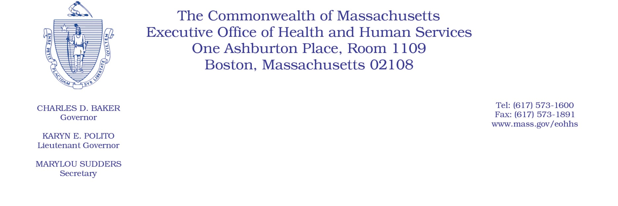

Administrative Bulletin 20-46

101 CMR 358.00: Rates of Payment for Applied Behavior Analysis

Effective May 11, 2020
Rate Update Applicable to Certain Applied Behavior Analysis Services During the Coronavirus Disease 2019 (COVID-19) Public Health Emergency
Purpose, Scope, and Effective Period
The Executive Office of Health and Human Services (EOHHS) is issuing this administrative bulletin pursuant to the authority of COVID-19 Order No. 20: Order Authorizing the Executive Office of Health and Human Services to Adjust Essential Provider Rates During the COVID-19 Public Health Emergency and Executive Order 591: Declaration of State of Emergency to Respond to COVID-19. In light of the state of emergency declared in the Commonwealth due to COVID-19, EOHHS, which administers the Massachusetts Medicaid and Children’s Health Insurance Program (CHIP) known as “MassHealth,” is updating codes and establishing rates for certain MassHealth-covered Applied Behavior Analysis (ABA) services established in 101 CMR 358.00: Rates of Payment for Applied Behavior Analysis and as further described in this administrative bulletin. If a rate is not being updated pursuant to this administrative bulletin, the rate remains at the currently established rate.
This administrative bulletin is effective as of May 11, 2020, and will apply for dates of service from May 11, 2020, through July 31, 2020.
Disclaimer: This administrative bulletin is not authorization for a provider’s use of the updated rates or services. Authorization for the provision of, and billing and payment for, ABA services are pursuant to the applicable MassHealth programmatic requirements.
Background
ABA services are provided to MassHealth members under the age of 21 with Autism Spectrum Disorder. ABA providers use a multi-pronged approach to treat challenging behaviors that interfere with successful functioning for these members. As a result of the COVID-19 public health emergency, EOHHS recognizes the challenge of providing parent support at a minimum of one hour to MassHealth members, as currently allowed under the regulations.

EOHHS seeks to promote continued delivery of parent support within ABA services to MassHealth members through allowing providers to provide parent support in 15-minute units. Accordingly, EOHHS is establishing a new rate as described below.

Updated Rates for Certain ABA Services to Address Concerns Related to COVID-19
To promote flexibility in the delivery of ABA services during the COVID-19 emergency, effective May 11, 2020, EOHHS will add a CPT code to allow providers to bill for time spent providing parent support in 15-minute units.
The following fee schedule identifies the services and new rates:

Code | Payment Rate | Service Description
97156 | $30.62 | Family adaptive behavior treatment guidance, administered by a licensed professional (with or without the patient present), face-to-face with guardian(s)/caregiver(s), every 15 minutes.

Public Comment
EOHHS will accept comments on the additional rate established via this administrative bulletin through May 25, 2020. Individuals may submit written comments by emailing: ehs-regulations@state.ma.us.
Please submit written comments as an attached Word document or as text within the body of the email with the name of this administrative bulletin in the subject line. All submissions of comments must include the sender’s full name, mailing address, and organization or affiliation, if any. Individuals who are unable to submit comments by email may mail written comments to EOHHS, c/o D. Briggs, 6th Floor, 100 Hancock Street, Quincy, MA 02171.
EOHHS may adopt a revised version of this administrative bulletin taking into account relevant comments and any other practical alternatives that come to its attention.

