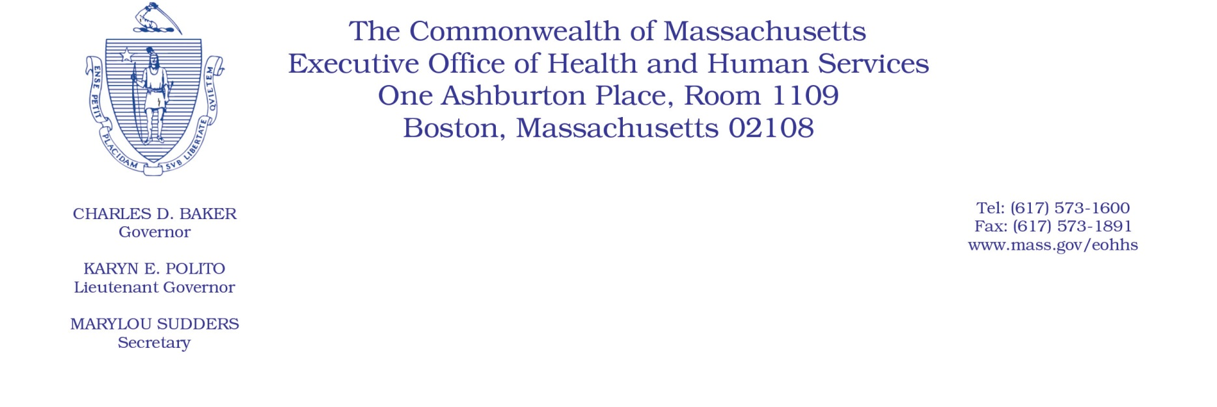

Administrative Bulletin 20-49

101 CMR 613.00: Health Safety Net Eligible Services

Effective May 13, 2020
Health Safety Net Coverage and Reimbursement Policy for Pharmacy Services During the Coronavirus Disease 2019 (COVID-19) Public Health Emergency
Purpose, Scope, and Effective Period
The Executive Office of Health and Human Services (EOHHS) is issuing this administrative bulletin pursuant to the authority of Executive Order 591: Declaration of State of Emergency to Respond to COVID-19. In light of the state of emergency declared in the Commonwealth due to COVID-19, EOHHS, which administers the Health Safety Net program, is introducing additional flexibilities for pharmacy coverage and billing for individuals who are Health Safety Net patients as further described in this administrative bulletin.
This administrative bulletin applies to acute care hospitals and community health centers that are Health Safety Net providers and that operate both a 340B pharmacy and a retail pharmacy. It shall be effective for dates of service beginning April 13, 2020, and remain effective for the duration of the state of emergency declared via Executive Order No. 591: Declaration of a State of Emergency to Respond to COVID-19.
Background
The Health Safety Net program pays for certain health care services provided by acute care hospitals and community health centers to low-income uninsured and underinsured residents of Massachusetts. Acute care hospitals and community health centers that operate a 340B pharmacy are known as “340B providers” and may be paid for certain pharmacy services provided through their 340B pharmacy or retail pharmacy for their Health Safety Net patients. EOHHS recognizes that, as a result of the COVID-19 public health emergency, Health Safety Net patients may be forced to relocate due to a COVID-19 diagnosis or face new obstacles to obtaining care through their typical provider location due to social distancing recommendations. These COVID-19 related challenges hinder Health Safety Net patients’ access to needed pharmacy services. Accordingly, The Health Safety Net is introducing additional flexibilities for certain 340B providers to render pharmacy services to Health Safety Net patients to enhance access to pharmacy services during the public health emergency.
Temporary Flexibilities for Certain 340B Providers
In order to facilitate continued access to pharmacy services for Health Safety Net patients during the COVID-19 public health emergency, the Health Safety Net will temporarily ease certain limits on 340B providers that directly operate both a 340B and retail pharmacy. Specifically, for dates of service beginning April 13, 2020, and for the duration of the state of emergency, and notwithstanding 101 CMR 613.03(2)(c): 340B Pharmacies, the Health Safety Net will temporarily remove the limit on the number of times a 340B provider may fill prescriptions from its retail stock for Health Safety Net patients who are not the 340B provider’s regular patients. The 340B provider may bill the Health Safety Net for these medications at the retail rate, and subject to all other applicable requirements of 101 CMR 613.00: Health Safety Net Eligible Services and 101 CMR 614.00: Health Safety Net Payments and Funding.
Additional Information
For the latest MA-specific information, visit the following link: https://www.mass.gov/resource/information-on-the-outbreak-of-coronavirus-disease-2019-covid-19.
The latest Centers for Disease Control and Prevention (CDC) guidance for healthcare professionals is available at the following link: https://www.cdc.gov/coronavirus/2019-ncov/hcp/index.html.
Questions
If you have any questions about the information in this administrative bulletin, please contact the Health Safety Net at (800) 609-7232, or email your inquiry to HSNHelpdesk@state.ma.us.

