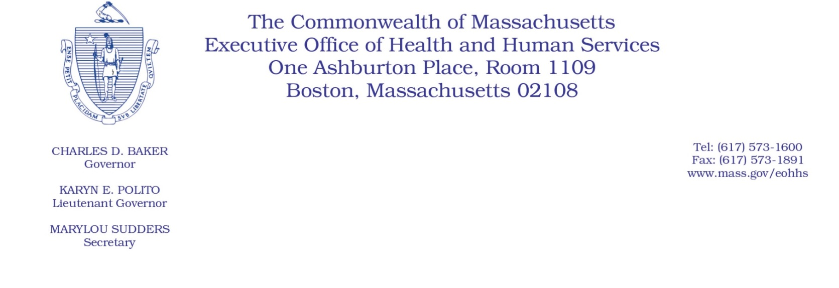
Administrative Bulletin 20-51
101 CMR 204.00: Rates of Payment to Resident Care Facilities

Effective May 14, 2020

COVID-19 Signing Bonuses for Resident Care Facility Staff

Purpose, Scope, and Effective Period
The Executive Office of Health and Human Services (EOHHS) is issuing this administrative bulletin pursuant to the authority of COVID-19 Order No. 20: Order Authorizing the Executive Office of Health and Human Services to Adjust Essential Provider Rates During the COVID-19 Public Health Emergency and Executive Order 591: Declaration of State of Emergency to Respond to COVID-19. In light of the state of emergency declared in the Commonwealth due to COVID-19, EOHHS is establishing supplemental payments for certain resident care facilities, notwithstanding 101 CMR 204.00: Rates of Payments to Resident Care Facilities, as further described in this administrative bulletin.
The supplemental payments established by this administrative bulletin will remain effective for the duration of COVID-19 Order No. 20, provided that notwithstanding the expiration of COVID-19 Order No. 20, the supplemental payments described in this bulletin will continue to be paid to eligible resident care facilities in accordance with the methodology described herein.
Disclaimer: This administrative bulletin is not authorization of a provider’s eligibility for the supplemental payments described herein. Eligibility for qualifying signing bonus supplemental payments made by resident care facilities are pursuant to EOHHS’s Resident Care Facility Bulletin 34: COVID-19 Signing Bonuses for Resident Care Facility Staff.

Background
As a result of the COVID-19 public health crisis, nursing facilities are facing higher patient volume and acuity, and staffing shortages are significant due to the increased patient needs and the increased risk of contracting the virus for staff providing such direct care. EOHHS recognizes that these factors have led to additional costs associated with hiring necessary direct care staff during this public health crisis. Accordingly, EOHHS is establishing supplemental payments for eligible resident care facilities that have paid qualifying signing bonuses to new employees, as described below. In order to qualify for supplemental payments under this administrative bulletin, a resident care facility provider must meet the substantive criteria established in EOHHS’s Resident Care Facility Bulletin 34 and submit an attestation of compliance with those criteria in the form and manner specified in EOHHS’s Resident Care Facility Bulletin 34.

Calculation and Distribution of Supplemental Payments
EOHHS will calculate the payment for each eligible resident care facility provider as follows.
- An eligible resident care facility’s supplemental payment will be based on the number of new direct care staff who received qualifying signing bonus payments from the resident care facility as well as the days and hours each new direct care staff member worked. The number of qualified signing bonus payments will be determined based on the successful submission of an attestation of compliance (which is ultimately accepted by EOHHS) and the number of qualifying hires listed in Table A submitted by the resident care facility in accordance with Resident Care Facility Bulletin 34.

- The supplemental payment for each eligible resident care facility will be calculated as follows:
  - The number of qualifying signing bonus payments paid by the facility for staff who worked for at least 64 hours at the facility within 15 days but who did not work 128 hours at the facility within 30 days multiplied by $500.
  - The number of qualifying signing bonus payments paid by the facility for staff who worked for at least 128 hours at the facility within 30 days multiplied by $1,000.
  - The supplemental payment for each eligible resident care facility will be equal to the sum of the products calculated in 2.a and 2.b above.

- EOHHS will disburse supplemental payments to eligible resident care facility providers, calculated under Paragraph 2, above, on or about August 15, 2020.

Public Comment
EOHHS will accept comments on the payment methodologies established via this administrative bulletin through May 28, 2020. Individuals may submit written comments by emailing: ehs-regulations@state.ma.us. Please submit written comments as an attached Word document or as text within the body of the email with the name of this bulletin in the subject line. All submissions of comments must include the sender’s full name, mailing address, and organization or affiliation, if any. Individuals who are unable to submit comments by email may mail written comments to Kara Solimini, Director of Purchase of Services, Executive Office of Health and Human Services, 100 Hancock Street, 6th Floor, Quincy, MA 02171.

EOHHS may adopt a revised version of this administrative bulletin taking into account relevant comments and any other practical alternatives that come to its attention.

