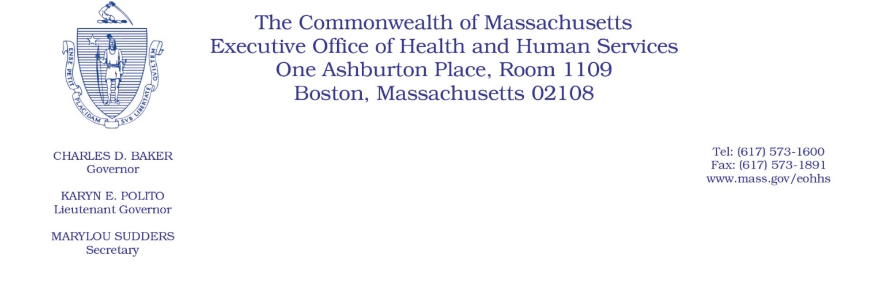

Administrative Bulletin 20-55

101 CMR 206.00: Standard Payments to Nursing Facilities

Eff. May 29, 2020

Supplemental Payments for Certain Nursing Facilities to Complete COVID-19 Baseline Testing Requirements During the Coronavirus Disease 2019 (COVID-19) Public Health Emergency

Purpose, Scope, and Effective Period

The Executive Office of Health and Human Services (EOHHS) is issuing this administrative bulletin pursuant to the authority of COVID-19 Order No. 20: Order Authorizing the Executive Office of Health and Human Services to Adjust Essential Provider Rates During the COVID-19 Public Health Emergency and Executive Order 591: Declaration of State of Emergency to Respond to COVID-19. In light of the state of emergency declared in the Commonwealth due to COVID-19, EOHHS, which administers the Massachusetts Medicaid program known as “MassHealth,” is establishing supplemental payments for certain nursing facilities, notwithstanding 101 CMR 206.00: Standard Payments to Nursing Facilities, as further described in this administrative bulletin.

The supplemental payments established by this administrative bulletin will remain effective for the duration of COVID-19 Order No. 20.

Disclaimer: This administrative bulletin is not authorization of a provider’s eligibility for the supplemental payments described herein. Eligibility for qualifying COVID-19 testing supplemental payments made by nursing facilities are pursuant to MassHealth Nursing Facility Bulletin 146: COVID-19 Baseline Testing Requirements for Nursing Facilities.

Background
As a result of the COVID-19 public health crisis, nursing facilities are facing high infection rates, high staff turnover, and more severe cases of COVID-19 due to their higher-risk populations. EOHHS recognizes that to protect residents and staff from the virus, testing must be completed to ensure that appropriate precautions can be taken to contain the virus. Therefore, EOHHS is requiring, through MassHealth Nursing Facility Bulletin 146, that nursing facilities complete baseline testing of both residents and staff by May 25, 2020. EOHHS is establishing a supplemental payment to be paid to nursing facilities to facilitate the completion of such testing, as further described in this administrative bulletin. In order to qualify for a supplemental payment under this administrative bulletin, a nursing facility provider must a use facility-organized testing method described in MassHealth Nursing Facility Bulletin 146 and meet the reporting and attestation requirements established in MassHealth Nursing Facility Bulletin 146.

Calculation and Distribution of Supplemental Payments

EOHHS will calculate the payment for each eligible nursing facility provider as follows:

- An eligible nursing facility’s supplemental payment will be based on the number of completed qualifying COVID-19 baseline tests that were administered using a facility-organized testing method described in MassHealth Nursing Facility Bulletin 146 and in Section 2 of this administrative bulletin.

- Completed qualifying COVID-19 baseline tests that were administered using a facility-organized testing method shall include tests:
  - That were administered between:
    - April 27, 2020, and May 10, 2020, regardless of whether the facility also received COVID-19 testing using a state-directed testing method described in MassHealth Nursing Facility Bulletin 146 during that time; and
    - May 11, 2020, and May 25, 2020, provided that the facility did not also receive COVID-19 testing using a state-directed testing method described in MassHealth Nursing Facility Bulletin 146 during that time.
  - That were administered on staff or residents who had not previously been tested for COVID-19 between April 8, 2020, and May 25, 2020;
  - That were not administered using a state-directed testing method described in MassHealth Nursing Facility Bulletin 146;
  - That were not facilitated by a staff member or resident on their own or without coordination by the facility, including tests completed during a staff member’s or resident’s hospital or primary care practitioner visit;
  - That were actually procured, organized, or secured by the facility for its staff or residents;
  - That included the collection of specimens sufficient for diagnostic testing, the processing of a COVID-19 diagnostic test by a qualified laboratory (which may include the State Public Health Laboratory), and the furnishing of results in accordance with MassHealth Nursing Facility Bulletin 146;
  - That were reported, in accordance with MassHealth Nursing Facility Bulletin 146, as tests administered on the nursing facility’s staff or residents using a facility-organized testing method, and such report was attested to in accordance with MassHealth Nursing Facility Bulletin 146; and
  - For which results were reported by the nursing facility as either positive, negative, or inconclusive; provided that if EOHHS determines that the rate of inconclusive test results is unreasonably high, EOHHS may exclude those inconclusive results from the number of completed qualifying COVID-19 baseline tests that were administered using a facility-organized testing method when calculating the supplemental payment under Section 3 of this administrative bulletin.

- The supplemental payment for each eligible nursing facility will be equal to the number of completed qualifying COVID-19 baseline tests administered through a facility-organized testing method, as such number is determined under Section 2 of this administrative bulletin, multiplied by $200.

- EOHHS will disburse supplemental payments to eligible nursing facility providers, calculated under Section 3 of this administrative bulletin on or about June 22, 2020.

Nursing facilities that utilize the state-directed methodology described in MassHealth Nursing Facility Bulletin 146 on or after May 11, 2020, will not be eligible for a supplemental payment under this administrative bulletin.

Public Comment
EOHHS will accept comments on the rate methodology established via this administrative bulletin through June 12, 2020. Individuals may submit written comments by emailing ehs-regulations@state.ma.us. Please submit written comments as an attached Word document or as text within the body of the email with the name of this administrative bulletin in the subject line. All submissions of comments must include the sender’s full name, mailing address, and organization or affiliation, if any. Individuals who are unable to submit comments by email may mail written comments to EOHHS, c/o D. Briggs, 100 Hancock Street, 6th Floor, Quincy, MA 02171.
EOHHS may adopt a revised version of this administrative bulletin taking into account relevant comments and any other practical alternatives that come to its attention.

