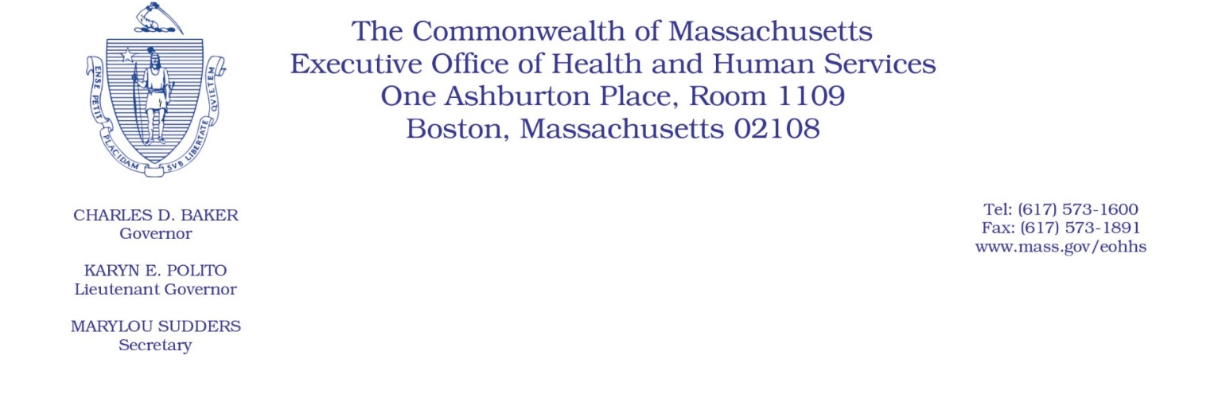

Administrative Bulletin 20-61
101 CMR 314.00: Dental Services

Effective June 16, 2020

Alternative Interim Payment Methodology Applicable to Dentists

Purpose, Scope, and Effective Period

The Executive Office of Health and Human Services (“EOHHS”) is issuing this administrative bulletin pursuant to the authority of COVID-19 Order No. 20: Order Authorizing the Executive Office of Health and Human Services to Adjust Essential Provider Rates During the COVID-19 Public Health Emergency and Executive Order 591: Declaration of State of Emergency to Respond to COVID-19. In light of the state of emergency declared in the Commonwealth due to COVID-19, EOHHS, which administers the Massachusetts Medicaid program known as “MassHealth,” is establishing an alternative interim payment methodology for dentists rendering services with rates established in 101 CMR 314.00: Dental Services (the “Dental Rate Regulation”), as further described in this administrative bulletin. If a rate or payment methodology is not being updated pursuant to this administrative bulletin, the rate or payment methodology remains as established.

This administrative bulletin is effective for dates of service beginning June 16, 2020, and shall remain effective for the duration of COVID-19 Order No. 20, provided, however, that the reconciliation of any interim payment made by EOHHS pursuant to this administrative bulletin may continue beyond the termination or expiration of that order, until the interim payment is fully reconciled in accordance with the process described in this administrative bulletin.

Disclaimer: This administrative bulletin is not authorization for a provider’s use of the updated rate or service. Authorization for the provision of, and billing and payment for, dental services are pursuant to the MassHealth dental program regulations at 130 CMR 420.000: Dental Services, and other applicable MassHealth provider regulations.

Background
Providers participating in the MassHealth Dental Program render a wide array of dental services (collectively, “Dental Services”) to MassHealth members. As a result of the COVID-19 public health emergency, EOHHS recognizes there are concerns about the ability of MassHealth members to continue to access these crucial Dental Services from these providers. Specifically, EOHHS recognizes that the financial stability of these providers is at risk because services must be canceled due to, among other things, limitations resulting from social distancing protocols. Additionally, providers rendering these Dental Services face additional financial pressure arising from changes in utilization patterns, and the need for alternative methods of care delivery resulting from the COVID-19 public health emergency. As a result, and as described in greater detail below, EOHHS is establishing an alternative interim payment methodology for providers rendering Dental Services who need immediate cash flow and financial support. All interim payments pursuant to this administrative bulletin will be subject to reconciliation, as explained in greater detail below.

To qualify for alternative interim payments under this administrative bulletin, a provider participating in the MassHealth Dental Program must meet the eligibility criteria set forth in MassHealth Dental Bulletin 47 and submit an attestation of compliance with those criteria in the form and manner specified in MassHealth Dental Bulletin 47.

Alternative Interim Payment Methodology and Reconciliation

- Alternative Interim Payment Methodology
Providers meeting the eligibility criteria set forth in MassHealth Dental Bulletin 47 may request an interim payment, using the attestation of compliance attached to MassHealth Dental Bulletin 47. Each such provider may request a single interim payment in an amount up to the lesser of:

- $500,000; or
- two months of the provider’s average monthly calendar year 2019 MassHealth payments for Dental Services. EOHHS will calculate this average monthly payment using the provider’s CY19 paid claims data residing in the Medicaid Management Information System (“MMIS”) as of June 2, 2020, for which MassHealth is the primary payer.
In accordance with MassHealth Dental Bulletin 47, providers seeking an interim payment must submit a compliant Alternative Interim Payment Application and Attestation Form for an interim payment no later than 5:00 p.m. on June 25, 2020. Provided that all properly and timely submitted requests for interim payments do not exceed, in the aggregate, $20,000,000 (including requests for interim payments submitted in accordance with Administrative Bulletin 20-62 and MassHealth Physician Bulletin 101), EOHHS will fund each properly and timely submitted Alternative Interim Payment Application and Attestation Form for an interim payment in the requested amount. If all such requested payments, in the aggregate, exceed $20,000,000, EOHHS will reduce each request on a pro rata basis so that all payments, in the aggregate, do not exceed $20,000,000. EOHHS will notify each provider receiving an interim payment pursuant to this administrative bulletin and MassHealth Dental Bulletin 47 (“Recipient”) of the amount of its interim payment (“Interim Payment Amount”) no later than July 8, 2020.

MassHealth will distribute interim payments in the form and manner specified in MassHealth Dental Bulletin 47.

- Reconciling Interim Payments
MassHealth will reconcile each Recipient’s interim payment by withholding a portion of each Recipient’s paid claims, in accordance with the process that follows.

Upon receipt of an interim payment, each Recipient must continue to submit claims through MMIS as it would in the ordinary course. MassHealth will continue to pay those properly submitted and payable claims in accordance with the Dental Rate Regulation and the MassHealth Dental Program manual.

On January 1, 2021, MassHealth will start withholding 50% of the payable amount of each Recipient’s paid claims processed through MMIS on or after January 1, 2021, regardless of the date of service, until the total amount withheld by MassHealth equals that Recipient’s Interim Payment Amount. Upon reconciling the full Interim Payment Amount, MassHealth will cease withholding a portion of a Recipient’s paid claims pursuant to this administrative bulletin.

Public Comment
EOHHS will accept comments on the alternative interim payment methodology established via this administrative bulletin through June 30, 2020. Individuals may submit written comments by emailing ehs-regulations@state.ma.us. Please submit written comments as an attached Word document or as text within the body of the email with the name of this administrative bulletin in the subject line. All submissions of comments must include the sender’s full name, mailing address, and organization or affiliation, if any. Individuals who are unable to submit comments by email may mail written comments to EOHHS, c/o D. Briggs, 100 Hancock Street, 6th Floor, Quincy, MA 02171.
EOHHS may adopt a revised version of this administrative bulletin taking into account relevant comments and any other practical alternatives that come to its attention.

This is an update to the original version of this bulletin, which required providers seeking an alternative interim payment to submit a completed application and attestation form no later than 5:00 p.m. on June 23, 2020.

