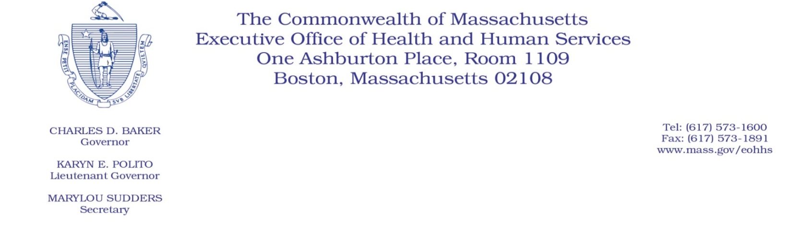
Administrative Bulletin 20-64
101 CMR 331.00: Prescribed Drugs

Effective June 17, 2020

Payment Adjustment to Professional Dispensing Fee

Purpose, Scope, and Effective Period
The Executive Office of Health and Human Services (EOHHS) is issuing this administrative bulletin pursuant to the authority of COVID-19 Order #20: Order Authorizing the Executive Office of Health and Human Services to Adjust Essential Provider Rates During the COVID-19 Public Health Emergency and Executive Order 591: Declaration of State of Emergency to Respond to COVID-19. EOHHS is establishing a payment adjustment to the professional dispensing fee set forth in 101 CMR 331.06 when medications are delivered to a member’s personal residence.
The payment adjustment begins for dates of service on or after April 28, 2020, and will remain effective for the duration of the state of emergency declared via Executive Order No. 591.

Disclaimer: This administrative bulletin is not authorization for a provider’s use of the payment adjustment to the professional dispensing fee. Authorization for the provision of, and billing and payment for, pharmacy services is pursuant to the MassHealth pharmacy services regulations at 130 CMR 406.00: Pharmacy Services and other applicable MassHealth provider regulations and subregulatory guidance, including Pharmacy Facts 145.

Background
To promote social distancing and to allow greater flexibility in providing patient care to individuals who may be affected by the 2019 novel Coronavirus (COVID-19), EOHHS is establishing a payment adjustment to the professional dispensing fee paid to eligible pharmacy providers when medications are delivered to a member’s personal residence. This is intended to encourage providers to expand delivery of medications, reducing the need for individuals to pick up medications in person.

Payment Adjustment to Professional Dispensing Fee
Effective for dates of service beginning April 28, 2020, and notwithstanding the professional dispensing fee set forth in 101 CMR 331.06, eligible providers will receive a payment adjustment to the professional dispensing fee equal to the lower of the provider’s usual and customary charge for prescription delivery or $8.00 when medications are delivered to a member’s personal residence in accordance with the requirements described in Pharmacy Facts 145.

Public Comment
EOHHS will accept comments on the payment adjustment established via this administrative bulletin through July1, 2020. Individuals may submit written comments by emailing
ehs-regulations@state.ma.us. Please submit written comments as an attached Word document or as text within the body of the email with the name of this administrative bulletin in the subject line: AB 20-64: Payment Adjustment to Professional Dispensing Fee. All submissions of comments must include the sender’s full name, mailing address, and organization or affiliation, if any. Individuals who are unable to submit comments by email may mail written comments to EOHHS, c/o D. Briggs, 100 Hancock Street, Quincy, MA 02171.
EOHHS may adopt a revised version of this administrative bulletin taking into account relevant comments and any other practical alternatives that come to its attention.

