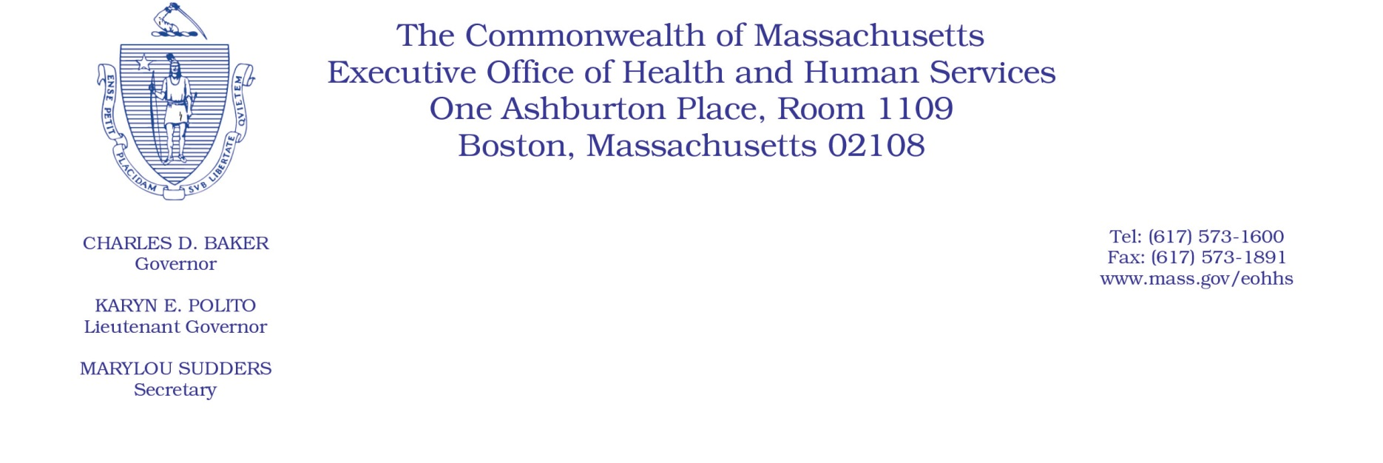

Administrative Bulletin 20-66

114.1 CMR 41.00: Rates of Payment for Services Provided to
Industrial Accident Patients by Hospitals

Effective July 1, 2020
Publication of Payment on Account Factors (PAFs) for Hospital Services
The Executive Office of Health and Human Services (EOHHS), pursuant to 114.1 CMR 41.05(1) and (3), is publishing the Payment on Account Factors (PAFs) for acute and nonacute hospital services rendered to industrial accident patients effective July 1, 2020.

Due to the delay in hospital cost reporting required pursuant to 957 CMR 9.04: Hospital Cost Reporting in response to the coronavirus disease 2019 (COVID-19) emergency, the current PAFs for acute and nonacute hospital services will continue through December 31, 2020, at which time EOHHS anticipates updating PAFs for acute and nonacute hospital services effective January 1, 2021.

Provided below are the PAFs for acute and nonacute hospital services rendered on or after
July 1, 2020.
Acute Hospitals | PAF
Anna Jaques Hospital | 55.36%
Athol Memorial Hospital | 32.89%
Baystate Franklin Medical Center | 48.52%
Baystate Medical Center | 54.80%
Baystate Noble Hospital | 41.98%
Baystate Wing Hospital | 45.35%
Berkshire Medical Center | 65.36%
Beth Israel Deaconess Hospital - Milton | 46.56%
Beth Israel Deaconess Hospital - Needham | 55.83%
Beth Israel Deaconess Hospital - Plymouth | 50.66%
Beth Israel Deaconess Medical Center | 57.99%
Boston Medical Center | 35.77%
Brigham and Women's Faulkner Hospital | 43.75%
Brigham and Women's Hospital | 43.28%
Cambridge Health Alliance | 50.76%
Cape Cod Hospital | 65.18%
Cooley Dickinson Hospital | 54.33%
Dana-Farber Cancer Institute | 38.40%
Emerson Hospital | 46.85%
Fairview Hospital | 69.62%
Falmouth Hospital | 65.81%
Harrington Memorial Hospital | 34.18%
Heywood Hospital | 47.16%
Holyoke Medical Center | 48.09%
Lahey Health - Winchester Hospital | 57.79%
Lahey Hospital and Medical Center | 54.42%
Lawrence General Hospital | 42.71%
Lowell General Hospital | 48.00%
Marlborough Hospital - A member of the UMass Memorial Health Center | 29.58%
Martha's Vineyard Hospital | 65.17%
Massachusetts Eye and Ear Infirmary | 46.01%
Massachusetts General Hospital | 43.96%
MelroseWakefield Healthcare | 52.86%
Mercy Medical Center | 57.50%
MetroWest Medical Center | 36.00%
Milford Regional Medical Center | 51.74%
Morton Hospital - A Steward Family Hospital Inc. | 69.71%
Mount Auburn Hospital | 62.12%
Nantucket Cottage Hospital | 75.38%
Nashoba Valley Medical Center - A Steward Family Hospital Inc. | 41.49%
New England Baptist Hospital | 57.99%
Newton-Wellesley Hospital | 43.10%
North Shore Medical Center | 46.03%
Northeast Hospital | 51.72%
Saint Vincent Hospital | 41.21%
Signature Healthcare Brockton Hospital | 41.35%
South Shore Hospital | 57.17%
Southcoast Hospitals Group | 50.75%
Steward Carney Hospital Inc. | 63.90%
Steward Good Samaritan Medical Center | 66.63%
Steward Holy Family Hospital Inc. | 61.24%
Steward Norwood Hospital Inc. | 64.14%
Steward Saint Anne's Hospital Inc. | 52.98%
Steward St. Elizabeth's Medical Center | 76.36%
Sturdy Memorial Hospital | 73.69%
Tufts Medical Center | 46.00%
UMass Memorial HealthAlliance - Clinton Hospital (Previously HealthAlliance Hospital) | 33.71%
UMass Memorial Medical Center | 39.31%
Acute Hospital Median PAF for  Out-of-State and New Hospitals | 50.75%

Nonacute Hospitals | PAF
Curahealth Stoughton | Median
Fairlawn Rehabilitation Hospital | 53.49%
HealthSouth Braintree Rehabilitation Hospital | 43.47%
HealthSouth New England Rehabilitation Hospital | 54.05%
HealthSouth Rehabilitation Hospital of Western Massachusetts | 51.21%
McLean Hospital | 49.18%
Spaulding Hospital Cambridge | 49.54%
Spaulding Rehabilitation Hospital - Cape Cod | 48.61%
Spaulding Rehabilitation Hospital | 45.14%
Vibra Hospital of Western Massachusetts | Median
Whittier Rehab Hospital Bradford | 37.85%
Whittier Rehab Hospital Westborough | 33.23%
Nonacute Hospital Median PAF for  Out-of-State and New Hospitals | 48.90%

