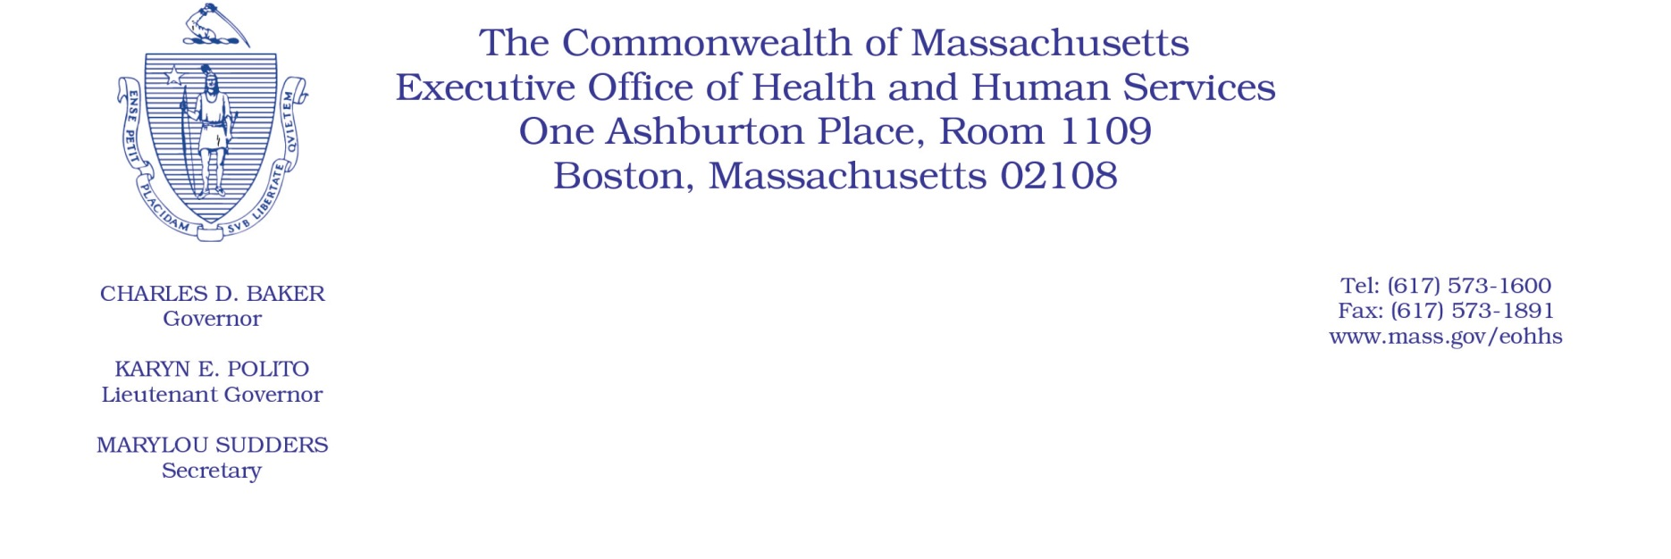

Administrative Bulletin 20-68

101 CMR 206.00: Standard Payments to Nursing Facilities

Effective July 10, 2020
Nursing Facility Direct Care Staff Rate Add-on Extension During the Coronavirus Disease 2019
(COVID-19) Public Health Emergency

Purpose, Scope, and Effective Period
The Executive Office of Health and Human Services (EOHHS) is issuing this administrative bulletin pursuant to the authority of COVID-19 Order No. 20: Order Authorizing the Executive Office of Health and Human Services to Adjust Essential Provider Rates During the COVID-19 Public Health Emergency and Executive Order 591: Declaration of State of Emergency to Respond to COVID-19. In light of the state of emergency declared in the Commonwealth due to COVID-19, EOHHS, which administers the Massachusetts Medicaid program known as “MassHealth,” is implementing certain rate adjustments for nursing facilities, notwithstanding 101 CMR 206.00: Standard Payments to Nursing Facilities, as further described in this administrative bulletin.

This administrative bulletin is effective upon its publication for dates of service beginning July 1, 2020.

Background
As a result of the COVID-19 public health crisis, nursing facilities are facing high infection rates, high staff turnover, and more severe cases of COVID-19 due to their higher-risk populations. In order to ensure that nursing facilities have sufficient staff and resources to provide the necessary level of care to residents while facing the additional pressures created by the COVID-19 public health crisis, EOHHS is extending the rate add-on for direct care staff compensation, established by 101 CMR 206.06(13): Direct Care Staff Add-on.

Direct Care Staff Add-on Rate Extension
For dates of service beginning July 1, 2020, and notwithstanding the June 30, 2020, expiration date in 101 CMR 206.06(13): Direct Care Staff Add-on, the rate add-on for direct care staff compensation, as established under 101 CMR 206.06(13) and calculated according to 101 CMR 206.06(13)(a): Calculation of the Add-on, is hereby extended through July 31, 2020.

EOHHS will file new certified rates, applicable to dates of service beginning July 1, 2020, with the Secretary of the Commonwealth incorporating this extension. EOHHS also intends to promulgate emergency amendments to 101 CMR 206.00: Standard Payments to Nursing Facilities to further extend this rate add-on through September 30, 2020.

Public Comment
EOHHS will accept comments on the rate methodology established via this administrative bulletin through July 24, 2020. Individuals may submit written comments by emailing ehs-regulations@state.ma.us. Please submit written comments as an attached Word document or as text within the body of the email with the name of this administrative bulletin in the subject line. All submissions of comments must include the sender’s full name, mailing address, and organization or affiliation, if any. Individuals who are unable to submit comments by email may mail written comments to EOHHS, c/o D. Briggs, 100 Hancock Street, 6th Floor, Quincy, MA 02171.
EOHHS may adopt a revised version of this administrative bulletin taking into account relevant comments and any other practical alternatives that come to its attention.

