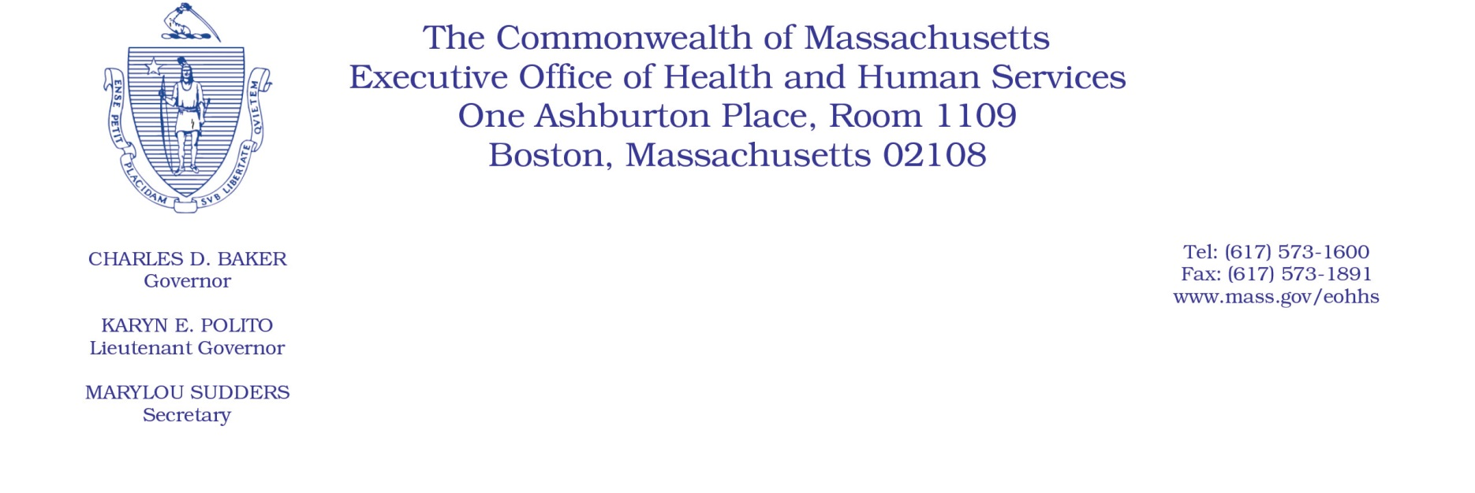

Administrative Bulletin 20-73

101 CMR 204.00: Rates of Payment to Resident Care Facilities

Effective July 10, 2020

Additional Rate Provisions for Resident Care Facilities to Complete COVID-19
Baseline and Surveillance Testing Requirements

Purpose, Scope, and Effective Period

The Executive Office of Health and Human Services (EOHHS) is issuing this administrative bulletin pursuant to the authority of COVID-19 Order No. 20: Order Authorizing the Executive Office of Health and Human Services to Adjust Essential Provider Rates During the COVID-19 Public Health Emergency and Executive Order 591: Declaration of State of Emergency to Respond to COVID-19. In light of the state of emergency declared in the Commonwealth due to COVID-19, EOHHS is establishing an additional rate provision to supplement 101 CMR 204.00: Rates of Payment to Resident Care Facilities to address costs associated with COVID-19 testing, as further described in this administrative bulletin.

This administrative bulletin contains rates effective beginning July 1, 2020, and in accordance with the terms of this administrative bulletin. EOHHS intends to promulgate emergency amendments to 101 CMR 204.00 to ensure the additional rate provisions established herein will remain effective through October 31, 2020.

Disclaimer: This administrative bulletin is not authorization for a provider’s use of the additional rate provisions described herein. Governmental units that authorize services with rates established in 101 CMR 204.00 are responsible for authorizing and determining the use of the additional rate provisions.

Background
As a result of the COVID-19 public health crisis, resident care facilities are facing high infection rates and more severe cases of COVID-19 due to their higher-risk populations. EOHHS recognizes that, consistent with the guidance issued on June 30, 2020, by the Department of Public Health (DPH), titled Long Term Care Surveillance Testing (the DPH LTC Testing Guidance) and any further guidance or direction issued by DPH, testing by resident care facilities of their staff must be completed to ensure that appropriate precautions can be taken to contain the virus. Accordingly, EOHHS is establishing a COVID-19 testing add-on rate under 101 CMR 204.00 to facilitate resident care facilities’ completion of these staff testing requirements, and as further described in this administrative bulletin.

In order to utilize the COVID-19 testing add-on rate described in this administrative bulletin, a resident care facility must have arranged for and paid directly for testing for its staff, must maintain documentation of such payment, must produce such documentation upon EOHHS’s request, and must report such staff testing in accordance with the reporting requirements established in any guidance or direction issued by DPH.

For the purposes of this administrative bulletin, the term “staff” includes all persons, paid or unpaid, working or volunteering at the resident care facility’s physical location, who have the potential for exposure to residents or to infectious materials, including body substances, contaminated medical supplies and equipment, contaminated environmental surfaces, or contaminated air. Staff includes, but is not limited to, physicians, nurses, nursing assistants, therapists, technicians, dental personnel, pharmacists, laboratory personnel, autopsy personnel, students and trainees, contractual personnel including those employed by temporary nurse staffing agencies, and persons not directly involved in resident care (such as clerical, dietary, housekeeping, laundry, security, maintenance or billing staff, chaplains, and volunteers) but potentially exposed to infectious agents that can be transmitted to and from staff and residents. Staff does not include persons who work entirely remotely or off-site, employees on leave or otherwise not working for the entirety of the relevant testing period (such as those on paid family medical leave), or staffing provided at the Commonwealth’s expense (such as those provided by EOHHS through a clinical rapid response team or the Massachusetts National Guard). Further, because the DPH LTC Testing Guidance does not recommend that staff or residents who have previously tested positive for COVID-19 get retested as part of baseline or surveillance testing, staff does not include persons who have previously tested positive for COVID-19.

For the purposes of this administrative bulletin, the term “testing period” means the period in which a resident care facility must complete baseline, biweekly surveillance, or weekly surveillance testing as specified in any guidance or direction issued by DPH. The baseline testing period begins on July 1, 2020, and ends July 19, 2020. For biweekly surveillance testing, the testing periods will each last for two weeks, from Thursday at 7:00 a.m. through the second subsequent Thursday at 6:59 a.m., with the first biweekly testing period running from July 23, 2020, through August 6, 2020. For weekly surveillance testing, the testing periods will each last for one week, from Thursday at 7:00 a.m. through the following Thursday at 6:59 a.m., with the first weekly testing period running from July 23, 2020, through July 30, 2020.

Add-On Rate to Address Costs Associated with COVID-19 Testing

The following add-on rate is intended to address costs associated with COVID-19 testing of resident care facility staff, and supplements the rate regulations at 101 CMR 204.00.

Add-On Name | Unit | Rate
COVID-19 Testing | Monthly | $100.00 per eligible test

Calculating the Amount of the COVID-19 Testing Add-On
EOHHS will calculate the amount of the COVID-19 testing add-on for each eligible resident care facility as follows.

1. An eligible resident care facility’s COVID-19 testing add-on payment will be based on the number of completed qualifying COVID-19 staff tests, as described in Item 2 below.

2. The number of completed qualifying COVID-19 staff tests means the total number of staff tests that meet all of the following criteria:
a. Staff tests that were arranged for and paid directly by the resident care facility, which does not include tests that were completed or facilitated by the staff member on their own time or at their own cost;
b. Staff tests that were conducted for the purposes of meeting the baseline, biweekly surveillance, or weekly surveillance testing requirements as established in any guidance or direction issued by DPH, provided that resident care facilities may test more than the percentage of staff members required to be tested in any given testing period and such tests will be included in the number of completed qualifying COVID-19 staff tests;
c. Not more than one test per individual staff member per baseline, biweekly, or weekly testing period;
d. Staff tests that included the collection of specimens sufficient for diagnostic testing, the processing of a COVID-19 diagnostic test by an FDA-approved method, and the furnishing of results to all appropriate parties in accordance with DPH and CDC guidance;
e. Staff tests that are able to detect SARS-CoV-2 virus, with a polymerase chain reaction (PCR) of greater than 95 percent sensitivity and greater than 90 percent specificity, within 48 hours of conducting the test;
f. Staff tests that were reported, in accordance with any guidance or direction issued by DPH, as tests administered on the resident care facility’s staff, and such report was attested to in accordance with any guidance or direction issued by DPH; and
g. Staff tests for which results were reported by the resident care facility as either positive, negative, or inconclusive; provided that if EOHHS determines that the rate of inconclusive test results is unreasonably high, EOHHS may exclude those inconclusive results from the number of completed qualifying COVID-19 staff tests.

3. The supplemental payments for each eligible resident care facility will be equal to the number of completed qualifying COVID-19 staff tests administered in accordance with any guidance or direction issued by DPH, as such number is determined under Item 2 above, multiplied by $100.

4. The first distribution of COVID-19 testing add-on payments will be calculated based on the number of qualifying COVID-19 staff tests conducted as part of baseline testing, and will be paid within 10 days of such tests’ reporting deadline of July 20, 2020.

5. The remaining COVID-19 testing add-on payments will be paid on a monthly basis, with each monthly payment calculated based on the previous months’ number of qualifying COVID-19 staff tests; provided, however, that the first of such monthly payments, to be paid in August 2020, will not include tests that were already included in the calculation of the payment described in Item 4 above.

Public Comment
EOHHS will accept comments on the rate methodology established via this administrative bulletin through July 24, 2020. Individuals may submit written comments by emailing ehs-regulations@state.ma.us. Please submit written comments as an attached Word document or as text within the body of the email with the name of this administrative bulletin in the subject line. All submissions of comments must include the sender’s full name, mailing address, and organization or affiliation, if any. Individuals who are unable to submit comments by email may mail written comments to EOHHS, c/o D. Briggs, 100 Hancock Street, 6th Floor, Quincy, MA 02171.
EOHHS may adopt a revised version of this administrative bulletin taking into account relevant comments and any other practical alternatives that come to its attention.

