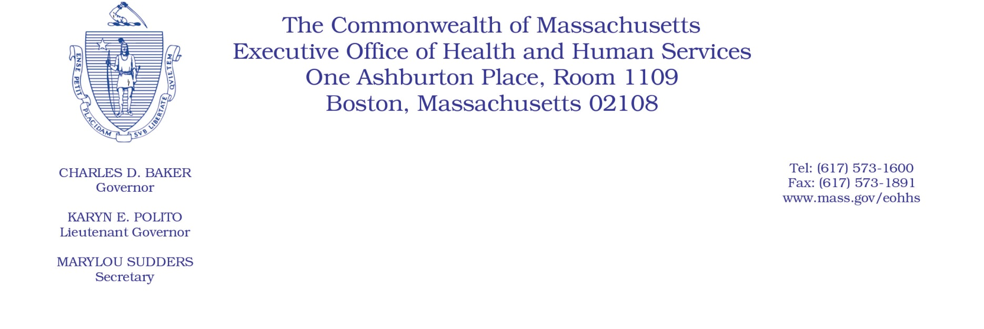

Administrative Bulletin 20-74

101 CMR 358.00: Rates of Payment for Applied Behavior Analysis

Effective August 1, 2020
Applied Behavior Analysis Code Update
In accordance with 101 CMR 358.00: Rates of Payment for Applied Behavior Analysis, the Executive Office of Health and Human Services (EOHHS) is issuing this bulletin to add a new code. In accordance with 101 CMR 358.03(4)(b), the added code will be reimbursed by individual consideration (I.C.). The code listed in this administrative bulletin is based on the 2020 CPT (Current Procedural Terminology) codes. The payment rate listed in this administrative bulletin is applicable until revised rates are issued by EOHHS. The following new code will be effective for dates of service rendered on or after August 1, 2020.
101 CMR 358.00: Rates of Payment for Applied Behavior Analysis - Added Codes
Code | Payment Rate | Service Description
97156 | I.C. | Family adaptive behavior treatment guidance, administered by a licensed professional (with or without the patient present), face-to-face with guardian(s)/caregiver(s), every 15 minutes.

