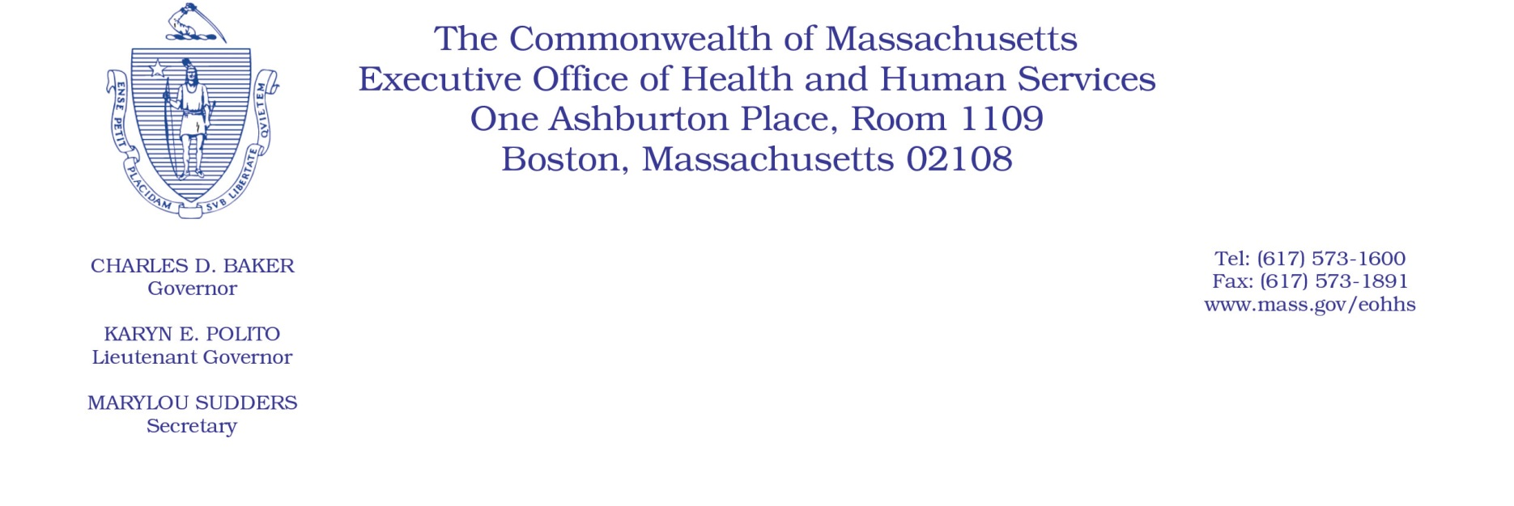

Administrative Bulletin 20-78

101 CMR 309.00: Rates for Certain Services for the Personal Care Attendant Program

Effective October 1, 2020
Update to the Personal Care Attendant Services Rates
The Executive Office of Health and Human Services (EOHHS) is issuing this administrative bulletin pursuant to 101 CMR 309.01(6) to clarify the substantive provisions of the rates for personal care attendant (PCA) services contained in 101 CMR 309.03(5) provided to MassHealth members. Specifically, the rate for PCA New Hire Orientation is being updated in accordance with 101 CMR 309.03(5)(a) to align with the provisions of the collective bargaining agreement effective October 1, 2020. The other rates remain in effect as updated effective July 1, 2020, pursuant to Administrative Bulletin 20-65.
Below is the rate of payment for PCA New Hire Orientation, inclusive of the wage component and the employer expense component, effective on October 1, 2020.
PCA Rate for New Hire Orientation Effective October 1, 2020:
Code | Modifier | Rate | Unit | Service Description
99509 | U3 | $71.20 | Per diem | Home visit for assistance with activities of daily living and personal care. (personal care services) (Use this code and modifier to bill for PCA new hire orientation, per diem, per eligible PCA.)

