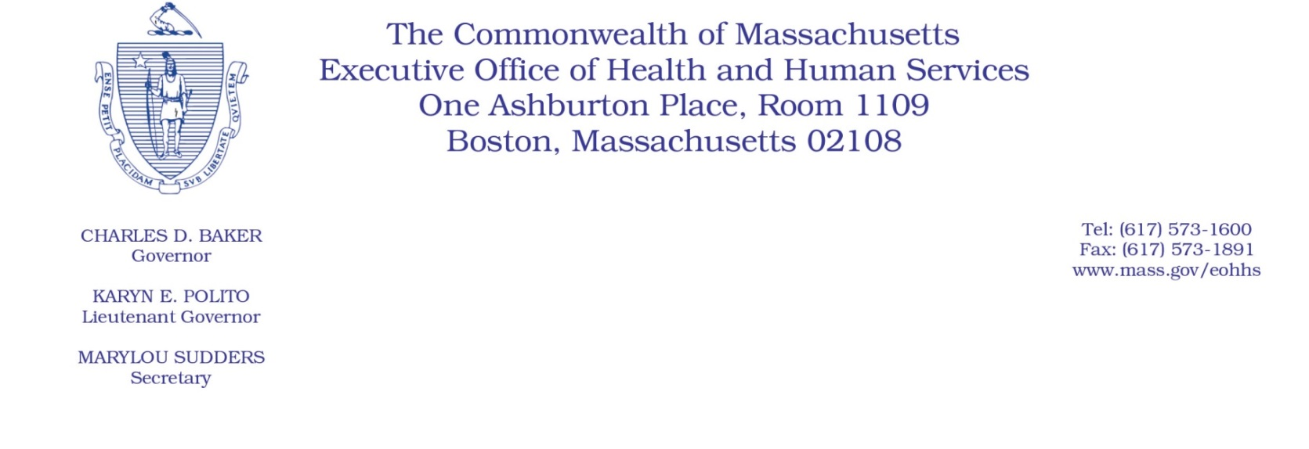
Administrative Bulletin 20-80

101 CMR 614.00: Health Safety Net Payments and Funding
Effective September 1, 2020

Health Safety Net Reimbursement Policy for Pharmacy Services During the Coronavirus Disease 2019 (COVID-19) Public Health Emergency

Purpose, Scope, and Effective Period
In light of the Governor’s March 10, 2020, Declaration of a State of Emergency within the ​​Commonwealth due to COVID-19, the Executive Office of Health and Human Services (EOHHS), which administers the Health Safety Net program, is introducing additional flexibilities for pharmacy coverage and billing for individuals who are Health Safety Net patients, as further described in this administrative bulletin. This guidance is intended to be generally consistent with that set forth in Administrative Bulletin 20-49.
The Health Safety Net program serves as the payer of last resort for health care services provided by acute care hospitals and community health centers to qualified uninsured and underinsured residents of Massachusetts. This administrative bulletin applies to Health Safety Net providers whose outpatient pharmacy services are fulfilled by a contracted third party. It shall be effective for dates of service beginning September 1, 2020, and is effective for the duration of the state of emergency declared by the Governor on March 10, 2020.

Background
The Health Safety Net program pays for certain health care services provided by acute care hospitals and community health centers to low-income uninsured and underinsured residents of Massachusetts. While many acute care hospitals and community health centers operate their own 340B pharmacy, some contract with third party pharmacies to provide pharmacy services. Such contract pharmacies obtain and dispense drugs purchased through the 340B drug pricing program to Health Safety Net patients on behalf of the Health Safety Net provider through this contractual arrangement.
However, recent changes in the pharmaceutical industry have created barriers for such contract pharmacies to obtain certain drugs through the 340B drug pricing program. EOHHS recognizes that these changes may make it difficult for Health Safety Net patients to fill their prescriptions, including prescriptions for life-saving drugs like insulin and epinephrine. Furthermore, EOHHS acknowledges that the COVID-19 public health crisis further limits Health Safety Net patients’ ability to change providers or obtain pharmacy services at a different Health Safety Net provider that operates its own 340B pharmacy.
Accordingly, the Health Safety Net is introducing additional flexibilities to Health Safety Net providers that rely on third-party contract pharmacies to render pharmacy services to Health Safety Net patients to maintain access to pharmacy services during the public health emergency.
Flexibilities regarding Non-340B Prescriptions
Notwithstanding 101 CMR 613.03(2), and in order to facilitate continued access to pharmacy services for Health Safety Net patients during the COVID-19 public health emergency, the Health Safety Net will allow Health Safety Net providers’ contract pharmacies to utilize retail stock to fill prescriptions for their Health Safety Net patients for drugs that are 340B-eligible but that are no longer available for purchase by the contract pharmacy through the 340B drug pricing program. Such retail stock must be billed to the Health Safety Net at Actual Acquisition Cost, as defined in 101 CMR 331.02. For calculation of the Reimbursable Health Services Amount, the claim will be priced at the Actual Acquisition Cost plus the appropriate dispensing fee set forth in 101 CMR 331.00.
However, 340B providers who operate their own 340B pharmacy may submit Health Safety Net claims only for outpatient pharmacy services provided through the provider's 340B pharmacy, except as described in 101 CMR 613.03(2)(c) or as described in Administrative Bulletin 20-49. Additionally, Health Safety Net contract pharmacies must continue to utilize 340B drugs that are in stock or available for purchase through the 340B drug pricing program when filling prescriptions for Health Safety Net patients. Finally, a 340B provider that operates both a 340B pharmacy and retail pharmacy may continue to fill prescriptions for any Health Safety Net patient, as described in Administrative Bulletin 20-49.
Additional Information
For the latest MA-specific information, visit the following link: https://www.mass.gov/resource/information-on-the-outbreak-of-coronavirus-disease-2019-covid-19.
The latest Centers for Disease Control and Prevention (CDC) guidance for healthcare professionals is available at the following link: https://www.cdc.gov/coronavirus/2019-ncov/hcp/index.html.
Questions
If you have any questions about the information in this administrative bulletin, please contact the Health Safety Net at (800) 609-7232, or email your inquiry to HSNHelpdesk@state.ma.us.

