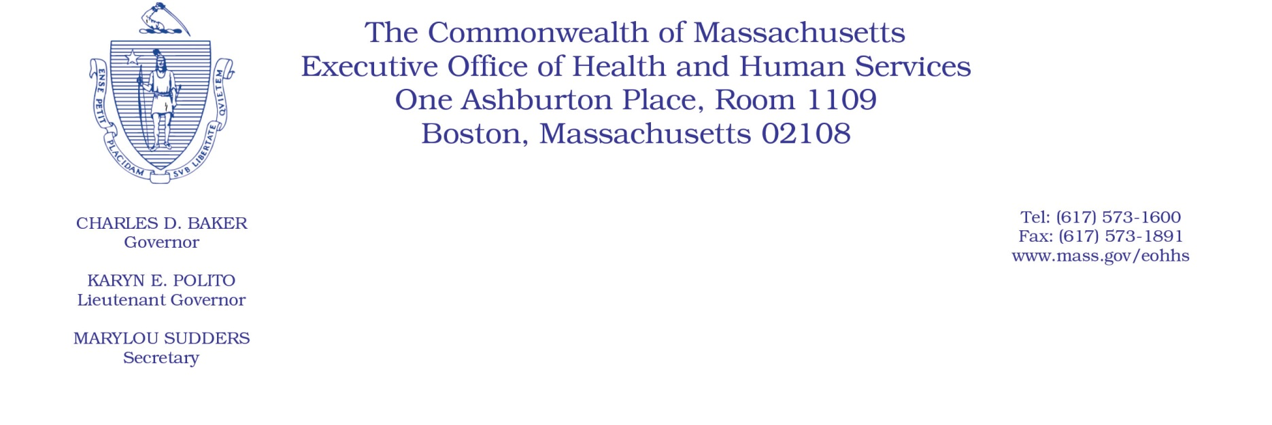

Administrative Bulletin 20-82

114.1 CMR 41.00: Rates of Payment for Services Provided to Industrial Accident Patients by Hospitals

Effective October 1, 2020
Publication of the Health Safety Net Uniform Assessment Percentage
The Executive Office of Health and Human Services is issuing this bulletin pursuant to 114.1 CMR 41.05(4) to publish the updated Health Safety Net Uniform Assessment for hospital outpatient workers’ compensation charges.

The revised percentage change from 0.66% to 0.62% will be effective for services rendered on or after October 1, 2020, and may be added to acute hospital charges in accordance with 114.1 CMR 41.04(1)(d). This percentage is applied to acute care hospital charges when the payment for the industrial accident patient is based on the ambulatory fees set forth in 114.3 CMR 40.00: Rates for Services under M.G.L. c. 152, Workers’ Compensation Act. This percentage includes hospital rates for restorative services and ambulatory surgical facility group fees.

