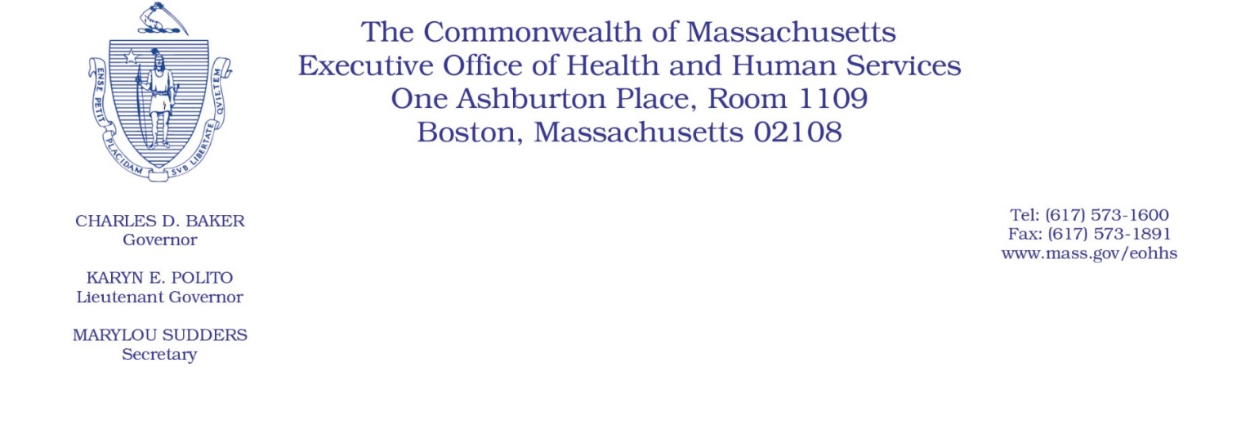

Administrative Bulletin 20-83

101 CMR 20.00: Health Information Exchange

November 1, 2020

Extension of ADT Requirement for Acute Care Hospitals

The Executive Office of Health and Human Services (EOHHS), including the Massachusetts Health Information Highway (Mass HIway), issues this administrative bulletin to extend the effective date for implementing the requirements of 101 CMR 20.08(4): Connection Requirements for Acute Care Hospitals, which describes when acute care hospitals have to submit Admit, Discharge, and Transfer (ADT) feeds to the Statewide Event Notification Services (ENS) Framework.

101 CMR 20.08(4)(b) requires acute care hospitals to submit ADT feeds to the statewide ENS framework as of January 1, 2020. In addition, 101 CMR 20.08(4)(d) states that penalties for noncompliance may be assessed as of July 1, 2020. Acute care hospitals that do not meet the requirement to submit ADT feeds by this date may be subject to the penalties set forth in 101 CMR 20.14 and 101 CMR 20.15.

EOHHS is extending the effective date for implementing the requirements of 101 CMR 20.08(4)(b) and 101 CMR 20.08(4)(d) by one year and three months. The effective date for implementing the requirements under 101 CMR 20.08(4)(b) is now April 1, 2021, and the effective date for implementing the penalties under 101 CMR 20.08(4)(d) is now October 1, 2021.

This bulletin supersedes Administrative Bulletin 20-47 (effective May 1, 2020). If you have any questions about this bulletin, please contact Mass HIway ENS Manager Pam Boutin-Coviello at pam.boutin-coviello@mass.gov or (855) MA-HIway (624-4929).

EOHHS may adopt a revised version of this administrative bulletin taking into account relevant comments and any other practical alternatives that come to its attention.

