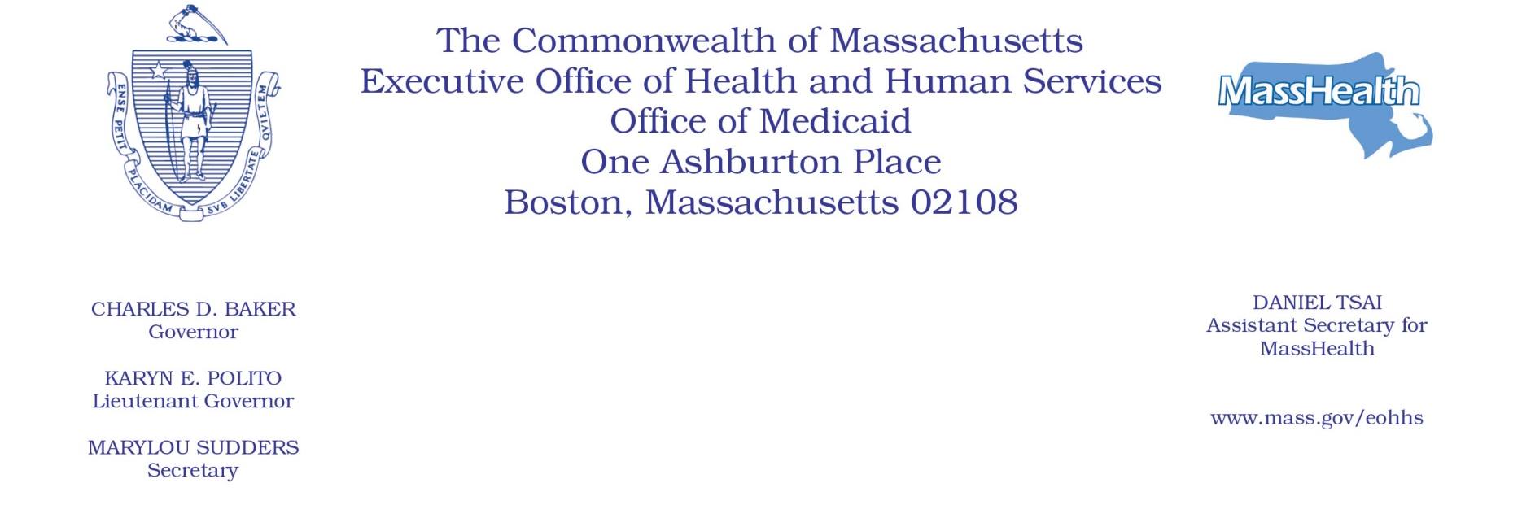

Administrative Bulletin 21-02

101 CMR 206.00: Standard Payments to Nursing Facilities

Effective February 10, 2021

Nursing Facility Direct Care Cost Quotient

The Executive Office of Health and Human Services (EOHHS) is issuing this administrative bulletin pursuant to 101 CMR 206.12: Direct Care Cost Quotient (DCC-Q) to set forth the compliance criteria, reporting requirements, penalty amount, and recovery and referral procedures for the nursing facility direct care cost quotient.
- DCC-Q Compliance Threshold
- As of October 1, 2020, nursing facilities must have a direct care cost quotient (DCC-Q), as described in 101 CMR 206.12, of at least 75% during the remainder of fiscal year (FY) 2021, from October 1, 2020, through June 30, 2021, and each full FY thereafter, running from July 1 through June 30.
- For the rate year beginning October 1, 2021, a nursing facility rate may be subject to a downward adjustment if the facility fails to be at or above the 75% DCC-Q for the period of October 1, 2020, through June 30, 2021.
- For the rate years beginning on or after October 1, 2022, a nursing facility rate may be subject to a downward adjustment if the facility fails to be at or above the 75% DCC-Q for the FY prior to such rate year.
- DCC-Q Calculation
- The DCC-Q will be calculated for each facility by dividing the facility’s Total Direct Care Expenses by its Total Adjusted Nursing Revenue, as defined below.
- “Total Direct Care Expenses” means the total amount calculated when adding together the following eligible expenses:
  - Eligible direct care workforce expenses attributable to the following workforce categories: registered nurses; licensed practical nurses, certified nurse aides; non-certified or resident care aides; director of nurses; in-house clerical staff regularly interacting with residents and caregivers (e.g., receptionists, business office staff working onsite), excluding administrator; security staff; staff development coordinator; dietary; housekeeping/laundry; quality assurance professional; unit clerks; MMQ evaluation nurse/MDS coordinator; social service worker; behavioral health staff; plant operations/maintenance; interpreter service; restorative therapy; recreational therapy; physician services; pharmacy consultant; provided however that expenses attributable to recreational therapy and social service worker workforce categories will be multiplied by 1.5 before being added to the overall direct care workforce expense amount.
  - Eligible additional direct care expenses attributable to the following categories, for resident care only: food and dietary supplies; laundry and housekeeping supplies.
- “Total Adjusted Nursing Revenues” includes eligible facility total revenue from the following revenue categories: Nursing Facility Payer Revenue and Residential Care Revenue (Level IV), provided that revenue adjustments are made to subtract expenses for the following categories: user fee expense, and Medicare ancillary costs including laboratory, pharmacy, x-ray, ambulance, and specialty beds.
- Reporting Requirements
- All nursing facilities, including facilities with less than 5,000 Massachusetts Medicaid Days in any given fiscal year, will be required to submit an interim compliance report and a final compliance report each year (see Section 4(c) of this administrative bulletin). Both the interim compliance report and the final compliance report must be submitted using the submission form available at the University of Massachusetts Portal at http://www.uenter.org/nf.
- For the rate year beginning October 1, 2021:
  - The interim compliance report, which will cover the reporting period of October 1, 2020, through December 31, 2020, is due by February 19, 2021, and will be used to inform nursing facilities if they are on track to meet the 75% DCC-Q threshold.
  - The final compliance report, which will cover the reporting period of October 1, 2020, through June 30, 2021, is due by July 30, 2021, and will be used for determining whether the facility met the 75% threshold for that reporting period.
  - A facility that does not meet the 75% DCC-Q threshold for the reporting period of October 1, 2020, through June 30, 2021, based on the data submitted through its final compliance report will be subject to a downward adjustment to its standard rates in the rate year beginning October 1, 2021.
- For rate years beginning on or after October 1, 2022:
  - The interim compliance report will be due by February 1 each year and will cover the reporting period of the previous July 1 through December 30. These interim compliance reports will be used to inform nursing facilities if they are on track to meet the 75% DCC-Q threshold for that fiscal year.
  - The final compliance report will be due by July 30 each year and the reporting period will cover the entire previous fiscal year, from July 1 through June 30.
  - A facility that does not meet the 75% DCC-Q threshold for the previous fiscal year, based on its final compliance report, will be subject to a downward adjustment to its standard rates in the rate year beginning October 1 of that year.
- Rate Adjustment Calculation and Enforcement
- If a facility fails to meet the 75% DCC-Q threshold, based on the data in its final compliance report, the facility’s standard rate will be subject to a downward adjustment in the following rate year. The downward adjustment will be calculated as follows.
- For every 1% below the 75% DCC-Q threshold, a 0.5% downward adjustment will be applied to the nursing and operating components of the facility’s standard payments, subject to the limitations in Section 4(a)(ii) of this administrative bulletin.
- The maximum downward adjustment calculated for a facility may be no more than 5% of the nursing and operating components of the facility’s standard payments in the following rate year.
- EOHHS may apply the maximum downward adjustment of 5% in the following rate year for facilities that fail to submit the final compliance report by the July 30 due date established under Section 3 of this administrative bulletin.
- Nursing facilities that will have less than 5,000 Massachusetts Medicaid Days in the previous fiscal year, as reported on their Quarterly User Fee Assessment Forms for the period of July 1 through June 30, will be exempt from the downward adjustment. However, any facilities that fail to comply with the final compliance report submission requirements under Section 3 of this administrative bulletin may be subject to an administrative fine of up to $5,000. Administrative fines will be applied in accordance with 130 CMR 450.239: Sanctions: Calculation of Administrative Fine.
- Contact Information for Provider Questions Regarding the Direct Care Cost Quotient
For any technical questions regarding the interim or final compliance form, or abbreviated compliance report, please email NFReporting@umassmed.edu. For all other questions, please email Pavel Terpelets, Deputy Director of Institutional Programs, at Pavel.Terpelets@mass.gov, or Meera Ramamoorthy, Institutional Program Manager, at meera.e.ramamoorthy@mass.gov.

