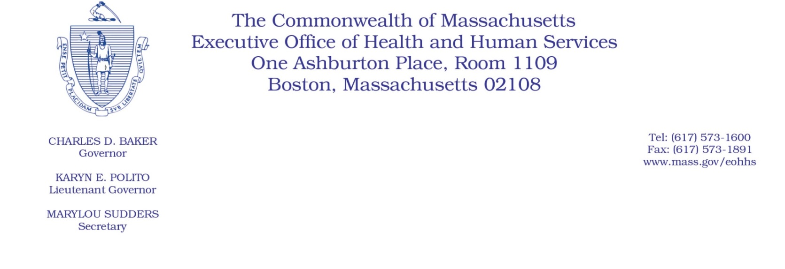
Administrative Bulletin 21-20
101 CMR 613.00: Health Safety Net Eligible Services
101 CMR 614.00: Health Safety Net Payments and Funding
Effective July 29, 2021

Health Safety Net Service and Reimbursement for COVID-19 Vaccines and Related Services

Background
The Health Safety Net program serves as the payer of last resort for health care services provided by acute care hospitals and community health centers to qualified uninsured and underinsured residents of Massachusetts.
The Health Safety Net has implemented certain flexibilities in response to the COVID-19 pandemic, most recently through Administrative Bulletin 21-15. As part of its ongoing response to the COVID-19 pandemic and in order to increase rates of COVID-19 vaccination in the Commonwealth, this administrative bulletin, effective for dates of service on or after July 26, 2021, introduces additional Health Safety Net guidance regarding billing for COVID-19 vaccine counseling services. It applies to acute care hospitals and community health centers that are Health Safety Net providers.
Billing for COVID-19 Vaccine Counseling Services
Beginning for dates of service on or after July 26, 2021, the Health Safety Net will reimburse acute outpatient hospitals for providing clinically appropriate, medically necessary COVID-19 counseling services through the following CPT codes: 99401, 99402, 99403, and 99404.
Additionally, effective for dates of service on or after July 26, 2021, the Health Safety Net will reimburse community health centers (CHCs) for providing clinically appropriate, medically necessary COVID-19 counseling services using the following CPT codes: 99401, 99403, and 99404. However, CHCs may either bill the Health Safety Net for an individual medical visit or for COVID-19 counseling services, but may not bill for both in a single visit. For further details, providers should review MassHealth Community Health Center Bulletin 112, the substantive provisions of which are incorporated herein by reference and applied to the Health Safety Net’s reimbursement of vaccine services provided by CHCs.

Other Considerations
Please note that all providers must make diligent efforts to obtain payment first from other resources, including MassHealth, so that the Health Safety Net will be the payer of last resort for Health Safety Net providers.

Additional Information
For the latest MA-specific information, visit the following link: www.mass.gov/resource/information-on-the-outbreak-of-coronavirus-disease-2019-covid-19.
The latest Centers for Disease Control and Prevention (CDC) guidance for healthcare professionals is available at the following link: www.cdc.gov/coronavirus/2019-ncov/hcp/index.html.

Questions
If you have any questions about the information in this administrative bulletin, please contact the Health Safety Net at (800) 609-7232, or email your inquiry to HSNHelpdesk@state.ma.us.

