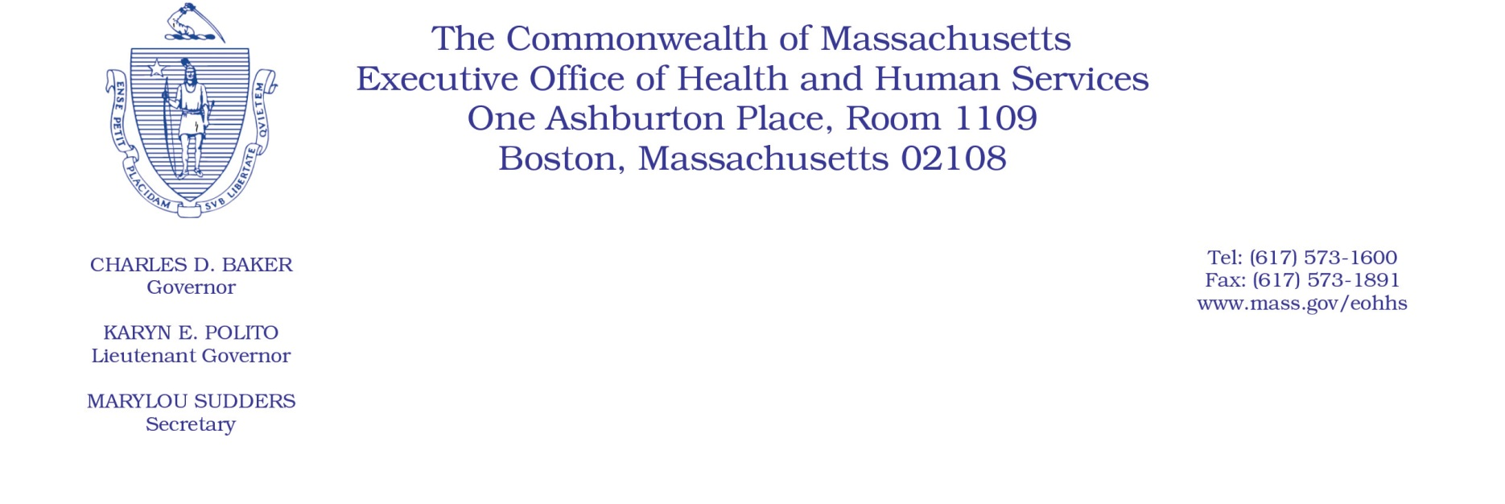

Administrative Bulletin 21-22

101 CMR 324.00: Nonpublic Ambulance Service Reimbursement
Trust Fund Assessment and Funding

Effective September 3, 2021

Reporting of Nonpublic Emergency Ambulance Assessed Charges and Payer Registration

Reporting of Nonpublic Emergency Ambulance Assessed Charges and Payer Registration
In accordance with 101 CMR 324.04: Nonpublic Ambulance Provider’s Liability and Payment to the Nonpublic Ambulance Service Reimbursement Trust Fund, the Executive Office of Health and Human Services (EOHHS) is issuing this bulletin to provide an ambulance revenue reporting mechanism for nonpublic ambulance providers who are not required to file cost reports with the Center for Health Information and Analysis (CHIA).

Ambulance Revenue Report and Financial Statements
Nonpublic ambulance providers include any ambulance provider licensed pursuant to M.G.L. c. 111C § 6 that is not a city or town, county, district, or other governmental body. Under 101 CMR 324.04(3), each nonpublic ambulance provider is required to report its nonpublic emergency ambulance assessed charges each year. Such reporting can be completed through the filing of the Ambulance Cost Report with CHIA, subject to all requirements under 957 CMR 6.00: Cost Reporting Requirements. Certain nonpublic ambulance providers may claim exemption from filing cost reports with CHIA (for example, if the provider was paid less than $100,000 from MassHealth for services provided in a fiscal year).
The Ambulance Revenue Report included as Attachment A to this Administrative Bulletin is required for nonpublic ambulance providers exempted from filing cost reports with CHIA, provided that they earn any revenue from providing ambulance services. Any such nonpublic ambulance provider that did not submit a cost report with CHIA for fiscal year 2019 must file the Ambulance Revenue Report, which includes a subset of information provided in the CHIA Ambulance Cost Reports.
EOHHS will be calculating the assessment for state fiscal year 2022 based upon each provider’s 2019 fiscal year revenue because of the effects of the COVID-19 pandemic on fiscal year 2020 data. The Ambulance Revenue Report must include the provider’s fiscal year 2019 operating revenue for basic life and advanced life ground service, not including air ambulance. EOHHS requests that nonpublic ambulance providers complete each line of the report, but if providers are unable to separate operating revenue by payer (lines 1-7), they may submit total operating revenue (line 8). Nonpublic ambulance providers must also submit financial statements for fiscal year 2019 if available.
Any nonpublic ambulance provider exempt from filing a cost report with CHIA for fiscal year 2019 that earned revenue for providing ambulance services in its 2019 fiscal year must submit its fiscal year 2019 Ambulance Revenue Report and financial statements to EOHHS by September 20, 2021.
Municipal or other governmental ambulance providers do not need to submit an Ambulance Revenue Report, nor do nonpublic ambulance providers that did not earn revenue from providing ambulance services in fiscal year 2019.

Nonpublic Ambulance Service Reimbursement Trust Fund Payer Registration Form
As described in 101 CMR 324.04(5), nonpublic ambulance providers must submit the nonpublic ambulance service reimbursement trust fund payer registration form to EOHHS if they receive revenue relating to the provision of ambulance services in Massachusetts. EOHHS anticipates issuing this registration form in the near future in connection with instructions on how to pay the assessment. Until EOHHS issues the registration form, providers do not need to submit a separate registration form.

Submission Instructions
As described above, providers submitting the Ambulance Revenue Report and financial statements for fiscal year 2019 must submit them to EOHHS by September 20, 2021. Documents should be submitted by email to Martura Amato, Transportation Program Manager, at Martura.Amato@mass.gov.

Questions
Please submit any questions in writing to Martura Amato at Martura.Amato@mass.gov.

