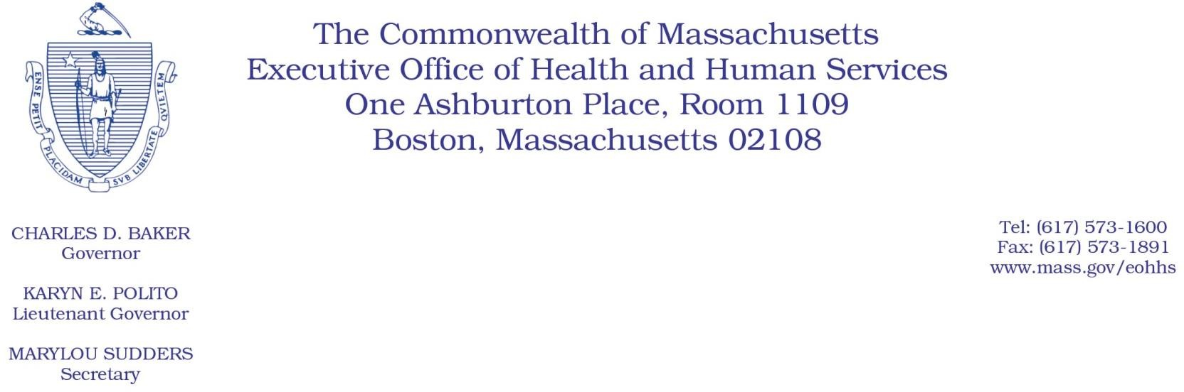

Administrative Bulletin 21-25

101 CMR 444.00: Rates for Certain Substance Use Disorder Services

Effective October 5, 2021

Code Updates

In accordance with 101 CMR 444.00: Rates for Certain Substance Use Disorder Services, the Executive Office of Health and Human Services (EOHHS) is issuing this bulletin to add a new code. In accordance with 101 CMR 444.04, the added code will be reimbursed by individual consideration (I.C.). The code listed in this administrative bulletin is based on the 2021 HCPCS (Healthcare Common Procedure Coding System) codes. The payment rate listed in this administrative bulletin is applicable until revised rates are issued by EOHHS. The following new code will be effective for dates of service rendered on or after October 5, 2021.

101 CMR 444.00: Rates for Certain Substance Use Disorder Services - Added Code

Code | Payment Rate | Service Description
H0047 | I.C. | Alcohol and/or other drug abuse services, not otherwise specified; oral medication preparation and administration (buprenorphine and associated drug screens); may not be combined with H0033; may be billed once per each day a member receives medication

EOHHS is also issuing this bulletin to delete codes for which there are no corresponding new codes. In accordance with 101 CMR 444.01, the following codes will be inactive for dates of service rendered on or after October 5, 2021.

101 CMR 444.00: Rates for Certain Substance Use Disorder Services - Deleted Codes

Code | Description
J0574 | Buprenorphine/naloxone, oral, greater than 6 mg, but less than or equal to 10 mg
J0575 | Buprenorphine/naloxone, oral, greater than 10 mg

Providers should use J0573 (for doses greater than 3 mg, but less than or equal to 6 mg) to approach the appropriate dose in multiples of 3.1- 6 mg and then, when necessary, a single unit of J0572 (for doses less than or equal to 3 mg) to achieve the exact dose (e.g., 24 mg dose = 4 units J0573, 22 mg = 4 units J0573, 20 mg dose = 3 units J0573 and 1 unit J0572).

