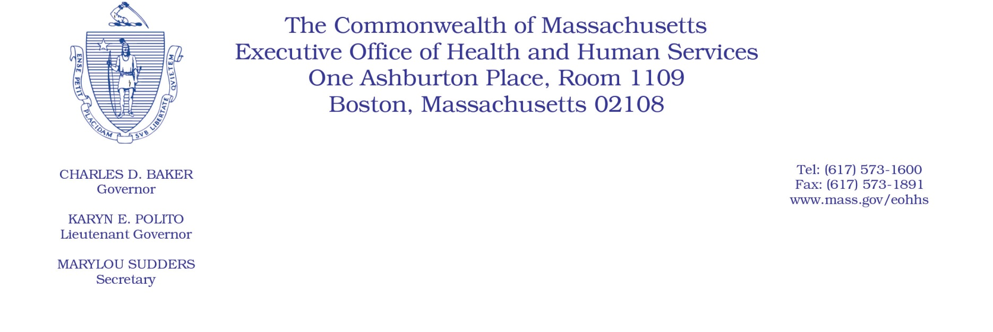

Administrative Bulletin 21-28

101 CMR 701.00: Community Hospital Reinvestment Trust Fund Payments and Funding

Effective November 1, 2021

Allocation and Requirements of Trust Fund Payments

The Executive Office of Health and Human Services (EOHHS) is issuing this Administrative Bulletin pursuant to 101 CMR 701.01(2) to
• identify amounts and recipients of payments from the Community Hospital Reinvestment Trust Fund (the “Trust Fund”) for state fiscal year 2021 (SFY2021); and
• set forth compliance criteria and reporting requirements relating to Trust Fund payments.

Payment amounts are determined by EOHHS, using the methodology described in 101 CMR 701.04(4), based on data reported to the Center for Health Information and Analysis (CHIA).

1. State Fiscal Year 2021 Payments by Eligible Acute Care Hospital
a. Anticipated SFY2021 payments to eligible acute care hospitals are identified in the table below.

Eligible Acute Care Hospital | SFY2021 Payment
Anna Jaques Hospital | $384,897
Athol Memorial Hospital | $275,765
Baystate Franklin Medical Center | $85,871
Baystate Medical Center | $119,825
Baystate Noble Hospital | $406,166
Baystate Wing Hospital | $348,638
Beth Israel Deaconess Hospital - Milton | $289,123
Beth Israel Deaconess Hospital - Needham | $174,270
Beth Israel Deaconess Hospital - Plymouth | $210,345
Beth Israel Deaconess Medical Center | $46,420
Brigham and Women's Faulkner Hospital | $88,219
Cambridge Health Alliance | $332,260
Cooley Dickinson Hospital | $78,745
Emerson Hospital | $184,793
Harrington Memorial Hospital | $257,364
HealthAlliance-Clinton Hospital | $304,264
Heywood Hospital | $436,630
Holyoke Medical Center | $423,868
Lahey Health - Winchester Hospital | $207,290
Lahey Hospital and Medical Center | $121,920
Lawrence General Hospital | $345,705
Lowell General Hospital | $255,502
Marlborough Hospital | $178,288
Massachusetts Eye and Ear Infirmary | $290,830
MelroseWakefield Healthcare | $161,948
Mercy Medical Center | $263,448
MetroWest Medical Center | $86,143
Milford Regional Medical Center | $247,782
Morton Hospital | $173,721
Mount Auburn Hospital | $125,700
Nashoba Valley Medical Center | $189,708
New England Baptist Hospital | $256,904
Newton-Wellesley Hospital | $130,147
North Shore Medical Center | $109,126
Northeast Hospital | $271,865
Saint Vincent Hospital | $134,760
Shriners Hospitals for Children - Boston | $421,352
Shriners Hospitals for Children - Springfield | $229,928
Signature Healthcare Brockton Hospital | $277,762
South Shore Hospital | $30,847
Southcoast Hospitals Group | $290,295
Steward Carney Hospital | $164,512
Steward Good Samaritan Medical Center | $112,433
Steward Holy Family Hospital | $180,754
Steward Norwood Hospital | $136,056
Steward Saint Anne's Hospital | $89,611
Steward Saint Elizabeth's Medical Center | $31,750
Tufts Medical Center | $20,867
UMass Memorial Medical Center | $15,581

b. EOHHS anticipates that SFY2021 payments will be disbursed during or around November 2021. Once EOHHS distributes SFY2021 payments, those payment amounts will be deemed final and will not be revised by EOHHS.

c. Although EOHHS has elected not to require acute care hospitals receiving SFY2021 payments from the Trust Fund to submit reports to EOHHS describing their activities supported by those payments, acute care hospitals that received payments from the Trust Fund in prior state fiscal years must continue to comply with any reporting requirements that EOHHS attached to those payments. See Administrative Bulletin 18-05.

2. Noncompliance
EOHHS may deny, reduce, or withhold payment to an eligible acute care hospital that fails to comply with any condition of payment or reporting requirement set forth in 101 CMR 701.00 or this Administrative Bulletin. EOHHS will notify the acute care hospital of its intention to deny, reduce, or withhold payment.

Payment amounts are subject to budget appropriation and availability of funds.

