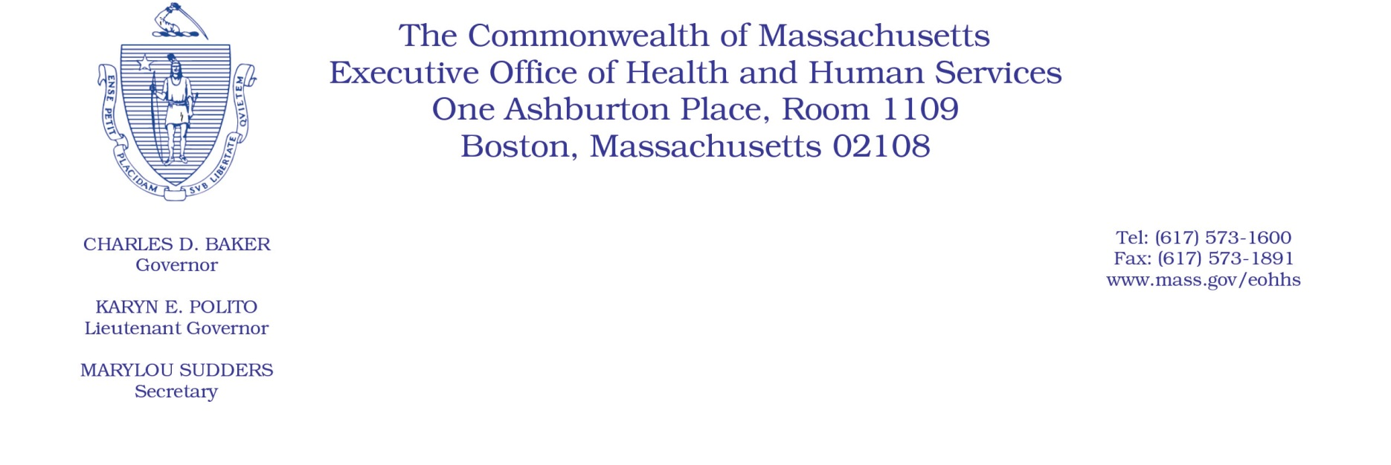

Administrative Bulletin 22-01

101 CMR 206.00: Standard Payments to Nursing Facilities

Effective January 15, 2022

Supplemental Payments for Nursing Facilities for Workforce Retention and Recruitment Initiatives

Purpose, Scope, and Effective Period

The Executive Office of Health and Human Services (EOHHS) is issuing this administrative bulletin to implement the legislative requirement in line item 1599-2029 in Section 2A of Chapter 102 of the Acts of 2021 to distribute a $25,000,000 appropriation for nursing facility workforce retention and recruitment initiatives. The funds will be distributed, in accordance with line item 1599-2029, through a one-time lump sum supplemental payment to MassHealth nursing facility providers (the “Workforce Supplemental Payment”), as described herein.

This administrative bulletin is effective beginning January 15, 2022. EOHHS intends to incorporate the Workforce Supplemental Payment calculation methodology described herein into the final amendments to 101 CMR 206.00: Standard Payment to Nursing Facilities, originally filed as emergency amendments effective for dates of service on or after October 1, 2021.

Calculation and Distribution of Supplemental Payments

Effective January 15, 2022, a nursing facility will be eligible for a Workforce Supplemental Payment, to support workforce retention and recruitment efforts during the COVID-19 pandemic. The aggregate total of Workforce Supplemental Payments will equal $25,000,000, in accordance with line item 1599-2029 of Section 2A of Chapter 102 of the Acts of 2021.

EOHHS will use the following methodology to calculate the Workforce Supplemental Payment for each MassHealth nursing facility provider:

- Determine the total number of Massachusetts Medicaid days, including fee-for-service (FFS) days and managed care days, as reported by all nursing facilities in their Quarterly User Fee Assessment Forms for the period of April 1, 2021 – September 30, 2021.
- Divide the total amount of available funds, $25,000,000, by the total number of Massachusetts Medicaid days as determined in step 1, above.
- For each nursing facility, multiply the quotient calculated in step 2, above, by the nursing facility’s Massachusetts Medicaid days, including FFS days and managed care days, as reported in the nursing facility’s Quarterly User Fee Assessment Forms for the period of April 1, 2021 – September 30, 2021.
- The total Workforce Supplemental Payment for each nursing facility will equal the total calculated in step 3, above.

EOHHS may adjust any Workforce Supplemental Payment upon EOHHS’s determination that there was a material error in the calculation of the payment. EOHHS will not adjust any Workforce Supplemental Payment solely because a facility under-reported Massachusetts Medicaid days in its Quarterly User Fee Assessment Form.

Permissible Uses of Workforce Supplemental Payments

Facilities shall use these Workforce Supplemental Payments to support direct-care staff recruitment and retention initiatives that may include but are limited to increases in base wages and/or retention bonuses for directly employed staff, signing bonuses for new employees, premium pay, and shift differentials. The permissible expenses to be funded through these Workforce Supplemental Payments must be incurred by June 30, 2022.

For the purposes of this bulletin, direct-care staff shall include the following staff categories: registered nurses; licensed practical nurses, certified nurse aides; non-certified or resident care aides; director of nurses; in-house clerical staff regularly interacting with residents and caregivers (e.g., receptionists, unit clerks, business office staff working onsite); security staff; staff development coordinators; dietary staff; housekeeping/laundry staff; quality assurance professional staff; MMQ evaluation nurse/MDS coordinators; social service workers; behavioral health staff; plant operations/maintenance staff; interpreter service staff; restorative therapy staff; recreational therapy staff; physician services staff; and pharmacy consultant staff. Direct-care staff shall not include nursing facility administrators or temporary nursing agency staff.

Reporting Requirements

Each facility will be required to report to EOHHS on the ways in which it expects to use, and ultimately uses, its received Workforce Supplemental Payments. The required reporting will be incorporated in the interim and final DCC-Q reports that facilities are required to submit by March 1, 2022, and July 30, 2022, respectively, in accordance with 101 CMR 206.12(3). Failure to complete the required Workforce Supplemental Payment reporting on the interim and final DCC-Q reports, failure to timely submit the interim or final DCC-Q reports, use of funds on anything other than permissible uses described herein, failure to incur permissible workforce expenses by June 30, 2022, or failure to actually pay the Workforce Supplemental Payment for such incurred permissible workforce expenses may result in partial or full recoupment of received Workforce Supplemental Payments as overpayments under 130 CMR 450.237: Overpayments: Determination.

All information included in the reports regarding Workforce Supplemental Payments is subject to verification and audit by EOHHS. Failure to submit the required reporting in accordance with this bulletin or comply with audits or document requests with respect to the requirements under this bulletin may result in partial or full recoupment of the Workforce Supplemental Payments as overpayments under 130 CMR 450.237: Overpayments: Determination, or sanctions under 130 CMR 450.238: Sanctions: General.

Public Comments

EOHHS will accept comments on the payment methodologies established via this administrative bulletin, which are proposed to be codified as additional amendments to 101 CMR 206.00: Standard Payments to Nursing Facilities in the final adoption of the emergency amendments to that regulation that were originally filed on October 1, 2021. Comments will be accepted through January 28, 2022, at 5:00 p.m., and EOHHS will also hold a public hearing regarding these amendments on January 28, 2022, at 10:00 a.m.

To register to testify at the hearing and to get instructions on how to join the hearing online, go to www.mass.gov/service-details/executive-office-of-health-and-human-services-public-hearings. To join the hearing by phone, call (646) 558-8656 and enter meeting ID 935 397 8200# when prompted. Individuals may submit written comments by emailing ehs-regulations@mass.gov.

Please submit written comments as an attached Word document or as text within the body of the email with the name of this administrative bulletin in the subject line. All submissions of comments must include the sender’s full name, mailing address, and organization or affiliation, if any. Individuals who are unable to submit comments by email may mail written comments to EOHHS, c/o D. Briggs, 100 Hancock Street, 6th Floor, Quincy, MA 02171.

